Supplies that are good to use for the rocks.

* Paint brushes
* Toothpicks
* Q-tips
* Items below are used my most donators from Michaels
  + Sharpies
  + Paint Pens
  + Rocks (From Michaels or what you find outdoors)
  + Acrylic Paint
  + Clear Latex Finish

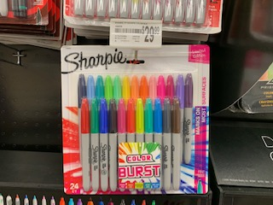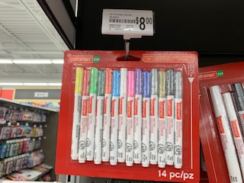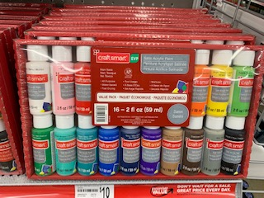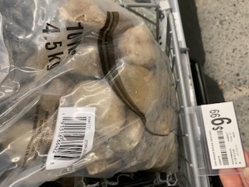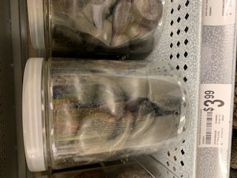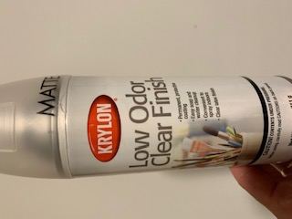

1. Start off with a rock smaller than the size of your palm. You can find a rock outside, Michaels and Lowe’s also sell rocks made for painting that are very smooth. Any size rock from outside that is easily carried can be used also.
2. Paint a base coat on the rock with acrylic paint. Be sure the base coat is thick enough that none of the rock shows through. Let the base coat dry completely. This usually takes ½ hour. You can paint a bunch of base coats in one color and then focus on decorating at a later date.
3. The theme can be anything from motivating to cheerful. These rocks are left in cancer centers where patients are entering in for chemo and radiation. Some people want something cute to cheer them up, others like motivation or need hope or inspiration. Popular rocks are ones worded with Hope, Love, Fight, Strong, and Believe. There are tons of examples on the internet for ideas.
4. Make cancer ribbons in all colors. Patients love to see a cancer ribbon representing their type of cancer.
5. Tips from frequent painters:
   1. Paint pens and Sharpie pens are great for writing the words. Beware that if writing in Sharpie pen you have to put a very light latex coat on first, let it dry, then add a second or the sharpie will run.
   2. Dipping a toothpick in acrylic paint is also very good for writing on the rocks and for fine details.
   3. Dipping the end of a Q-tip in acrylic paint and dabbing it will make a perfect circle.
   4. Using stencils, coins, etc. works very well. Trace the stencil with a pencil and paint over it with a paint pen or toothpick and acrylic paint. Pencil erases from the base coat easily so you can get the design correct first.
   5. To get words centered on the rock, draw the letters on a piece of paper below the rock, then draw them on the rock.
6. After your design is completely dry, spray them with a clear latex paint. To avoid any running of the sharpies or paint pens first spray the rocks very lightly. Let it dry at least 10 minutes, then spray it very lightly again. Wait another 10 to 20 minutes, then you can spray the sides and the top more heavily.
7. Be original. We have had rocks of sponge bob, animals, cookies, lady bugs, along with the motivational rocks. Many times the rock ‘speaks’ to you and you envision a design based on the shape.
8. The rocks will be placed in the Making Strides Against Breast Cancer Walks and in Chemo/

**Thank you very much for participating in this activity. If you are making rocks we would love to post pictures on our Facebook page. The patients love to see the kids behind the rocks.**

**To see the difference you are making in someone’s life you can go to**

**Facebook Page YouthAgainstCancerMI**