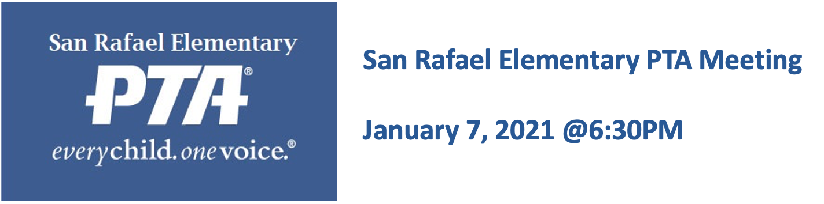

AGENDA

https://zoom.us/j/92308671101
Meeting ID: 923 0867 1101

Call to order

- Presentation of minutes from 12/3 (Gargi Matuszeski)

- President’s Report (Gargi Matuszeski)
- Review of the fall semester
- Board Retreat & Self-evaluation
- Spring plans
  - 5th grade planning committee
  - Bylaws Review
  - Math Stairs
  - Community Engagement Survey

- Principal’s Report (Principal Ramirez)
- Math Field Day
- Spelling Bee
- Second Steps Curriculum

- Treasurer’s Report (Heidy Garibaldo)
- Budget update

- Auditor (Debbie Melahouris)
- Mid-year Audit
- Audit Committee

- Membership (Andrea Torosian)
- 220 members

- Historian (Ericka Avelar)
- Volunteer hours
- Box Tops

- Parent Leadership Groups
  - Annual Fund
  - AAPC
  - SSC
  - ELAC

- New business

- Open Forum: Community questions, announcements, concerns

Meeting Adjourned.

** PLEASE JOIN US AFTER THE MEETING FOR A PRESENTATION
FROM PAPER TUTORING SERVICES. **

