2018 NSAO Conference & Vision Expo
NEW Halifax Convention Centre
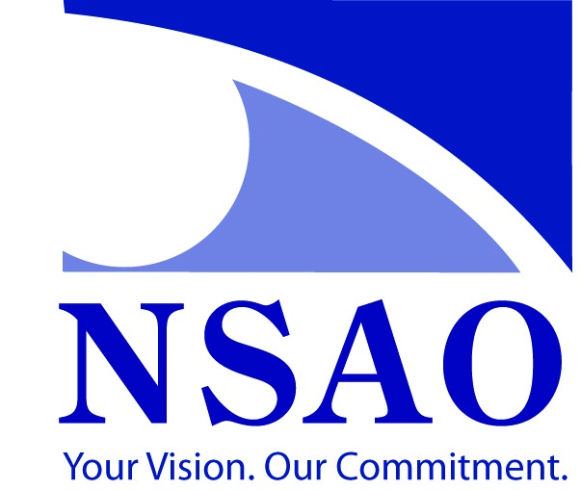
Friday, November 23, 2018
Optometrists (8 CE Hours)
07:15 | Registration
08:00 | CE Lectures
09:00
10:00 | Refreshment Break
10:15 | CE Lectures
11:15
12:15 | Working Lunch in Room
12:45 | CE Lectures
01:45
02:45 | Refreshment Break
03:00 | CE Lectures
04:30
05:30 – 9:30 | NSAO Vision Expo – NEW Halifax Convention Centre – Convention Hall
9:30-12pm | Hospitality After Party – Venue TBD
Saturday, November 24, 2018
 | Optometrists | Optometric Personnel (8 CE Hours)
07:00 | Registration | Tier I | Tier II
08:00 | OD Breakfast (8:30) | CE Lectures | CE Lectures
09:00 | NS College of Optometrist Meeting
10:00 | Refreshment Break
10:15 | NSAO AGM (begins immediately following the NSCO Meeting – approx. 10:45) | CE Lectures | CE Lectures
11:15
12:15 | Luncheon for OD’s & Optometric Personnel
01:15 | NSAO AGM | CE Lectures | CE Lectures
02:45 | Refreshment Break
03:00 | NSAO Council Meeting  NSCO Board Meeting (TBD) | CE Lectures | CE Lectures
04:00
7pm | OD Dinner – Venue: TBD
Revised: April 25, 2018 (ke))

