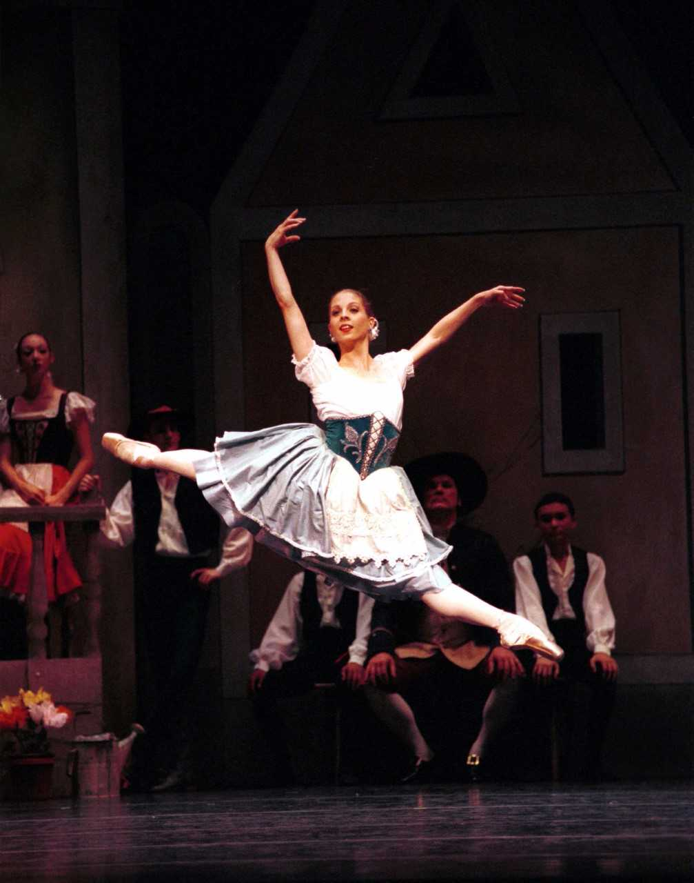  OPEN BALLET  TEEN/ADULT  FRI. 9:30 AM – 11:00 AM  SAT.9:00 AM – 10:30AM  INTRO SPECIAL (new students)  2 CLASSES FOR $24  ($6 SAVINGS)  GOOD FOR 30 DAYS AFTER PURCHASE | T.U.P.A.C.  ────  WORLD RENOWED  PNB  BALLET DANCER  JULIE TOBIASON  ────  TEACHES  at  Tacoma Urban Performing Arts Center  ────  tacomaupac.org  ────  Children’s Classes  Mon. Fri. Sat.  253-327.1873  t.u.p.a.c.  734 Pacific Ave 3rd fl.  253-327-1873  253-327-1873  Tacomaupac.org  office@tacomaupac.org

