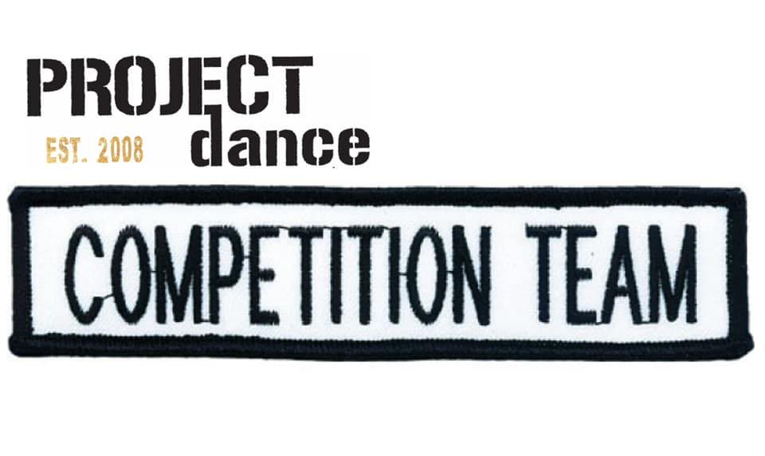 REQUIREMENTS 2021-2022

We are so proud of our Competition Team. We began this program 10 years ago as a positive step for the dancers who want more dance and be part of a fabulous team. We can’t wait to see you all on stage this season.

WHAT IS THE COMMITMENT?
- ATTENDANCE IS STRICTLY ENFORCED
- BALLET IS NOT MANDATORY, BUT ENCOURAGED
- 2 LOCAL COMPETITIONS ARE MANDATORY. SCHEDULES COME ABOUT 2 WEEKS PRIOR TO EVENT, DATES WILL BE GIVEN OUT NOVEMBER/DECEMBER.
- COMPETITION FEES ARE BETWEEN $40-50 PER DANCE, PER COMPETITION
- COMPETITION COSTUMES RANGE FROM $80-120
- THERE WILL BE A PREVIEW SHOW IN MARCH, HOPEFULLY WITH AN AUDIENCE THIS YEAR.
- A TEAM JACKET OR ARTICLE OF CLOTHING WILL BE REQUIRED FOR COMPETITIONS.
- SUMMER TECH IS MANDATORY TO ATTEND AT LEAST 3 ARE ATTENDED FROM JULY 16-18TH

WHAT IS REQUIRED?
JAZZ, CONTEMPORARY, LYRICAL AND MUSICAL THEATRE=
JAZZ TECH IS REQUIRED, BALLET IS HIGHLY RECOMMENDED
ACRO = ACRO TECH REQUIRED, JAZZ TECH IS RECOMMENED
HIP HOP = HIP HOP TECH REQUIRED
TAP= TAP TECH IS REQUIRED

LEVELS OF COMPETITION TEAM:
SPARKLE
GLOW
SPARK
SHIMMER
VELOCITY

LEVELS OF COMPETITION TEAM ACRO:
FUEL
ENERGY
POWER

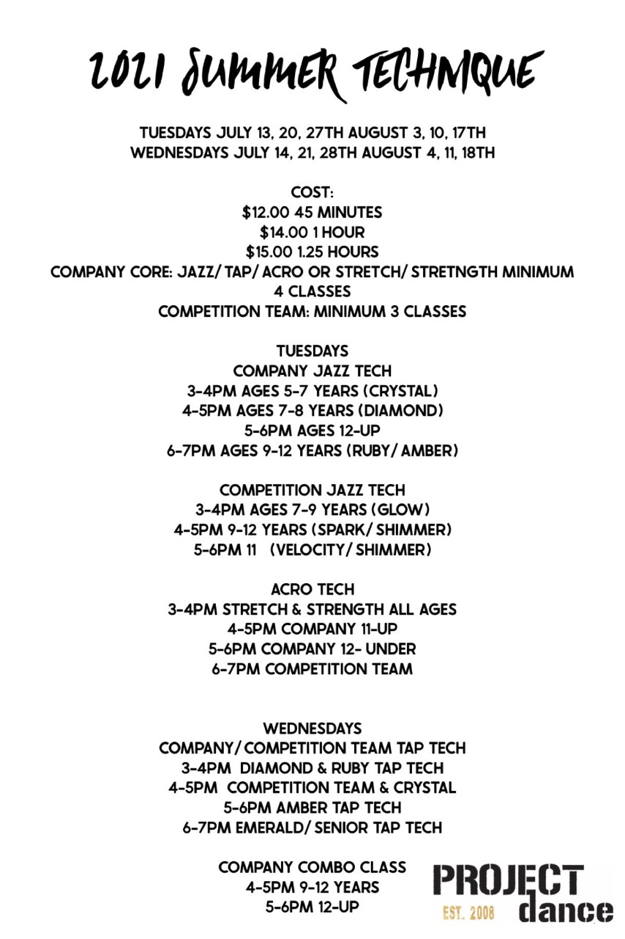
DRESS CODE

Jazz Technique and Choreography classes: Jazz, Lyrical, and Stage.
Hair up and in a secure bun
Tight clothing, any colour preferably black especially for choreography classes
Pirouettes

Contemporary and Acro
Hair up and in a secure bun
No T-shirt’s (they flip over the head) bodysuits and shorts or leggings only
Bare feet

Tap
Hair up and in a secure bun
Tight clothing, preferably black
Black Oxford tap shoes with laces

Hip Hop
Hair up and off face
Loose fitting clothing, no ballet tights
Clean Runners

Ballet
Required colour ballet bodysuit for certain RAD grade
(Grade 1-5 will be getting new colours/styles please wait to purchase)
Convertible Ballet tights
Canvas Ballet shoes
Hair up in a bun with a hairnet

Boys Ballet
White bodysuit or tank top
Black leggings
White socks
White ballet shoes

