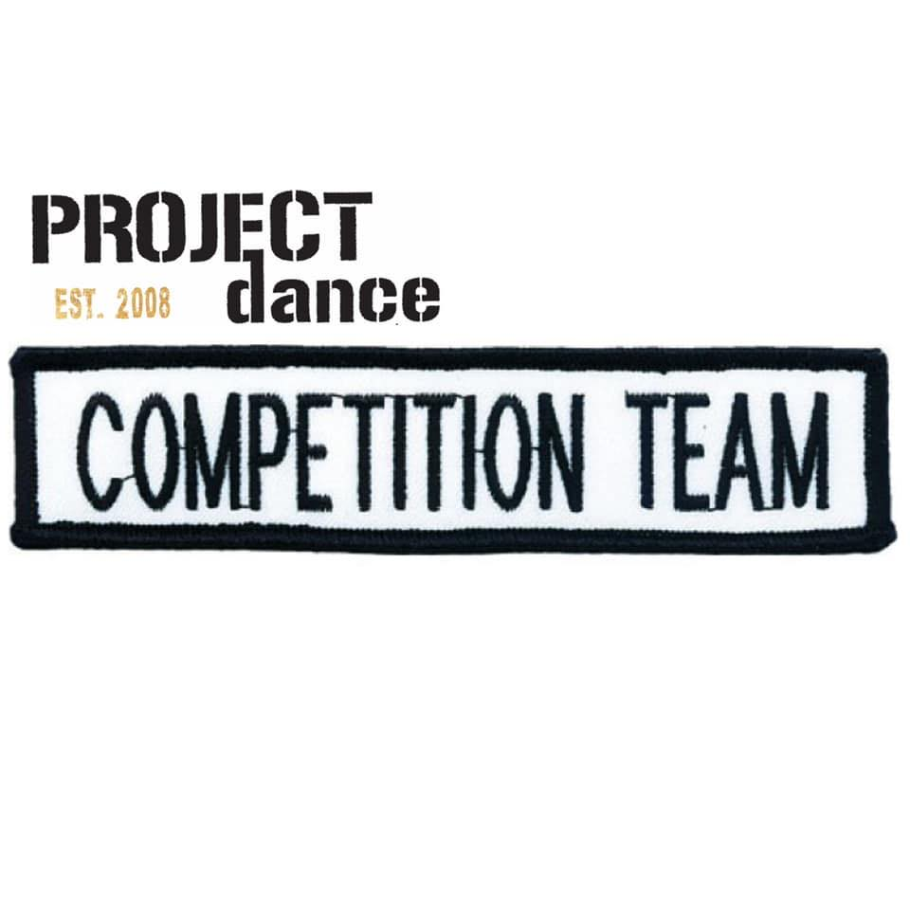 **REQUIREMENTS 2021-2022**

*We are so proud of our Competition Team. We began this program 10 years ago as a positive step for the dancers who want more dance and be part of a fabulous team. We can’t wait to see you all on stage this season.*

**WHAT IS THE COMMITMENT?**

* ATTENDANCE IS STRICTLY ENFORCED
* BALLET IS NOT MANDATORY, BUT ENCOURAGED
* 2 LOCAL COMPETITIONS ARE MANDATORY. SCHEDULES COME ABOUT 2 WEEKS PRIOR TO EVENT, DATES WILL BE GIVEN OUT NOVEMBER/DECEMBER.
* COMPETITION FEES ARE BETWEEN $40-50 PER DANCE, PER COMPETITION
* COMPETITION COSTUMES RANGE FROM $80-120
* THERE WILL BE A PREVIEW SHOW IN MARCH, HOPEFULLY WITH AN AUDIENCE THIS YEAR.
* A TEAM JACKET OR ARTICLE OF CLOTHING WILL BE REQUIRED FOR COMPETITIONS.
* SUMMER TECH IS MANDATORY TO ATTEND AT LEAST 3 ARE ATTENDED FROM JULY 16-18TH

**WHAT IS REQUIRED?**

JAZZ, CONTEMPORARY, LYRICAL AND MUSICAL THEATRE=

JAZZ TECH IS REQUIRED, BALLET IS HIGHLY RECOMMENDED

ACRO = ACRO TECH REQUIRED, JAZZ TECH IS RECOMMENED

HIP HOP = HIP HOP TECH REQUIRED

TAP= TAP TECH IS REQUIRED

**LEVELS OF COMPETITION TEAM:**

SPARKLE

GLOW

SPARK

SHIMMER

VELOCITY

**LEVELS OF COMPETITION TEAM ACRO:**

FUEL

ENERGY

POWER

**SUMMER TECH 2021**

**TUESDAYS JULY 13, 20, 27TH AUGUST 3, 10, 17TH**

**WEDNESDAYS JULY 14, 21, 28TH AUGUST 4, 11, 18TH**

**COST:**

**$12.00 45 MINUTES**

**$14.00 1 HOUR**

**$15.00 1.25 HOURS**

**COMPANY CORE: JAZZ/TAP/ACRO OR STRETCH/STRETNGTH MINIMUM 4 CLASSES**

**COMPETITION TEAM: MINIMUM 3 CLASSES**

**TUESDAYS**

**COMPANY JAZZ TECH**

3-4PM AGES 5-7 YEARS (CRYSTAL)

4-5PM AGES 7-8 YEARS (DIAMOND)

5-6PM AGES 9-12 YEARS (RUBY/AMBER)

6-7:15PM AGES 12+

**COMPETITION JAZZ TECH**

3-4PM AGES 7-9 YEARS (GLOW)

4-5PM 9-12 YEARS (SPARK/SHIMMER)

5-6PM 11+ (VELOCITY/SHIMMER)

**ACRO TECH**

3-4PM AGES 7+ COMPETITION TEAM

4-5PM STRETCH AND STRENGTH 9+

5-6PM COMPANY 12-UP

6-7PM COMPANY 12- UNDER

**WEDNESDAYS**

**COMPANY/COMPETITION TEAM TAP TECH**

3-4PM DIAMOND & COMPETITION TEAM 7+

4-4:45PM RUBY TAP TECH

5-6PM AMBER TAP TECH

6-7PM EMERALD/SENIOR TAP TECH

**COMPANY COMBO CLASS**

3-4PM 9-12 YEARS

4-5PM 12-UP

 **DRESS CODE**

**Jazz Technique and Choreography classes: Jazz, Lyrical, and Stage.**

Hair up and in a secure bun

Tight clothing, any colour preferably black especially for choreography classes

Pirouettes

**Contemporary and Acro**

Hair up and in a secure bun

No T-shirt’s (they flip over the head) bodysuits and shorts or leggings only

Bare feet

**Tap**

Hair up and in a secure bun

Tight clothing, preferably black

Black Oxford tap shoes with laces

**Hip Hop**

Hair up and off face

Loose fitting clothing, no ballet tights

Clean Runners

**Ballet**

Required colour ballet bodysuit for certain RAD grade

(Grade 1-5 will be getting new colours/styles please wait to purchase)

Convertible Ballet tights

Canvas Ballet shoes

Hair up in a bun with a hairnet

**Boys Ballet**

White bodysuit or tank top

Black leggings

White socks

White ballet shoes