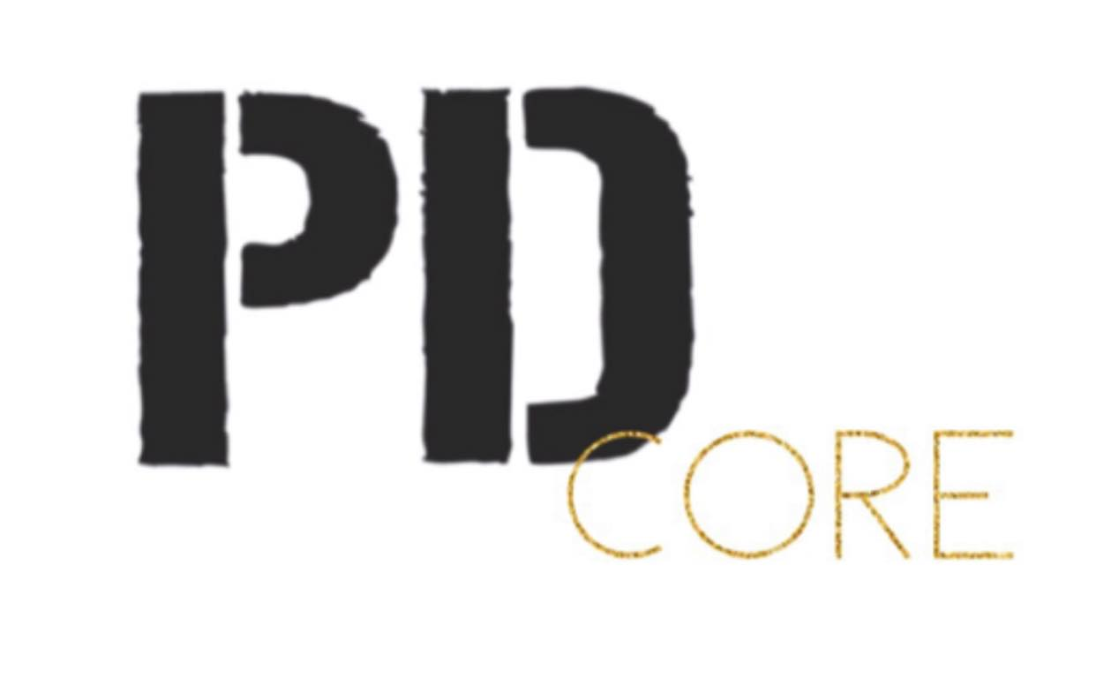
During registration, you will just need to register for your “CORE” and we will insert you into the mandatory classes, you may choose the “Optional” ones to save spots in those classes.

What is CORE?
It’s the 2021-22 Company Program at Project Dance.
Definition of a CORE: the central or most important part of something.
C- commitment
O- originality
R- respect
E- excellence
A group of dancers with Passion, Dreams and Commitment.
We are excited for a fresh start after a couple really trying years for our dancers. We are so thankful for those who persevered and are falling in love with dance again or even more.

ATTENDANCE: We have created PD Core for a variety of reasons, one is attendance. I have talked to many studio directors, teachers and mentors. Without commitment, results plummet and the team truly doesn’t feel whole. We are reasonable, things happen and we also need to work on our communication when things do arise so we are aware.
For the 2021-22 season, we are implementing a 6 miss policy. Dancers can only miss 6 classes in the season. If the dancer surpasses this, class time will be made up with the instructor in a private. This doesn’t mean skip to get a private. Our hope is that dance is more of a priority especially in classes like tech, combo and ballet. If you are too sick to dance or are contagious, ZOOM will still be an option for company dancers.

CRYSTAL CORE
Ballet:
5 years= Pre Primary (45 minutes)
6 years= Primary (1 hour)
7 + years= Grade One x 2 classes per week (2 hours per week)
Crystal Jazz Choreography (1 hour)
Crystal Jazz Technique (1 hour)
Optional:
Crystal Lyrical Choreography
Crystal Acro Technique
Crystal Tap

DIAMOND CORE
Grade Two Ballet (2 classes per week)
Diamond Jazz Choreography (1 hour)
Diamond Lyrical Choreography (1 hour)
Diamond Jazz Technique (1 hour)
Diamond Acro Technique/ Stretch & Strength (1 hour)
Optional:
Diamond Tap Choreography & Diamond Tap Technique (30 minutes) *Mandatory to be in tap group.
Hip Hop Choreography
RUBY/AMBER
2 RAD Ballet classes a week (2 hours)
Beginner Pointe (30 minutes)
PBT 12- under
Combo Class
Jazz Choreography
Lyrical Choreography
Contemporary Choreography
Jazz Technique
Acro Tech/Stretch & Strength (1 hour)
Optional:
Hip Hop Technique **Jr. Lady Venom highly recommended.
Tap & Tap Technique * Mandatory to be in group

PEARL
1.5 Hour Ballet class (Intermediate)
Combo Class
Jazz Choreography
Lyrical Choreography
Contemporary Choreography
Jazz Technique
Turns & Jumps Technique
Acro tech/stretch & Strength
Optional:
Hip Hop Technique **Group highly recommended.
Hip Hop Group
Stage

EMERALD/ONYX/QUARTZ**QUARTZ I will speak to you individually after registration. Sign up for QUARTZ Core for now.
2 RAD Ballet classes a week (2 hours)
Intermediate or Advanced Pointe (30-45 minutes)
PBT 12+
Combo Class
Jazz Choreography
Lyrical Choreography
Contemporary Choreography
Jazz Technique
Turns & Jumps Technique
Acro Tech/Stretch & Strength (1 hour)
Optional:
Hip Hop Technique **Group highly recommended. (Tech mandatory to be in Diva Dynasty, Kool Kidz or Lady Venom- NO exceptions)
Ballet Group- Contemporary Ballet
Tap
Hip Hop Group
Large Group Jazz
Stage

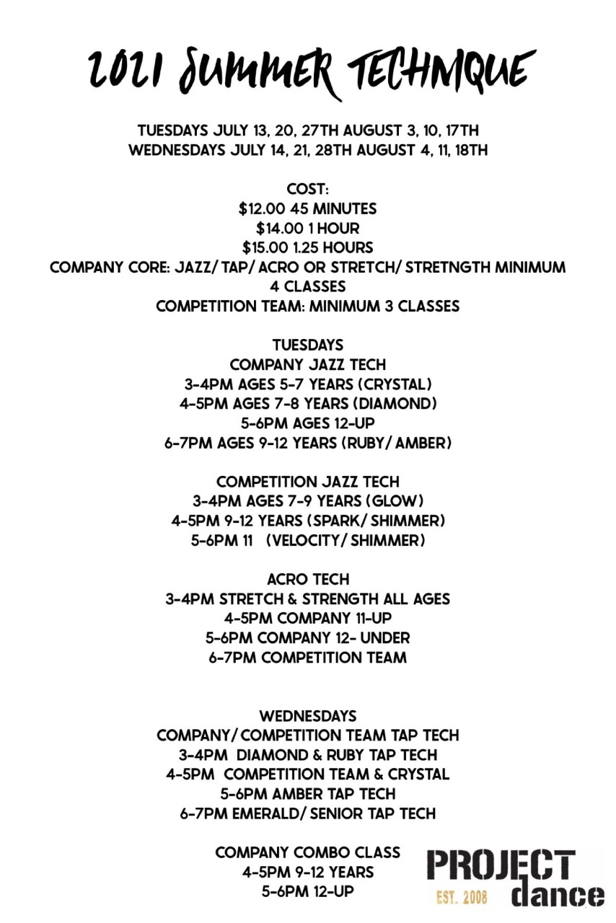

PROJECT DANCE CORE DRESS CODE

Jazz Technique and Choreography classes: Jazz, Lyrical, and Stage.
Hair up and in a secure bun
All black tight clothing
Pirouettes

Contemporary and Acro
Hair up and in a secure bun
All black tight clothing
Bare feet

Tap
Hair up and in a secure bun
All black tight clothing
Black Oxford tap shoes, Amber and up Split sole recommended

Hip Hop
Hair up and off face
Loose fitting clothing, no ballet tights
Clean Runners

Combo Class
Hair up and off face
Anything you feel comfortable to move in (No baggy sweatshirts)
Pirouettes or bare feet

Ballet
Required colour ballet bodysuit for certain RAD grade
(Grade 1-5 will be getting new colours/styles please wait to purchase)
Convertible Ballet tights
Canvas Ballet shoes
Hair up in a bun with a hairnet

Pre Pointe: Canvas ballet shoes, tennis ball and Theraband
Beginner Pointe: Wait to buy pointes shoes with the ballet teachers.
Intermediate and Advanced: Pointe Shoes

Boys Ballet
White bodysuit or tank top
Black leggings
White socks
White ballet shoes

PBT (Progressive Ballet Technique)
Hair up in a secure bun
Ballet bodysuit any colour
Ballet tights or black leggings

