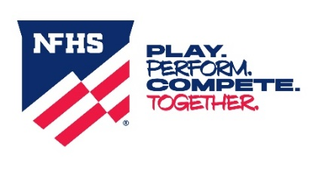

2025-26 NFHS Swimming and Diving Resources
NFHS.org – https://nfhs.org/tools
Rules Proposals System
Rule Interpretation Request
NFHS Swimming and Diving Web Page - https://nfhs.org/sports/swimming-diving
Rules
Swimming and Diving Rules Changes
Swimming and Diving Comments on the Rules
Swimming and Diving Points of Emphasis
Swimming and Diving Uniform Rules
Swimming and Diving Rule Interpretations
Swimming and Diving Rules Poster
Resources
Backstroke Ledge FAQ
Teaching Starts Using the Backstroke Ledge
Adapted Sports Links
Swimming and Diving Championships & Large Meet Administration
Swimming and Diving Finish Rules Best Practices
One Meter Diving Table with Video Clips
Guidelines for Virtual Swimming and Diving Competition
Guidelines for Officiating Swimmers with Disabilities
Diving Judge vs. Diving Referee Calls
Diving Silhouettes
Swimming and Diving Pool Diagrams
Rules Writing Process Video
Rules Codes Comparisons For Swimming - Our Kids Initiative
Rules Codes Pool Depth Comparisons – Our Kids Initiative
NFHS Concussion Courses
Shallow Water Blackout Prevention
NFHS Swimming and Diving My Groups - https://members.nfhs.org/groups/79
**When accessing My Groups login is necessary via your associated NFHS My Groups email and password**
Important Dates
Mid-Season Meetings - Recordings
Press Releases
Questionnaires and Surveys
Resources
Rules Book
Rule Change Proposals
Rules Changes
Rules Committee Minutes
Summer Meeting Discussion Forum Topics
NFHS Learn - https://nfhslearn.com/
Coaching Swimming Course
Coaching Diving Course
Officiating Swimming and Diving Course
Judging Springboard Diving
You Be the Judge Diving Clips (78) – Go to NFHSLearn.com, select “NFHSLearn FOR YOU”, click
on “OFFICIALS”, click on “Video Library” located on the left side of the page, and then
select the sport of “Swimming and Diving”

Rev. 8/14/2025

