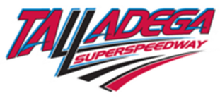 | 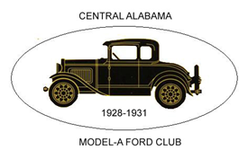 | 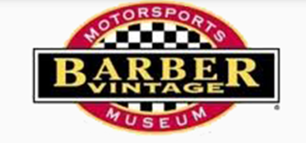
MARCH 13-14, 2026
RACETRACK ADVENTURE II REGISTRATION FORM

Name: |  | Name of Guest(s):
Street Address: |  |  |  | City: | State:
Zip Code: | Phone Number: | Email:
Cell Number: |  | Car Club:
Year of Model "A: Ford: | Model: | License Number: |  | Trailering: Y/N  (Circle One) | Arrive:  TH/FRI/SAT  (Circle One)
Auto Insurance Company:

Event Registration: |  | Qty: | @ | Fee: | Total:
Registration Fee |  |  | @ | $15.00 per car | $
Barber Vintage Motorsports Tour (Includes tour of the basement restoration area, and an orientation lap on the track’s outer ring road). |  |  | @ | $20.00 per person
Blue Tequila Restaurant |  |  | @ | $15.00 per person includes drink and gratuity | $
Tour of Antique car collect |  |  | @ | FREE | FREE
Welcome Dinner, BBQ with all the trimmings, drink, dessert with door prizes and 50/50 |  |  |  | $25.00 per person
Talladega laps and Jack links 500 event |  |  |  | $79.00 per car, includes all passengers
TOTAL AMOUNT ENCLOSED:  (Refunds on a case-by-case basis) |  |  |  | $
Make your reservations directly with Home 2 Suites 300 Colonial Drive, Oxford Alabama 36203, phone number (256) 831-7008, Make sure you mention that you are with the Model “A” Ford tour to receive the special suite room rate of $110.00 plus tax. This rate was quoted for March’s busy season.
The signers below, agree to indemnity and hold harmless for any and all liability due to my attendance and participation in the 2026 Speedway tour, The Central Alabama Model “A” Ford Club (CAMAFC), CAMAFC Members, their officers, directors, staff and any and all constituents acting on behalf of the aforementioned affiliations and/or Tour Volunteers. Submission of this Tour Registration Form (signed or unsigned) constitutes acceptance of the terms of this release. The vehicle being used has all required automobile insurance established by state statute.

Make Your Check Payable to the “Central Alabama Model ‘A’ Ford Club”
Send your completed registration form and payment NO LATER THAN MARCH 1, 2026 to:
Race Track ADVENTURE 3507 Vaughn Road, Montgomery, Alabama 36106

Signed:

