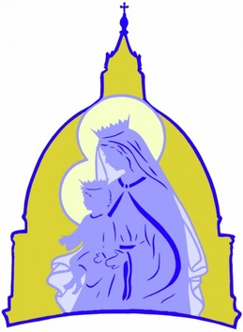
St Mary Parish
Totus Tuus Registration
July 31- August 5
Grades 1-Grade 5 (Mon-Fri) 9:00 AM- 2:30 PM
Grade 6- Grade 12 (Sun- Thurs) 7:30 PM- 9:45 PM
Cost $25.00 per child or $60.00 per family
Totus Tuus

Family NameClick or tap here to enter text. | Parent NamesClick or tap here to enter text.
Mailing AddressClick or tap here to enter text.
Email Click or tap here to enter text.
Cell # MotherClick or tap here to enter text. | Cell # Father Click or tap here to enter text.
Emergency Contact Click or tap here to enter text. | Phone Click or tap here to enter text.
Allergies/ Medical Conditions or other concerns we need to be aware of

Click or tap here to enter text.
Name(s) of Students attending | Grade Entering
- Click or tap here to enter text. | Click or tap here to enter text.
- Click or tap here to enter text. | Click or tap here to enter text.
- Click or tap here to enter text. | Click or tap here to enter text.
- Click or tap here to enter text. | Click or tap here to enter text.
- Click or tap here to enter text. | Click or tap here to enter text.
Parent/ Guardian SignatureClick or tap here to enter text.

Please return form to the Parish Office or email it to Marianna Merkatoris at dreyouth@smctomahawk.com by June 15, 2022

