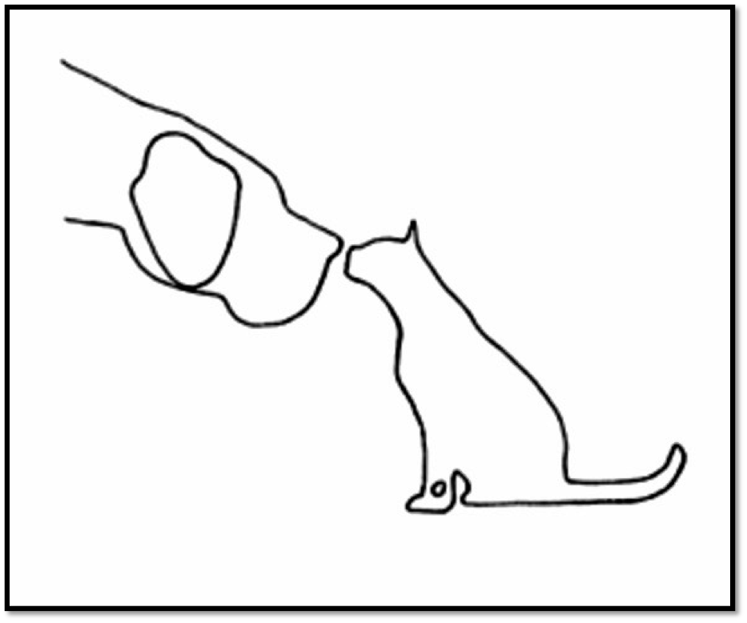

All Pets Health and Rehab
Julia Moore, DVM, CCRT, CVCP
1324 Main Street
Philomath, Or. 97370

juliamooredvm@gmail.com
(541) 602-1893
allpetshealthandrehab.com

By submitting the form below, I affirm that I agree to the following terms and conditions: I give Dr. Julia Moore, DVM, permission to treat my pet; I will pay by check or cash at the time of service (credit cards not accepted); appointments canceled or rescheduled with less than 48 hours' notice will be billed in full except in case of emergencies, inclement weather, if my pet or I am sick; I understand that Dr. Moore only provides rehab services and that I will continue to present my pet to a general practice veterinarian for primary care services; I give permission to use email for all communications including transfer of medical records.

Client name, pronouns (optional):
Address:
Cell Phone:
Email:

Pet name:
Pet’s age, gender, color, breed, date of birth:
Approximate date your pet joined your family:

Name of primary care veterinarian and clinic name:
Pet insurance:

How did you hear about us?

What are your concerns about your pet?
How long has this been going on?
Have x-rays been taken? If so, please request they are emailed to juliamooredvm@gmail.com.

What care is your pet getting for the problem now, for example medicines, dietary supplements, use of harnesses or other assistive devices, changes made to your home, surgeries?

How do you exercise your pet now compared to before the problem occurred?

What are your goals for your pet?

If your pet is excessively nervous or frightened during veterinary visits, what helps them?

Do you anticipate that your pet will allow Dr. Moore to touch them?

Does your pet have any specific dietary needs or food sensitivities?

Is there anything else we should know?

