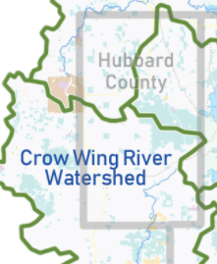

Nevis

**N**

**Project Location**

**Nevis**

**Assessment and Recommendations Report**

Project Name

Project Location

City, MN

|  |
| --- |
|  |

**Onsite Report**

**Technician Assessment and Recommendations**

Report By:

Date: //2021

**Significant dates, location, and design objective**

|  |  |  |  |  |  |
| --- | --- | --- | --- | --- | --- |
| **Onsite Date:** | | **Address:** | | **TRS: T. R. Sec.** | |
| **Pre-Design Meeting Date: TBD** | | **Location**: ☐ Office X Onsite ☐ Phone ☐ Video ☐Other | | | |
| **Purpose of onsite:**  **Resource Concerns:** Soil__Water__Shoreline__Habitat__ **MNDNR Lake:** | | | | | |
| **Budget Range (including cost share):** | | | | | |
| **Project Contact Information** | | | | | |
|  | **Owner or Authorized Representative** | | **SWCD** | |
| **Name:** |  | | **Name:** | |
| **Address:** |  | | **Address:** | |
| **Phone:** |  | | **Phone:** | |
| **Email:** |  | | **Email:** | |
| **Priorities**  Protect water quality _ Slow surface runoff _ Intercept & treat subsurface flow **_**Add Pollinator Habitat _ | | | | | | |
| **Findings**   * Describe where the project is located and orientation or other aspect related to the location * Location of issues and description of issues * Physical aspects of site, slope, % impervious to vegetated * Hydrological issues related to project * Soils information and affects to project * Plant communities, description and density * Urgency * Dimensions * **Site assessment & objectives**   Summarize, start with the primary factors causing the issues and when they started, if applicable. Explain compounding issues then briefly discuss proposed solutions and how they align with landowner goals. | | | | | | |
|  | | | | | | |

|  |  |  |
| --- | --- | --- |
| **Conceptual Project Overview of Recommendations**  ***Project costs, diagrams, and drawings in the concept plan are approximate***.  Final plans and specifications will be completed in accord with, and upon receipt of, signed Project Agreement | | |
| **Issue** | **NRCS Practice** | **Benefit** |
| 1. x | x | x |
| 1. x | x | x |
| 1. x | x | x |

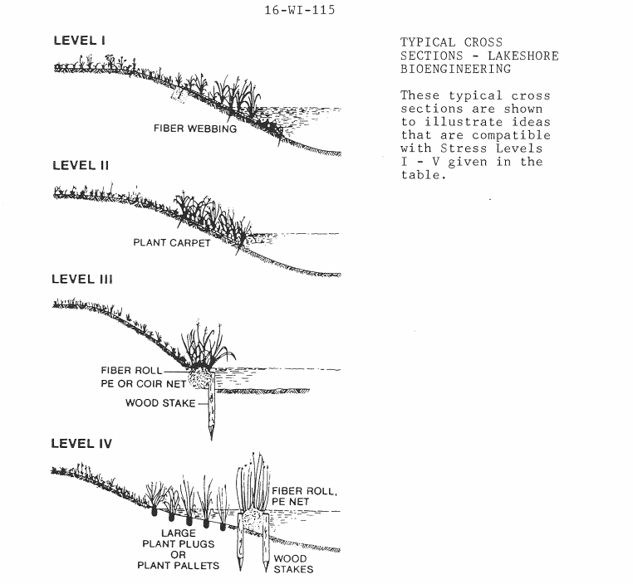

(Add schematic or sketch if needed)

Below: Cross-section example of proposed coir-log installation

Include caption with an explanation of what is on the map.

Insert and aerial picture of the site and show where the proposed practices will be installed.

**Pre-Design Notes**

**Changes discussed in meeting will be noted and applied to final design.**

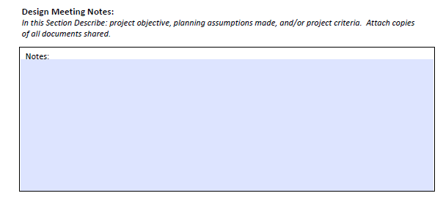

|  |  |
| --- | --- |
| We understand and agree the concepts proposed in this plan will be modified and completed to incorporate the changes noted above. | |
| Owner Signature | Date |
| Technician Signature | Date |