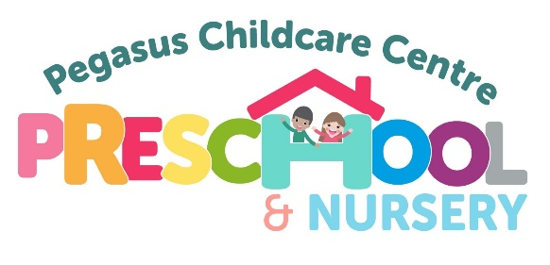
LATE PAYMENT POLICY

Pegasus Childcare Centre recognise that some families may find the payment of fees difficult at times and are keen to support those who find themselves in this situation. Pegasus Childcare are able to offer a Payment Plan to help to spread the cost of childcare fees, please contact the Centre Manager or Chair of the Management Committee for further details.
Payment terms and late payment policy:
Day 1 – Invoice Issued with payment terms 7 day from date of invoice.
Day 8 – Invoice due by this date.
Day 11 – Invoice 3 days late – Deputy Manager will send a reminder by email.
Day 14 – Email from The chair of the management committee as an additional reminder advising a late payment fee of £25.00 will be applied if payment is not received by day 21. A payment plan will also be offered.
Day 18- Telephone call from the Chair of the Management Committee £25.00 late payment fee invoiced and statement to parent/carer sent.
Day 21– If payment still not made – a meeting will be arranged with the Chair of the Management Committee to discuss non-payment and any support which can be provided.
Should a satisfactory resolution not be reached at this meeting, the child will be excluded and legal action taken to recover the debt..

This policy was reviewed and adopted on 4th October 2023

Signed MRHeavens (Chair)

The Policy will be reviewed annually.

Date of Review | Policy Updated | Signed (Chair)
13th November 2024 | Yes

