Pegasus Childcare Centre:
Summer Term Event Newsletter 2023
May to July
Do you have time to Volunteer….  If you would like to come to volunteer your skills of woodwork, sewing, painting, music, reading, singing and any other talents you may have or you just want to come and have a play, you are more than welcome! Just let a member of staff know so we can arrange a time and date! | Pegasus Committee Message….  Would you like to be a trustee of the committee?  If you would like more information, please email us, or speak to a member of staff!
Open Morning for New Families!  Thursday 1st June 2023  10am to 12pm  Come along to meet staff team, ask questions, have a look around and allow your child to explore and play!  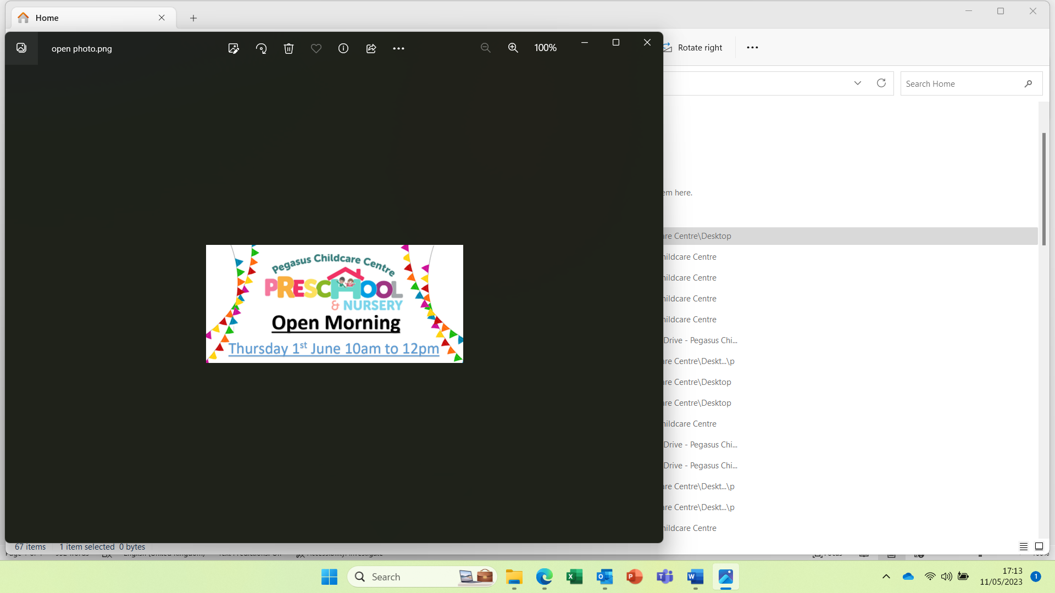 | Fundraiser Movie ‘Drive-In’  Thursday 29th June 2023 - 3.30pm to 4.30pm  For children aged 2-4 years  Just £5 a ticket for your child to watch a movie with their friends in their very own ‘drive-in’ seating!  Comfy seating, popcorn, treats and drinks.  Limited spaces so book now!  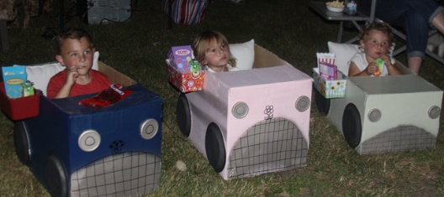
Summer Fair and Pegasus 25th celebration!  Saturday 15th July 2023  10am to 3pm  Lovely family event for all, games, bouncy castle, refreshments, fire engine, fun & laugher, and many stalls!  If you would like to hire a stall, please contact Tasha by emailing natasha.taylor@pegasuschildcare.co.uk   |     Tuesday 30th May –  Food Day    - Wednesday 31st May - Cardboard Chaos Day  9am to 3pm  For all children aged 2 to 11 years.  Book now so you don’t miss out.
Planning  Here is an outline of special days we will be exploring during this term:  - Our environment and our world  - Transition to big school  - King Charles III Coronation  - The Market Rasen Fire Station has agreed to come to Pegasus to show the children equipment and the fire engine – Date to be confirmed.  - Sports games  - National Smile month is May  - Deaf Awareness week  - National Numeracy Day  - World Bee Day  - National Biscuit Day  - Water play  - Loads of outdoors play  We plan and brainstorm with the children to work out our weekly planning and at any point the children may decide they would rather explore a different topic halfway through the week, so keep an eye on your weekly email for updates!  Transition  Gemma will be working with local schools to develop on and improve a stronger transition plan for the children that will be going to school in Sept 2023.  Gemma will be updating you with the Rising five programme and the Shining star programme and what your child will be working on. Please look at your child’s daily sheet to find out what they are working on that week.  Gemma is currenting gathering from you all what school your child has go into for September 2023. If you still haven't let us know please do.    Don't forget to upload photos and observations onto Tapestry.  The children love showing their friends what they do outside of Pegasus. |   We will be continuing to write to our pen pals – Open Woodgate in Derbyshire and Market Rasen Poplars Care Home and we will also be inviting others to join in with our pen pals.  If you know of anyone who has an interesting job that the children would love to explore, then please let us know or get them to get in touch!  On Friday 28th April at 11.00am we had a Teams call with The Poplars Care Home which is in Market Rasen for a Question-and-answer session, singing and getting to know the elderly. It was great!  Facebook  For those of you who use Facebook please like and share our Facebook page! Just search for Pegasus Childcare to find us! Latest news, photographs and information will be shared on our page.  If you could leave us a star rating and a comment on your child's experience here at Pegasus, we would be very grateful.  Thank you for your continued support  Nursery Clubs  Don’t forget we are now open 7.30am to 5.30pm Monday to Friday.  Here are the nursery clubs:  Monday – Animal Club  Tuesday –Story Club  Wednesday – Painting Club  Thursday – Construction Club  Friday – Movie Club  Book in so your child doesn’t miss out!
Fundraising!
This year we will be raising money for –
- New front door to complete the new front area!
- New experiences for children such as day out and/or inviting people in such as Musicians / P.E / Doctors / Dentists / local authors / Cote Hill cheese and so many more!
- New roof in the conservatory. As its freezing in winter and too hot in summer.
- New table and chairs for the children

- We completed our Easter Egg Hunt around the Village and we raised £193.30!!!
Thank you to everyone who attended our fundraiser event.

Don’t forget in just a few weeks, a parent from the setting is taking part in the Rob Burrow Leeds Marathon 2023 on the 14th May 2023.
We all wish Wesley the very best for his marathon and a massive thank you from the children, staff, and committee. All money raised will go towards new resources, experiences, and equipment for the children.
For more information and donations please go to - Wesley Caton is fundraising for The Pegasus Childcare Centre (justgiving.com)

- There will be fundraisers throughout the year so everyone can get involved!
Here are a few top ones we will be doing –
- Pegasus Fairs (Summer & Christmas)
- Wellie Wanging
- Photo Fundraisers
- Movie Drive-In

