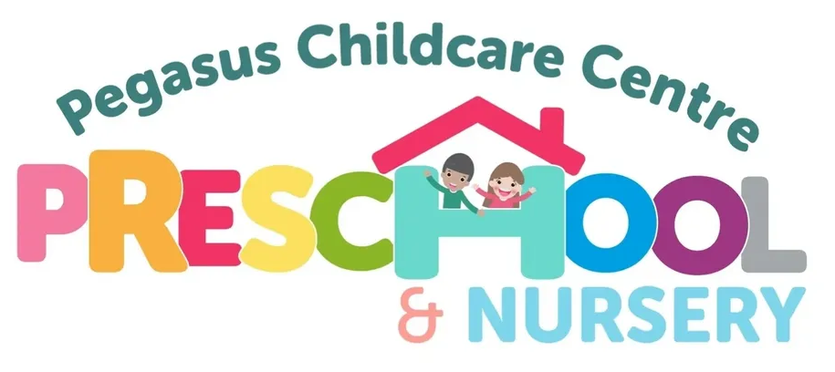

**General Data Protection Regulation (GDPR) Policy**

GDPR stand for General Data Protection Regulation and covers personal data relating to individuals that must be collected and used fairly, stored safely and not disclosed unlawfully.

**Policy Statement**

Pegasus Childcare Centre needs to gather and use certain information about individuals. This includes anyone who is connected with the nursery, such as parents, children, staff, suppliers and business contacts.

Pegasus Childcare Centre must comply with data protection law and follow good practice, protect the rights of individuals connected with the nursery and explain how we store and process individuals’ data.

**Rights for Individuals**

The Right to be Informed:

Pegasus Childcare Centre is required to collect, process and manage certain data.

The data we require is:

**Employees**: Names, Addresses, Telephone Numbers, Email Addresses, Date of Birth,

National Insurance Numbers, Bank Details, DBS Certificate/ Number, Photographic I.D (Passport and Driving Licence).

This information is also required for Disclosure and Barring Service Checks (DBS) and proof of eligibility to work in the UK. The information is sent securely to E-bulk who complete the DBS checks with the information we provide to them. All employees and volunteers must also complete an OFSTED suitability check.

**Parents/Carers**: Names, Addresses, Telephone Numbers, Email Addresses, Date of Birth, National Insurance Numbers, Occupation, Passwords for an alternative person collecting your child.

**Children:** Names, Addresses, Date of Birth, Ethnicity, Religion, Sessions, Copy of I.D - Birth Certificate, Medical Information, Permission Forms, Accident Forms, Incident Reports, Routine Forms, Tapestry – Observations.

For parents/carers claiming the free entitlement funding we are requested to provide this data to Lincolnshire County Council; this information is uploaded to a secure online portal which has a username and password log in.

**Visitors:** Name, Company Name, Reason for Visiting the Nursery, Time Signed In, Time Signed Out and a Signature

**The Right of Access:**

At any point individuals can request to see their data, which Pegasus Childcare Centre will respond to within 7 days. The request however can be refused, if we have a lawful obligation to retain data, but we will inform the individual of the reasons why. The individual will have the right to complain to Pegasus Childcare Centre Committee if they are not happy with the decision.

**The Right to Erasure:**

You have the right to request the deletion of your data where there is no compelling reason for its continued use. However, Pegasus Childcare Centre has a legal duty to keep the details of children and their parent/carer for a reasonable amount of time (Please see the Retention Period for Records). The data is archived safely and securely on site and once the retention period has passed the data will be shredded.

**The right to restrict processing:**

Any individual can object to Pegasus Childcare Centre processing their data. This means that records can be stored but must not be used in any way. *(data is only processed for the reasons identified at the time of collection. If there is a necessary change to this, consent will always be sought before the data is processed for a different reason.)*

**The right to object**:

Any individual can object to their data being used for certain activities, such as marketing or research. Pegasus Childcare Centre may use photos from the nursery to put on the nursery website; however permission is sought from parents/carers and staff for this prior to them starting at the nursery and throughout.

**The right not to be subject to automated decision making:**

Pegasus Childcare Centre will always involve individuals in the decision making with regards to their data. We will not make a decision by automated means.

**Storage and Use of Personal Data**

All paper copies of children and staff records are kept in locked filing cabinets in the office. The office is also locked at night and over the weekends. Staff have access to the children’s files; however these are kept in the office at all times. The information about individual children is confidential and the records remain on site at all times.

Staff can request to see their own personal file at any time and will only have access to their file. Staff and children’s files are shredded after the retention period for records has passed.

Information about individual children is used in certain documents, such as daily registers, medicine forms, accident books and referrals to external professionals. These documents include data such as children’s names, date of birth and address. These records will be shredded after the retention period for records has passed.

Pegasus Childcare Centre collects large amounts of personal data annually, including names and addresses of those on the waiting list. These records are shredded if the child ends up not attending the setting or they are added to the child’s file and stored safely and securely once they start at the nursery.

Any information regarding a family’s involvement with other agencies is stored safely on the office computer and is password protected and also in the child’s file, which is in a locked cabinet in the office. These records are shredded after the retention period for records has passed.

Pegasus Childcare Centre stores photos of the children on the Tapestry , which is password protected. These photos are used for children’s peg pictures, the dietary board, to display around the nursery, to use as evidence with observations in learning journals and also for the nursery website. We obtain consent from parents/carers for photos to be displayed around the nursery, for use in other children’s learning journals as evidence with observations and for the nursery website.

Access to the office computer and the staff laptop is password protected. Any portable storage, such as USB sticks, are password protected and/or stored in the office, which is locked overnight and at weekends.

**Data Protection Risks**

Everyone at Pegasus Childcare Centre has a responsibility for ensuring data is collected, stored and handled appropriately. However there are always risks that come with data protection. These could be:

❖ Breaches of confidentiality – If any information is given out inappropriately

❖ Not offering choice – all individuals should be free to choose how Pegasus Childcare Centre uses data relating to them

❖ Reputational Damage – Any information that is successfully gained by hackers or

a break in.

*Pegasus childcare centre takes every precaution to mitigate against these risks*

**Information sharing**

We are expected to share information with other childcare providers if a child also attends another setting.

We are also required to share information with services covered under the local authority, i.e. the health care services in regards to the childcare and early year’s entitlements (15 or 30 free education hours).

When a child leaves Pegasus Childcare Centre to go to school or to another setting, data held on the child may be shared with the receiving school/setting. Alternatively this information could be given to the parent/carer to pass on to the school/setting, such as their child’s learning journal.

We will not share any information with anyone without parents’ consent, unless there is a child protection concern.

OFSTED may require access to our records at any time.

**This policy was adopted on** June 5th 2024

**Signed (Chair)**

**Signed (Manager)**

The Policy will be reviewed every two years.

|  |  |  |
| --- | --- | --- |
| **Date of Review** | **Policy Updated** | **Signed (Chair)** |
|  |  |  |
|  |  |  |
|  |  |  |
|  |  |  |
|  |  |  |