
Pegasus

Newsletter
Term dates
Autumn Term:
Term 1
4th September – 18th October.
Half Term:
19th October – 28th October.
Term 2
29th October – 19th December.
Christmas Holidays:
20th December – 5th January.


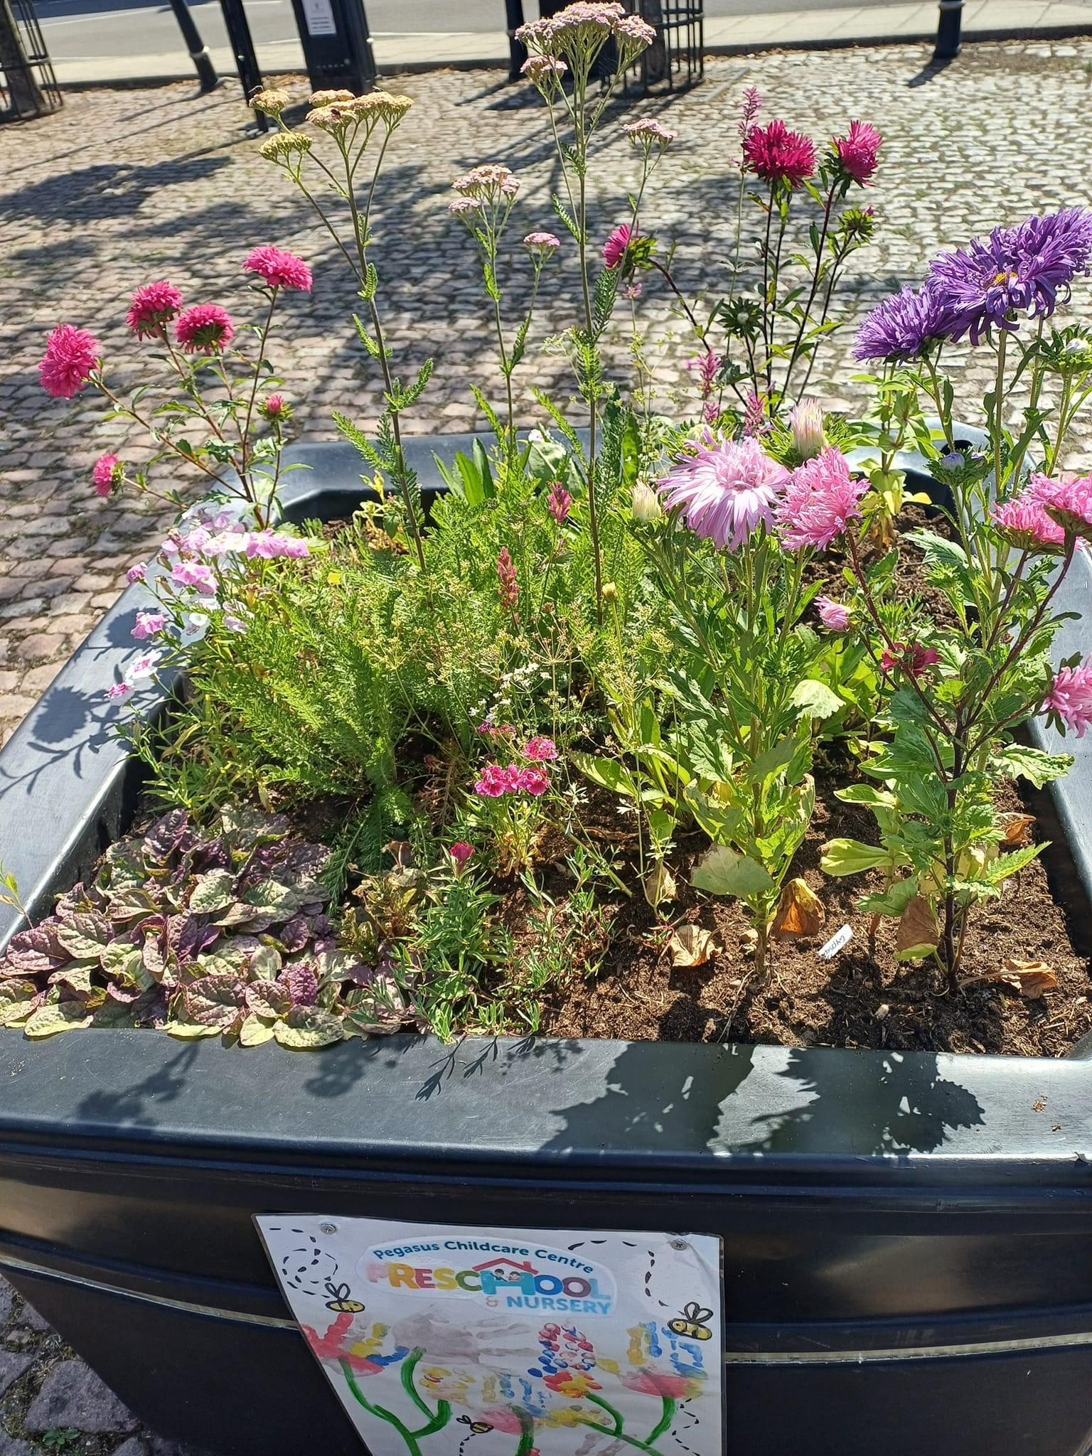

  - September – October 2024

Welcome Back
Emma and the Pegasus team would like to welcome you all back after the summer break, we hope you have had a lovely time. This term will be mainly settling into life at Pegasus and enjoying lots of fun learning opportunities inside and outside. Please stay tuned for dates to add to your calendars in the upcoming weeks.

We will be focusing on our Pegasus 5 Finger Rules…
- Kind Hands.
- Listening Ears.
- Inside Voices.
- Walking Inside.
- Taking Turns.

Here are some of the days that we will be exploring throughout the Autumn term:
- Read a book Day – 6th September.
- Emergency Services Day – 9th September.
- Roald Dahl Day – 13th September.
- Recycle Week – 16th – 20th September.
- World smile day – 4th October.
- Halloween Party – 11th October (Details to follow)
- Diwali – 1st November.
- And much more to be added in the upcoming weeks. Our planning isn’t set in stone, and we encourage the children to decide what they wish to learn, and we use these special days as a guide.

Community links:
The Rasen Area Environment Group will be coming into the setting in September to bring certificates after the successful planting of our seeds in July. We are also hoping to organise a visitor to come and talk to children about recycling ready for recycle week.
We will be making seasonal cards for our loal community and inviting the local communy into the setting to offer the children different experiences and knowledge of different jobs and experiences.

Would you volunteer your time?
Would you like to come to Pegasus and volunteer your time to share some experiences with our children. You could come and have a reading session with the children, talk about the job that you have, maybe you have an animal you could bring in for the children to meet. If you would like to volunteer at any time please speak to a member of staff or email us and we can arramge a day.

A few changes:

The Pegasus Team.
Contact Us
Pegasus Childcare Centre
Main Street
Osgodby
Market Rasen
LN8 3TA.
01673828187
 | HOLIDAY CLUBS:  We are still in the process of organizing any upcoming holiday clubs that we will be doing. As soon as we have finalized dates, we will send out emails to you all and it will also be updated on our website and Facebook page. So, keep a look out for those.  WE NEED YOUR HELP:  We always like to use as many natural resources as we can during our learning activities! So, during these next couple of Autumnal months could you please bring any of the following:  - Conker’s.  - Dried Leaves.  - Pinecones.  - Pumpkins / Squash.

Paige is on Maternity Leave after the birth of her beautiful baby boy, both mum and baby are doing really well. Emma is now acting manager.
Natasha is Acting Deputy manager and Designated Safeguarding Lead.
Gemma is now our Deputy Safeguarding Lead.
Sarah and Natasha are continuing to better their knowledge with their level 3 childcare course.
TAPESTRY:
We will continue to update observations on Tapestry weekly including WOW moments. Please add your own pictures and videos so that we can share them with the children during circle time.

