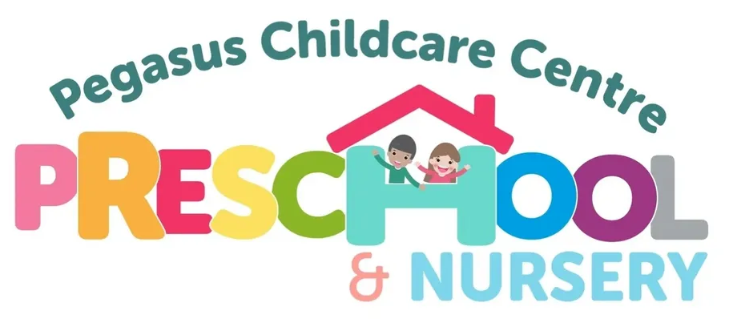

WHISTLE BLOWING POLICY AND PROCEDURE

This policy applies to all employees and applies equally to those designated as casual, temporary, voluntary, or work experience students.
As childcare providers it is our individual responsibility to maintain the welfare of both the children and staff.
It is our duty to express any concerns or issues to a senior member of staff as soon as we notice anything that could raise concern.

What is whistleblowing?

Whistleblowing is a term used when someone who works in or for an organisation wishes to raise concerns about malpractice in the organisation. Whistleblowing encourages and enables staff to raise serious concerns within the setting, rather than overlooking a problem or “blowing the whistle” outside.
Pegasus Childcare Centre is committed to the highest possible standards of openness, probity, and accountability.
Making a disclosure in the public interest (whistleblowing) is essential for keeping children safe in the setting and to ensure good quality practice across the setting.
This policy is underpinned by the Public Interest Disclosure Act 1998, which encourages people to raise concerns about misconduct or malpractice in the workplace, to promote good governance and accountability in the public interest. The act covers behaviour that amounts to.

- A criminal offence
- Failure to comply with any legal obligation
- A miscarriage of justice
- Danger to health and safety of an individual and/or environment
- Bullying, humiliation, discrimination, poor practice, unsafe practice, abuse or neglect
- Deliberate concealment of information about any of the above

Aim of the policy

- To encourage employees to feel confident in raising concerns and to question and act upon concerns and practice
- To provide avenues for employees to raise concerns in confidence and receive feedback on any action taken
- To reassure employees that they will be protected from possible reprisals or victimisation if they have a reasonable belief that they have made a disclosure in good faith.
- To ensure that employees receive a response to their concerns and that they are aware of how to pursue them if they are not satisfied.

The management committee encourages employees and others with concerns about any aspect of the setting’s operations to come forward and voice those concerns. All our staff have a right and a responsibility to raise any matters of concern regarding poor and ineffective practice at work or any inappropriate behaviour displayed by other members of staff, or any other person working with the children. This includes situations where a member of staff becomes aware that a colleague has failed to execute their duty to safeguard children within the setting or elsewhere.

Staff are responsible for the safety and well-being of all children attending the setting and this is a priority over loyalty towards colleagues. All concerns will be responded to and dealt with in accordance with the setting’s confidentiality policy.

In addition to the whistle blowing policy, the setting has other policies and procedures covering discipline, grievance and complaints. This policy is intended to complement these, and to cover concerns that fall outside the scope of other procedures.

Managers, including the management committee where required, will investigate, promptly and thoroughly, all concerns raised in accordance with this policy, and will take appropriate action.

Confidentiality

Managers will do their best to protect a person’s identity when a concern is raised, however in some circumstances identities will have to be revealed to the person complained against and the complainant may be asked to provide written or verbal evidence in support of their complaint.

If a person’s identity is to be disclosed, he or she will be told before the disclosure and the reasons why the disclosure is necessary.

Having raised the concerns, managers will expect the complainant not to talk about it to any other person, inside or outside the setting.

Anonymous complaints

Concerns expressed anonymously are much less powerful and harder to investigate, however they may be considered.

Untrue allegations

If an allegation is made in good faith but it is not confirmed by the investigation, no action will be taken against the complainant. If, however, an allegation proves to be malicious, action may be taken against the person responsible for the malicious act.

How to raise a concern

In the first instance, concerns should be raised with your immediate line manager (usually your appraiser.) However this may not always be appropriate, in which case concerns should be raised with the Centre Manager or the Chair of the Management Committee.

Concerns are best raised in writing. You are invited to set out the background and history of the concern giving names, dates and places where possible, and the reason why you are particularly concerned. A form is provided at Appendix 1 for this purpose. The earlier you express your concerns the easier it is to take action. If you do not wish to put the allegations in writing, the person to whom you are making the complaint will make a written record of the interview and will ask you to sign to confirm accuracy of the notes taken.

Although you will not be expected to prove the truth about your allegations, you will be required to demonstrate that there are sufficient grounds for your concern.

You should NOT:

- Investigate the matter yourself.
- Alert those suspected of being involved.
- Approach or accuse individuals.
- Tell anyone other than the person to whom you are voicing your concern.

Within a week of the receipt of your concern, you will receive a written acknowledgment, with a copy of your statement where appropriate.

Depending on the nature of the complaint the manager will either investigate or elevate concerns to appropriate agencies. Where a safeguarding allegation is made against a member of staff the procedure for allegations against a member of staff within our safeguarding children procedure will be followed.

You will also be informed of the outcome any investigation. If you are not satisfied with the outcome of the investigation, you may elevate your concerns directly to the Management Committee who will review the case. If you are not satisfied with the outcome of the review, you may elevate your concerns directly to the EY team at LCC or to Ofsted.

This policy was reviewed and adopted on …………

Signed (Centre Manager)

Signed (Chair)

The Policy will be reviewed every two years.

Date of Review | Policy Updated | Signed (Chair)


APPENDIX 1

CONCERN RAISED IN LINE WITH WHISTLEBLOWER’S POLICY

Name

Name of person about whom there is a concern

Date
Details of Concern (Set out the background and history of the concern giving names, dates and places where possible, and the reason why you are particularly concerned.)

