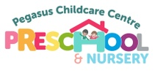
sUMMER END OF TERM NEWSLETTER…
time to say goodbye to our rising 5 children.
This is the term we say Goodbye to our School Leavers. Our children are all ready for their next big adventure to Primary School. They are all so fiercely independent, very clever and kind children and I don’t doubt that they will do amazing on their journey through Primary School. It is certainly a sad time for The Pegasus Ladies because we have to say goodbye! We are so proud of every one of them and wish them all the luck in the world.
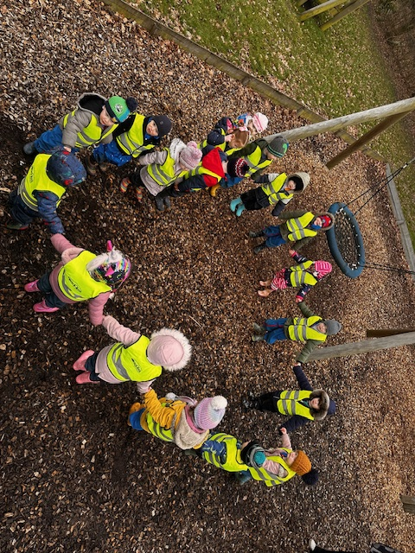
Valentines Day Heart.

tHIS TERM SO FAR…
This term the Children have had many adventures here at Pegasus including some exciting visitors! We have had The Recycling Officers in to talk to the children all about recycling and why it is important. Happy Hooves came to visit with some animals; The library van visited which is always a favourite with the children. We’ve had the wonderful Charlotte from Super-strikers, we released our Butterflies that we grew from Caterpillars and so much more! The children have grown so much in confidence, independence and throughout their learning journey this term, it’s been so lovely watching them all learn and thrive.

Here are some more important dates for your diaries for the next two very busy and exciting months ahead…


19th May – 19th June – World Smile Month.
- 20th May – World Bee Day.
- 21st May – International Tea Day.
- 23rd May – BREAK UP
- 27th May – 29th May – Holiday Club.
- 2nd June – TERM BEGINS.
- 5TH June – Environment Day.
- 6th June – EID.
- 12th June – Superman Day.
- 16th June – Father’s Day Stay&Play. 10-11am
- 20th June – Summer Solstice.
- 15th July – Sports Day (Information to follow).
- 21st July – Rising 5s Leavers Show (Information to follow).
- 22nd July – Leavers Party and END OF TERM.

Throughout this term we will be continuing to focus on our 5 finger rules, ask your child, see if they remember…
- Kind Hands.
- Inside Voices.
- Walk Inside.
- Listening Ears.
- Taking Turns.
This Month we say our goodbyes to Paige! Good Luck from The Pegasus Team.




Meet the Pegasus Team:



Tasha Gemma Sarah Jess Machaela

In the moment planning / child led:
Our Planning is not set in stone. The children are the foundation of our learning, and we know that children learn best when they are interested in a certain subject. We have the dates above as planning guidelines but a lot of our activities and learning opportunities are child-led and implemented in the moment.

Would you like to volunteer:
Would you like to come to Pegasus and volunteer your time to share some experiences with our children. You could come and have a reading session with the children, talk about the job that you have, maybe you have an animal you could bring in for the children to meet. If you would like to volunteer at any time, please speak to a member of staff or email us and we can arrange a day.
HOLIDAY CLUBS:
We are opening for May Half Term on the following days:
- Tuesday 27th May. 9am-3pm
- Wednesday 28th May. 9am-3pm
- Thursday 29th May. 9am – 3pm
We will be opening for Summer Holiday Club; we are working on dates to ensure we have available staff for the dates we may open for.
TAPESTRY:
Tapestry observations will remain weekly including WOW moments. Please continue to upload any adventures you’ve been on or news’s you’d like to share as the children really enjoy looking at these during circle time. If at any time you have any issues with observations that have been uploaded to Tapestry, please speak to your child’s keyworker.



