
Pegasus

Newsletter
Term dates
Spring Term
Term 3
6th January – 14th February.
Half Term
15th February – 23rd February.
Term 4
24th February – 4th April.
Easter Holidays
5th April – 22nd April.

Happy New Year



  - January – April 2025
Spring Term.

Welcome Back
Emma and the Pegasus team would like to wish you all a Happy New Year, we hope you have had a lovely Christmas. This term we will be starting off gently and settling back into life at Pegasus after a busy Christmas break. We will be watching how the season moves into Spring and enjoying lots of learning experiences and adventures inside and outside. Please stay tuned for dates to add to your calendars in the upcoming weeks.

We will be focusing on our Pegasus 5 Finger Rules…
- Kind Hands.
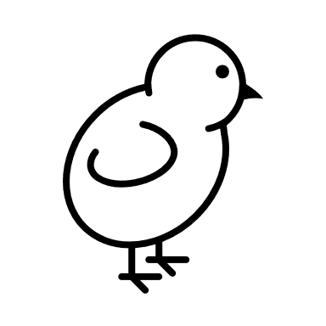
- Listening Ears.
- Inside Voices.
- Walking Inside.
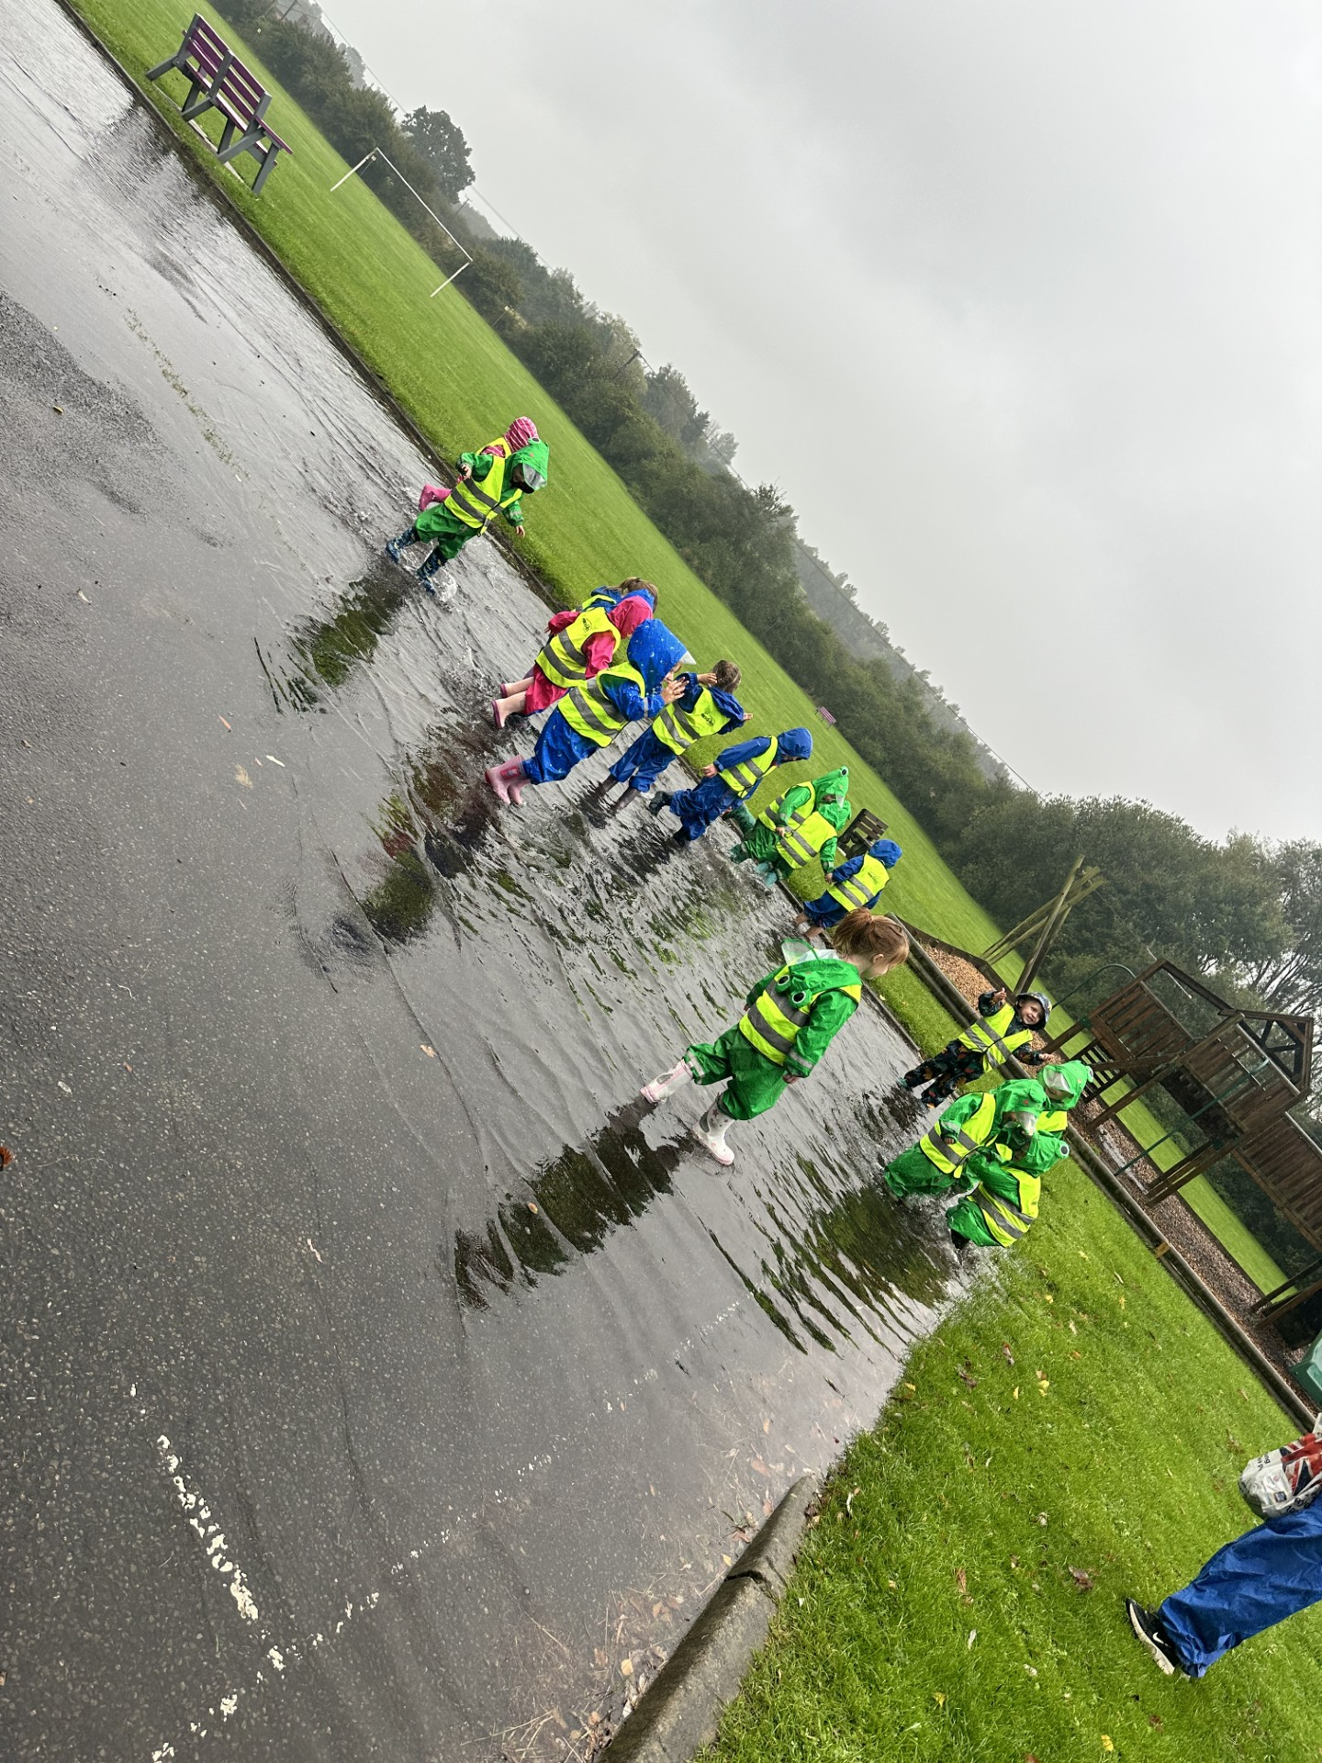
- Taking Turns.

Here are some of the different things we will be exploring during the Spring term:
- The Big School Bird Watch – 8th Jan – 19th Feb.
- Penguin Awareness Day – 21st Jan
- National Hug Day – 21st Jan.
- National Reading Day – 23rd Jan.
- Chinese / Lunar New Year 29th Jan.
- National Draw A Dinosaur Day – 30th Jan.
- Children’s Mental Health Week – 3rs Feb – 9th Feb.
- Wear Red Day – 7th Feb.
- Valentins’s Day – 14th Feb.
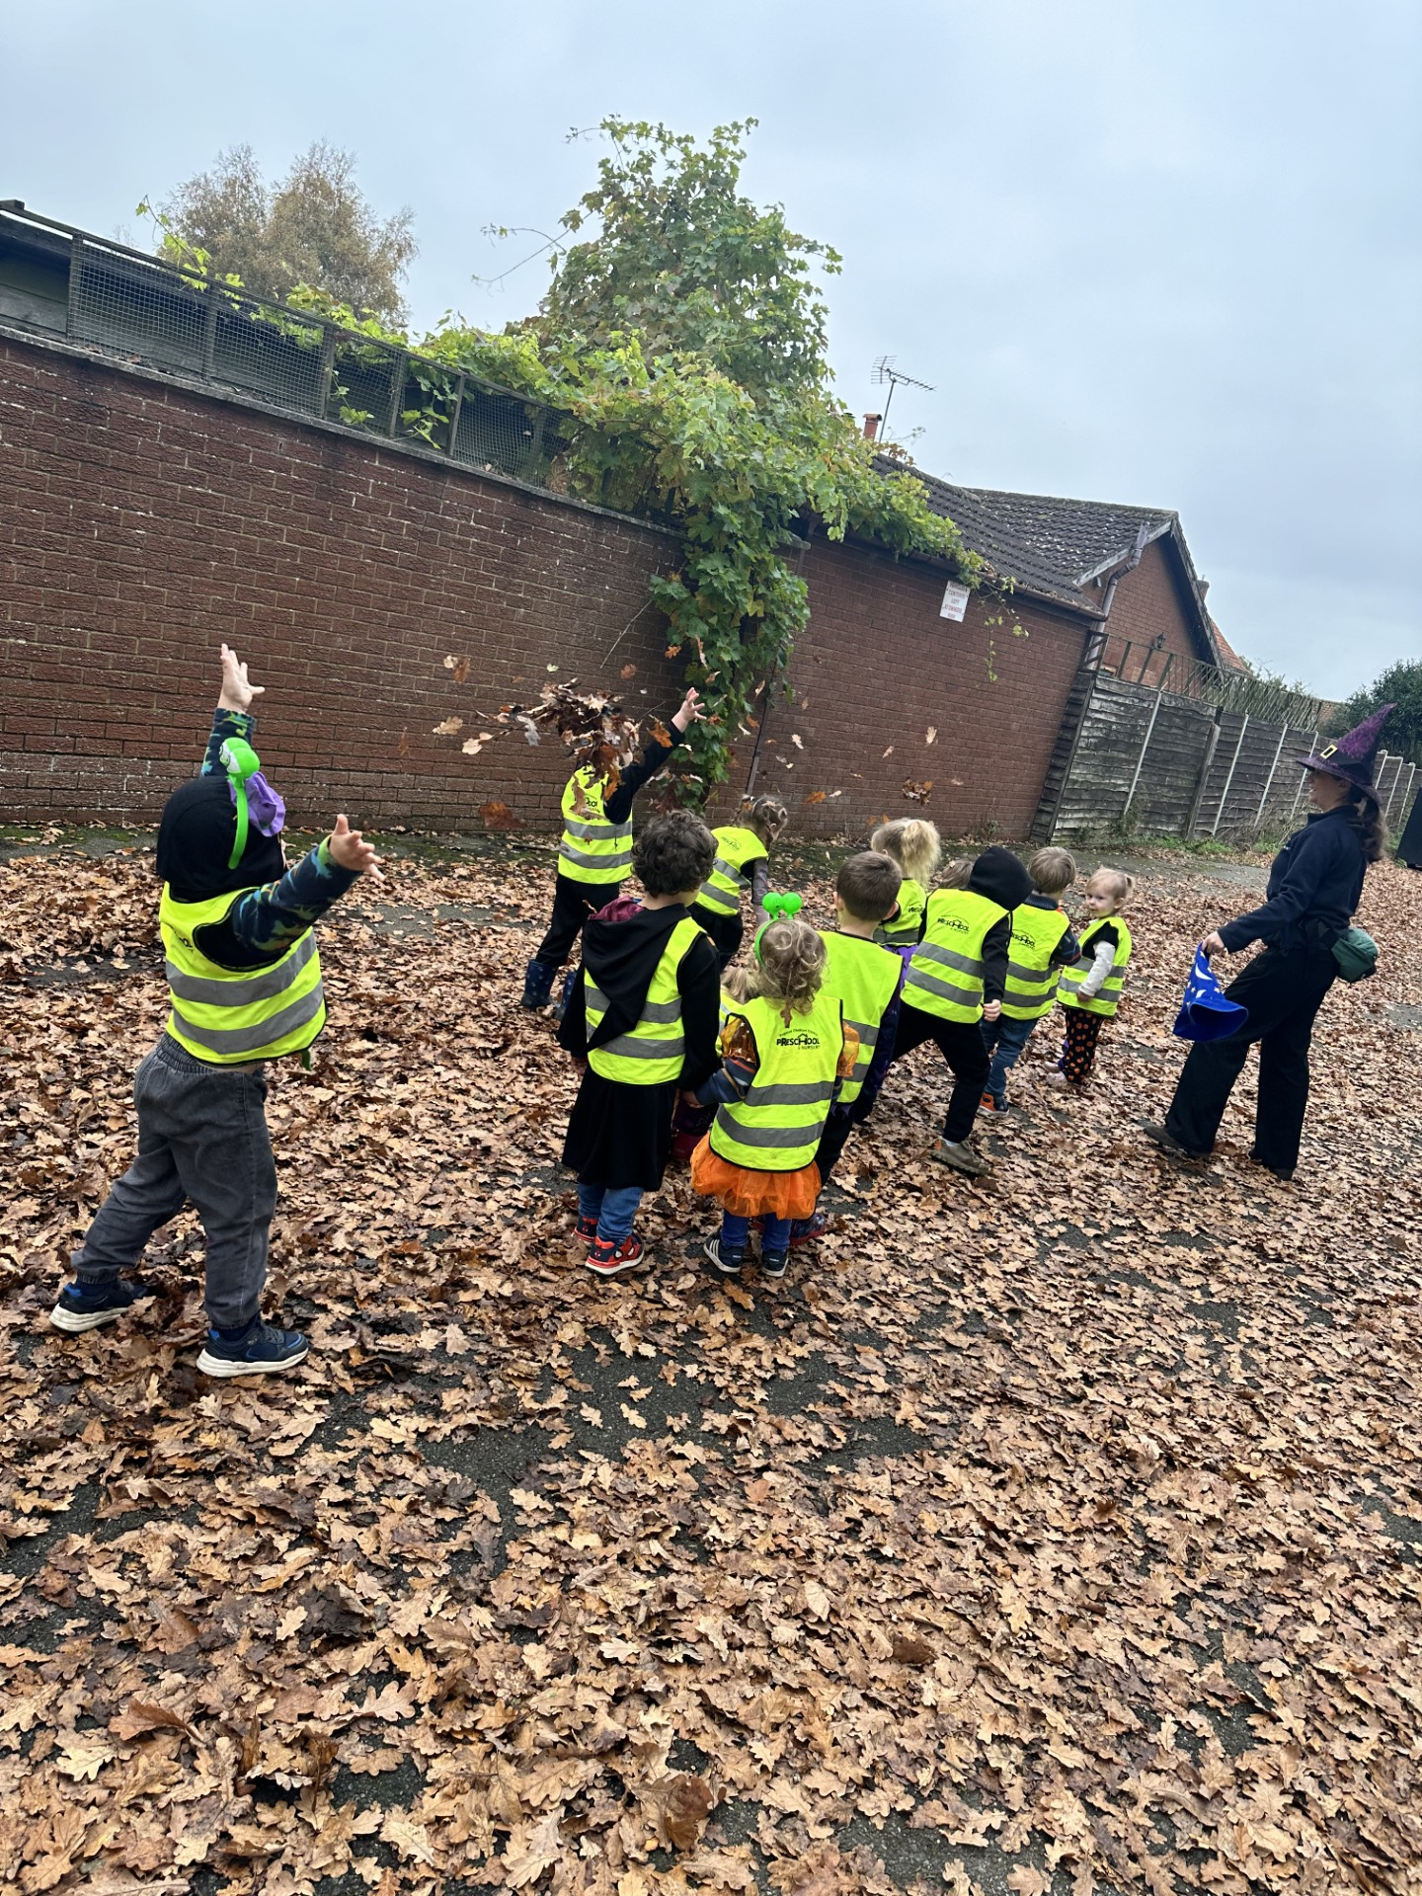
- Half Term 14th Feb – 24th Feb.
- Pancake Day – 4th March.
- World Book Day – 6th March.
- British Science Week – 7th – 16th March.
- Comic Relief – 14th March.
- St. Patrick’s Day – 17th March.
- Global Recycling Day – 18th March.
- Spring Equinox (First day of Spring) – 20th March.
- Easter Holidays – 4th – 22nd April.



IN THE MOMENT PLANNING/CHILD LED.



Our Planning is not set in stone. The children are the foundation of our learning, and we know that children learn best when they are interested in a certain subject. We have the dates above as planning guidelines but a lot of our activities and learning opportunities are child-led and implemented in the moment.

COMMUNITY LINKS:
We are hoping to have lots more exciting visits to Pegasus this term. We have asked the Recycle people to come back as the children really enjoyed their visit and we are hoping to get some birds to vissit for the Big School Bird Watch. We are also going to be joining in a Sunflower growing competition with Market Rasen Environmental Group, we did the planters in Market Rasen with them. More informatioon to follow.

Would you volunteer your time?
The Pegasus Team.
Contact Us
Pegasus Childcare Centre
Main Street
Osgodby
Market Rasen
LN8 3TA.
01673828187
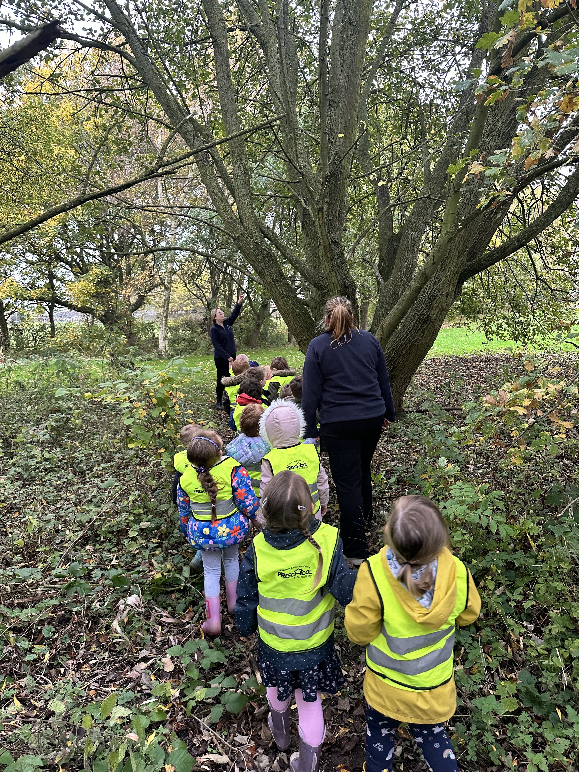
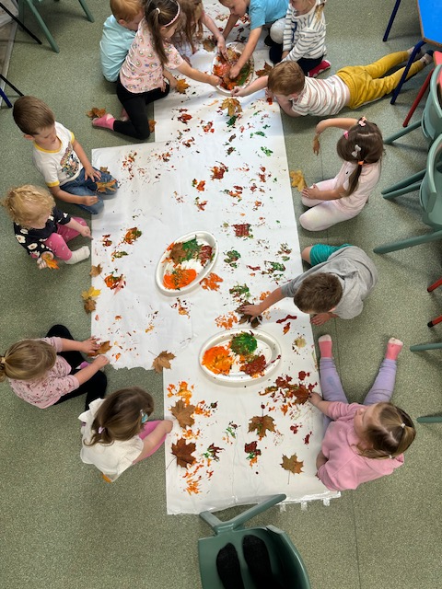
Would you like to come to Pegasus and volunteer your time to share some experiences with our children. You could come and have a reading session with the children, talk about the job that you have, maybe you have an animal you could bring in for the children to meet. If you would likevolunteer at any time please speak to a member of staff or email us and we can arramge a day.
HOLIDAY CLUBS:
We are still in the process of organizing any upcoming holiday clubs that we will be doing. As soon as we have finalized dates, we will send out emails to you all and it will also be updated on our website and Facebook page. So, keep a look out for those.
WE NEED YOUR HELP:
We are hoping to grow lots of wonderful flowers and vegetables at Pegasus during the Spring and Summer terms. If you have any seeds lying around that you don’t want or any plants/bulbs that you wish to donate we would really appreciate it.
TAPESTRY:
Tapestry observations will remain weekly including WOW moments. Please upload pictures from your Christmas break so we share at circle time. If at any time you have any issues with observations that have been uploaded to Tapestry, please speak to your child’s keyworker.

