Gifting Support Documents
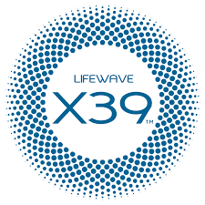
Giving a Gift of X39 can change someone's life and your business! Some feel it fast, some slow, but it always immediately begins working at a cellular level from the very first day. This is a powerful and proven way to open a meaningful discussion and evaluation of X39, and if done properly, will constantly result in new Customers and Distributors.

Click to Review and Download the Gifting Daily Method of Operation (DMO) Guidelines

Two Excellent X39 Gifting Options
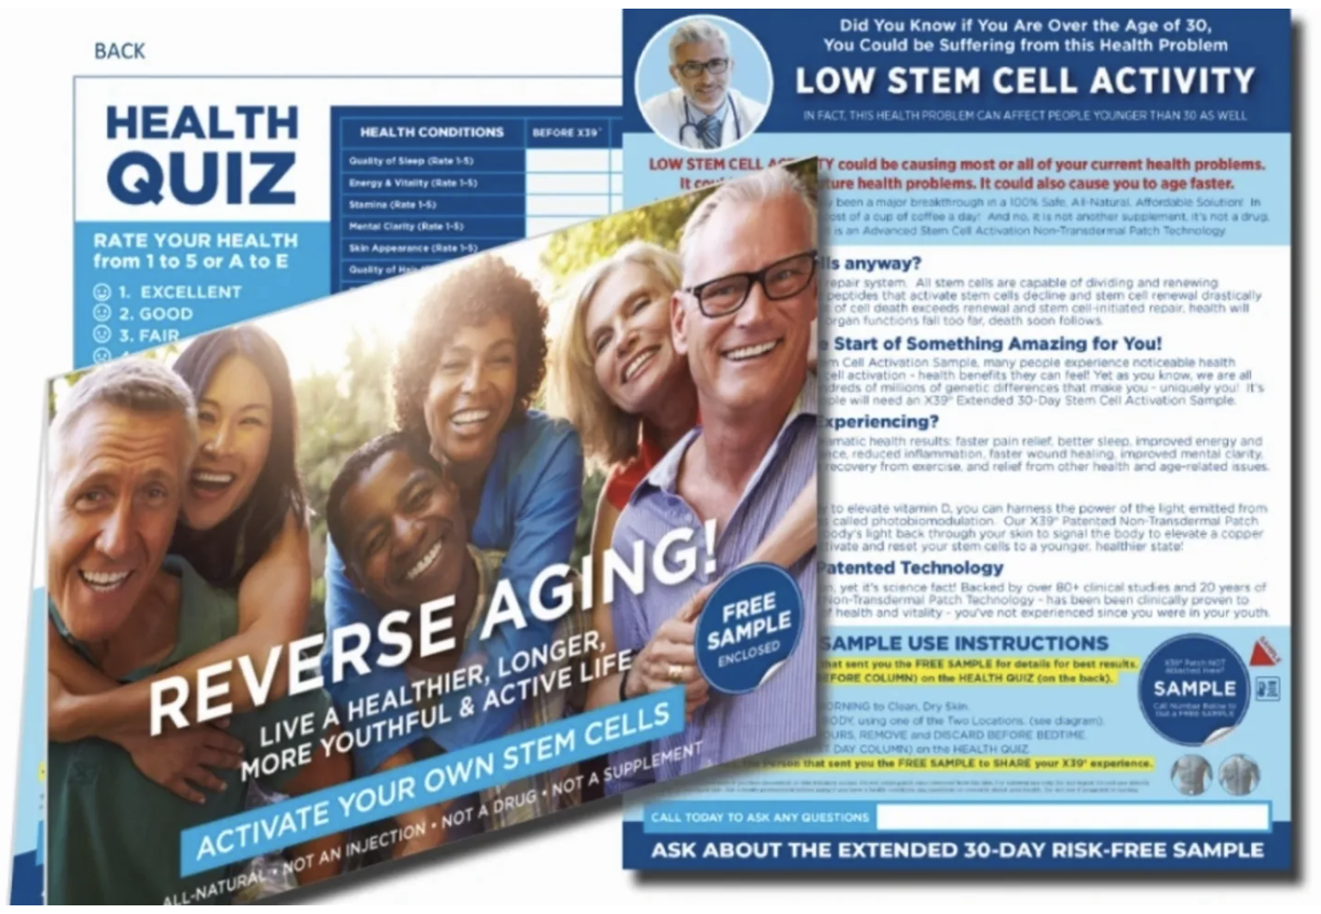
- The One-Patch Sample Card
This professionally printed and attractive 4-color sample card created by Sr. Presidential Ron Ledford. They can be personalized or left blank and ordered along with an attractive blue mailing envelope directly from VistaPrint in the US and Canada.

For a 50% First Order Discount use code XBIZBOX50.

US: https://xbizbox.go.customprintcenter.com/

CA: https://livingbetterteamca.go.customprintcenter.ca/

- The X39 Gift of Good Health Flyer
This simple downloadable, 2-color, 2-sided print-at-home flyer clearly outlines X39’s benefits, usage instructions and on the back side contains the Health Tracker for recipients to document their before and after results.

If you use this flyer, consider also including the LifeWave X39 Tri Fold Brochure (10 for $3.50 in your back office store) and possibly one of the Stem Cell article reprints in the Distributor => Resources section of NittyGritty101.
