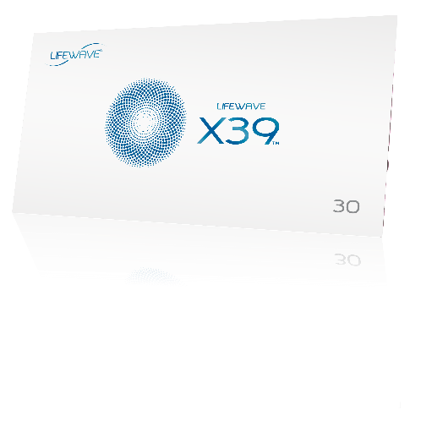

**LifeWave X39™ ELEVATOR PITCH**

**Elevator Pitch # 1**

This is an elevator pitch that would be a phone call to someone that you know.

**LifeWave member:** Hi (name of person) this is (you), did I catch you at a good time to talk?

**Prospect:** Hi (you), yes this is a good time to talk.

**LifeWave member:** I was thinking about you the other day and I came across something I thought you might be interested in. It’s this new product for activating stem cells.

**Prospect:** Oh, that sounds interesting, what is it?

**LifeWave member:** Well I know how interested you are in health, and what caught my interest is that this is a new technology for resetting stem cells to a younger state using light.

**Prospect:** I’ve never heard of anything like that; how does it work?

**LifeWave member:** I’ll send you a link to a short video that will explain everything. I’ve been using the product for the past month and what got me excited is that (provide your own experiences) e.g. It gave me more energy, I’m sleeping better, and I even noticed that a few old injuries I had are gone now; it’s really been incredible!

**Prospect:** Oh, wow I can’t wait to try it! Thanks so much for thinking of me.

**LifeWave member:** My pleasure! I will send you that link now and some other information. Nice talking to you and I hope you have been well.

**Prospect:** Thanks, you too.



**LifeWave X39™ ELEVATOR PITCH**

**Elevator Pitch # 2**

This is an elevator pitch to a stranger; depends on where and how you meet them.

**LifeWave Member:** I noticed that you were looking at this patch that I am wearing. Actually, it is a new technology that activates the stem cells in your body; have you ever tried it before?

**Prospect:** Yes, I did see that. No I never heard of that before.

**LifeWave member:** I hadn’t either until recently. A friend recommended it to me and I found it all really interesting so I decided to try it.

**Prospect:** What does it do?

**LifeWave member:** Well it’s really been remarkable. (provide your own experiences) e.g. I noticed the first few days that I had more energy during the day and I was sleeping better. But then after about 3 weeks I noticed that an old injury I had just disappeared, which was really amazing to me.

**Prospect:** Wow, that does sound incredible. How does it work?

**LifeWave member:** I asked my friend the same question and he sent me the link to this website. There is a video there that will explain it better than me. I’ll give it to you; it’s **www.LifeWave.com/myname**

**Prospect:** Ok thanks I’ll have to check that out.

**LifeWave member:** The company runs discounts from time to time; I can see if I can get you one, so you can try it. Do you have a business card?

**Prospect:** Yes, here you go.