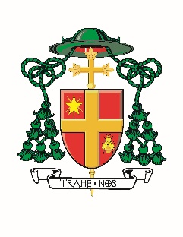
Memorandum

Memo To: All Pastors and All Parishes
Memo From: Most Reverend Douglas Crosby, OMI
Date: Monday, March 23, 2020
Re: Church Bells for Healthcare Workers

The bells of the Cathedral Basilica of Christ the King in Hamilton will ring out each day at 9:00 a.m.; 12 Noon; 3:00 p.m. and 6:00 p.m. to invite parishioners … and all who hear the bells … to pray (an “Our Father”) for our healthcare workers dealing with the COVID-19 pandemic.

Parishes with bells, across the Diocese, are invited to join in this effort and to share the invitation to prayer through social media. Let us pray for doctors, nurses, hospital staff, and first-responders during this difficult time.

/cd

