In the Autumn term children will be learning:

Skills for Life:  - Communication  - Team Work  - Resilience  - Being Safe | CoEL:  Playing and exploring  - Showing curiosity about objects, events and people.  - Showing particular interests.  - Representing their experiences in play.  Active learning  - Maintaining focus on their activity for a period of time.  - Showing high levels of energy, fascination.  - Persisting with activity when challenges occur.  Being Creative and thinking critically  - Finding new ways to do things.  - Making links and noticing  patterns in their experiences. |  | Childhood Experiences:  - Catch a falling leaf  - Collect conkers  - Make a mud pie  - Run around in the rain | Reading for Pleasure:  Dear zoo  Shark in the park  Room on the broom  Each Peach Pear Plum  Humpty Dumpty (national nursery rhyme week)  Gingerbread Man  The Christmas story | KSU Passports:  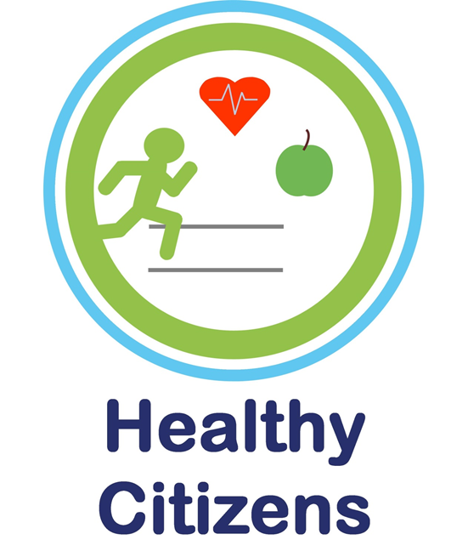
Personal, Social and Emotional Development |  | This term focuses on settling into our nursery classes, building relationships with individual key workers, meeting new friends and learning nursery rules and expectations.  We will be promoting turn taking and working within a team.
Communication and Language |  | Opportunities will be provided to develop language and listening skills; this will include small games and role play scenarios.  We will build up a bank of familiar stories, focusing on joining in with repeated refrains and retelling the stories ourselves.  We use Launch Pad for Literacy as our approach in order to identify speech, language and other developmental needs as soon as possible and to embed specific skill-based intervention into practice and Quality First Teaching.
Physical Development |  | This term we will focus on developing both gross and fine motor skills, such as pouring, lacing, threading, cutting and mark making.  We will be focussing on promoting independence in self-care.
Literacy |  | As well as introducing new stories, access to the reading areas will be encouraged. Different types of mark making will be introduced encouraging children to give meaning to their marks- distinguishing between their picture and writing.  Each week there are planned inputs taken from Launch Pad, focusing on early reading and writing skills.
Mathematics |  | This term we will be learning to count in order, making connections between the counting and total amount. We will learn counting songs and rhymes to promote this.  We will also explore 2D shapes and begin to learn their mathematical name and their properties.
Understanding the World |  | This term we will see many changes happening outside as the seasons change. We will observe these closely through OPAL.  We will be learning about different celebrations and calendar events.
Expressive Arts and Design |  | Imaginative play will be encouraged in the role play areas, basing these on the children’s own experiences. Singing both new and familiar songs and rhymes will be planned into the daily routine.  We will be using various construction blocks, focusing on developing hand-eye coordination to balance and build. Different purposes of building will be introduced, e.g. a house or bridge.

