In the Autumn term children will be learning:

Skills for Life:  - Communication  - Team Work  - Resilience  - Being Safe | CoEL:  Playing and exploring  - Finding out and exploring  - Playing with what they know  Active learning  - Being involved and concentrating  - Enjoying achieving what they set out to do  Creating and thinking critically –  - Having their own ideas |  | Childhood Experiences:  - Make a pud pie  - Build a Den  - Eat an apple straight from a tree  - Go for anAutumn walk around the school grounds.  - Make smores around the fire pit. | Reading for Pleasure:  - You Choose!  - Winnie’s amazing pumpkin  - Kipper’s toy box  - How to catch a star  - Christmas story | KSU Passports:  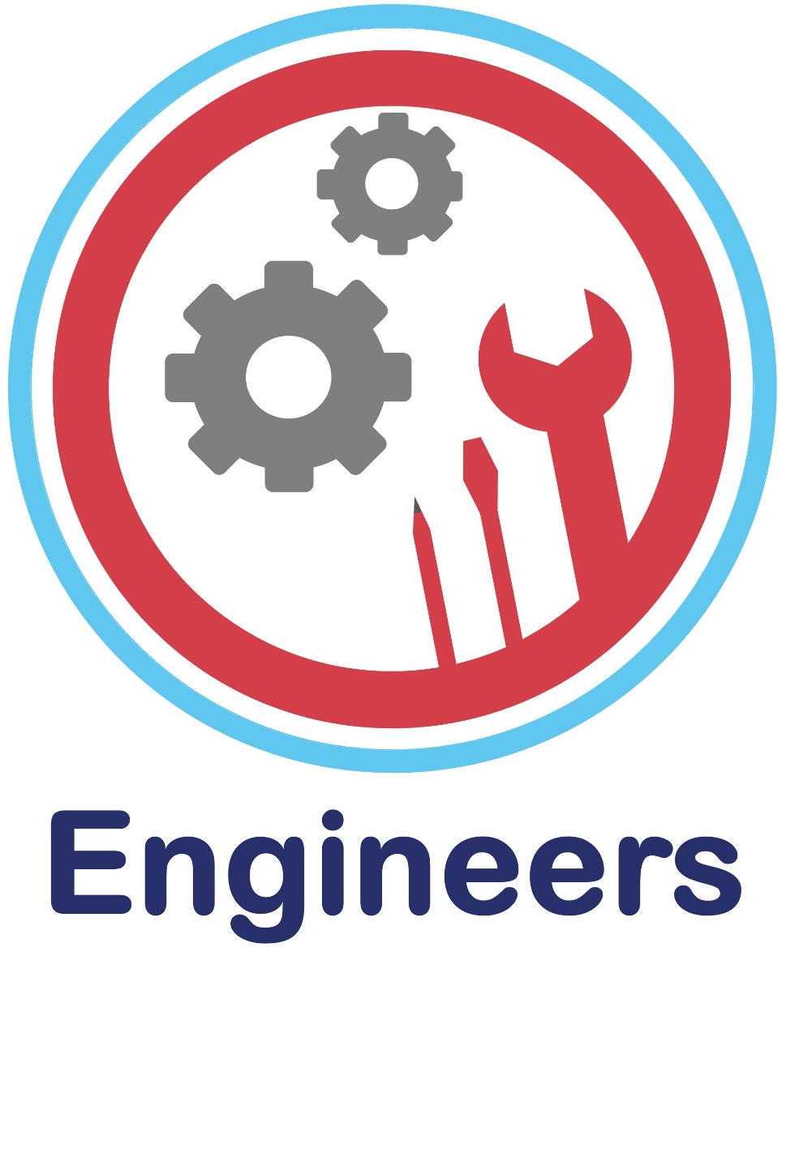  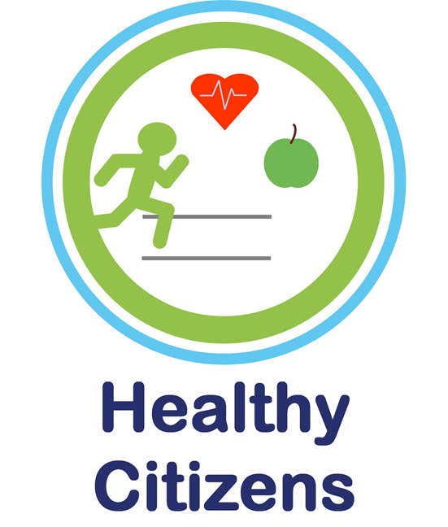
Personal, Social and Emotional Development |  | This term focuses on settling into our 4 Reception classes and meeting new friends. We will look at who we are as individuals and what makes people special, celebrating similarities and differences.
Communication and Language |  | Communication and Language skills will be developed this term with a strong focus on developing vocabulary and conceptual understanding. We use Launch Pad for Literacy as our approach in order to identify speech, language and other developmental needs as soon as possible and to embed specific skill-based intervention into practice and Quality First Teaching.  We also learn how to use very simple greetings in French and in other languages spoken by our friends.
Physical Development |  | We will be using whole class sessions in the large space of the school hall to focus on spatial awareness, getting changed for these PE lessons independently. We develop our gross motor skills through access to our Outdoor Play and Learning curriculum (OPAL).  Fine motor control will be reinforced, for example by letter formation activities and the safe use of scissors.
Literacy |  | Daily phonics sessions are ongoing this term, focusing on Set 1 letters from the Read, Write Inc programme. Sounds are recapped consistently through Pinny Time. Blending and segmenting of simple words using these sounds are reinforced daily through Fred games. Early Literacy skills gaps are identified through Launch Pad and opportunities to bridge these gaps are provided through informed intervention. Regular story sessions play an important part of the day where both new and familiar stories are shared.
Mathematics |  | We will focus on regular counting, reading and writing numbers using these numbers to solve simple problems.We will focus on securing numbers to 5, placing them in order and saying which number is one more or one less than a given number. Using quantities and objects, we will add and subtract two single-digit numbers and count on or back to find the answer. We also explore simple shapes and their properties, and begin to use everyday language related to money. We explore pattern and measures through OPAL.
Understanding the World |  | During OPAL, we look for changes that occur during Autumn to support our scientific understanding. Children are encouraged to be curious and to ask questions – stimulating a sense of excitement about natural phenomena and developing the foundations of scientific enquiry.We find out about different festivals such as Divali and Christmas and how people celebrate them. We explore a range of techniciology toys and equipment.
Expressive Arts and Design |  | Through stories, role play and small world play, we extend opportunities to explore imagination. Creative materials such as paint, dough and collage are used to explore colour and texture. Music and movement experiences are ongoing too, through the use of instruments and regular songs and rhymes. Through OPAL, we explore the world of engineering by visits to our Invention Hut.

