Academic Year:2018/19 Impact
School Focus/Impact on pupils | Actions to achieve | Funding allocated £19,269 | Impact
To support class teachers with planning and delivering high quality lessons and schemes of work. | Specialist PE teaching assistant to team teach with class teacher | £14,000 | Teachers more confident to deliver a range of fun and engaging PE lessons. Children make good progress in PE.  ‘Mr Murton has been very supportive with the use of the PE Passport and how to organise my lessons’  ‘He has great ideas and I’m more confident in delivering my own PE lessons’  ‘He helped assess my classes using the PE Passport’  ‘His clubs have engaged lots of KS1 pupils’  ‘He’s shared some great ideas during lesson planning that I will use next year’.
Premier League Reading Stars | TA and PE staff to conduct reading intervention |  | More children are reading for pleasure.  7/15 target group are now reading 3 times per week
Playmaker Award | To support with the learning journals in the Playmaker Accreditation |  | School Sport Crew have more effective leaders delivering daily activities in the yard spaces and during extra-curricular activities.  X98 Year 6 achieved Playmaker award  X30 actively promote PESSPA and deliver active play during break times
School Games Entries | Enter all competitions offered from the School Sport Partnership |  | More children have the opportunity to compete  30% have represented the school at level 2  10 Girls represented Ashington and Coquet at the Level 3 School Games final in Girls Football  1 Boy represented Ashington and Coquet at the Level 3 School Games final in Athletics  100% competed in inter house competitions
East Northumberland U11 Team | Manage/Coach and organise fixtures for the U11 Football team |  | Weekly fixtures offered to the U11 Football team. Profile and support b4l.
KS1 Extra-Curricular clubs | Coordinate KS1 Extra Curricular clubs. |  | Increased after school club offer. 50 pupils weekly participating in KS1 PE Activities.  Delivering 2 clubs weekly. 6 Different clubs over the academic year.  45% - 99 Year 1 and 2 pupils have attended extra-curricular clubs
Active break times | KS2 Active breaks. Use the Outdoor Gym equipment and sound system to get more pupils physically active |  | More pupil meeting the daily physical activity requirements of 30minutes during school time.  90% of pupils are active during break times compared to 60% during Autumn 1
Festival Support | To support with organising whole school and year group festivals |  | 100% will attend School Sport Partnership festivals:  Year 1 – Hula Hooping  Year 2 – Gymnastics  Year 3 – Tag Rugby  Year 4 – Orienteering  Year 5 – Skipping  Year 6 – Hula hooping
PE Passport support | To upskill KS1 staff on effective use of the PE Passport Application. |  | KS1 teachers are more confident in planning, delivering and assessing PE.
To provide a range of competitions and festivals throughout the year. | Join the Ashington and Coquet School Sport Partnership including Primary membership of Youth Sport Trust.  Attend School Sport Partnership and School Games competitions  Record which children are participating so each pupil has the opportunity to compete. | £3300 | 100% have attended School Sport Partnership festivals:  Year 1 – Hula Hooping  Year 2 – Gymnastics  Year 3 – Tag Rugby  Year 4 – Orienteering  Year 5 – Skipping  Year 6 – Hula hooping  Coordinator offered curriculum support consistently and Sports Day help by providing young leaders and expertise throughout.
Balance ability  - To increase the number of pupils riding bikes competently and offer an innovative afterschool club  - To develop staff confidence/competence | - Book staff CPD for Peter Murton  - Order 5 14” balance bike package  - Order 5 12” balance bike package  - Organise storage  - Complete cycling audit in year 1  - Target pupils and invite to an afterschool club | £1500 | To increase the number of pupils riding bikes competently and offer an innovative afterschool club in KS1  30 pupils weekly attended and have all received their balance ability award.
Booster Swimming | - Complete a swimming audit  - Target those who are underachieving in swimming  - Invite to the club and analyse responses  - Plan SOW to develop water confidence  - Staff CPD/Swimming qualification | £1000 | - Increase the number of pupils being able to swim 25m (Current 40%)  - Develop water confidence  Name Year 5 Attain Year 6 Assessment 12 Week stage progress  C.C Duckling 3 Stage 2 2.2  C.C Stage 1 Stage 3 2  K.L Duckling 2 Stage 1 3  E.G Stage 1 Stage 3 2  B.H Stage 1 Stage 2 1  L.W Duckling 4 Stage 3 4  D.M Stage 1 Stage 3 2  A.P Duckling 4 Stage 3 4  L.T Stage 1 Stage 3 2  O.B Stage 1 Stage 3 2  B.R Stage 1 Stage 3 2  C.S Stage 1 Stage 3 2
Protective equipment for a biking/scootering club | Purchase 20 helmets | £300 | More confident pupils riding their bicycle across the keys stages.  30 pupils completed Bike ability training in year 5
Fit bit challenge | - Purchase a class set of Fit bits  - Track and record step count data  - Organise a competition throughout the year  - Reward winning classes  - Link to the behaviour system | £1000 | More active children during playtime, supporting the active 30 initiativ.  Pending – PE Passport Application needs updated to allow this intervention to proceed
PE Passport | - To ensure PE staff are confident in using the app  - To complete the admin and set up of the app.  - Ensure staff are using it effectively and all evidence is recorded.  - Analyse data | £599 for the package | Lessons are designed to ensure that all children are physically active within their PE lessons. They are written with a target ratio of 75:25 physically active: using AFL to move on the learning of the students.  The formative assessment model allows for staff to identify which children are not physically active in lessons allowing for targeted intervention if appropriate.  The data from the extra-curricular registers allows staff to identify which children are not participating in the extra-curricular programme, giving schools the opportunity to approach those children to see if it is because they are already active out of school or if there is something else in school which might appeal and get them involved.

Pupils meeting national curriculum requirements for swimming and water safety
What percentage of your current Year 6 cohort swim competently, confidently and proficiently over a distance of at least 25 metres? | 9/80  11%
What percentage of your current Year 6 cohort use a range of strokes effectively [for example, front crawl, backstroke and breaststroke]? | 31/80  38%
What percentage of your current Year 6 cohort perform safe self-rescue in different water-based situations? | 61/80  76%
Primary PE and Sport Premium to provide additional provision for swimming but this must be for activity over and above the national curriculum requirements. | See above for Booster swimming data from current Year 6 target group
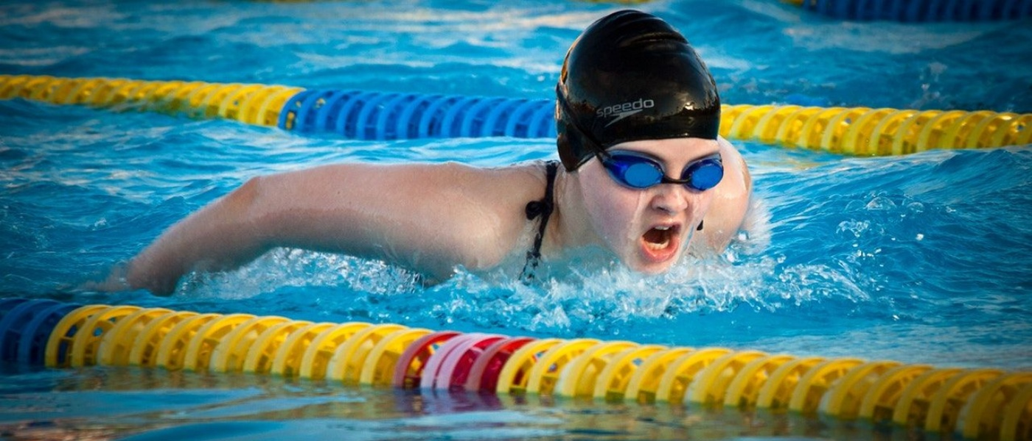
Central Primary School
Sport Premium Impact 2018/19
The Primary PE and Sport Premium is awarded to every school with primary aged pupils and must be used to fund additional and sustainable improvements to the provision of PE and sport, to encourage the development of healthy, active lifestyles.

