MICHAEL' S Believe FOUNDATION 11th ANNUAL GOLF OUTING

Michael's Believe Foundation was started to honor a young man, Michael Tepe, who passed away in an automobile accident on November 10, 2013. Michael was a 2010 graduate of Springboro High School, and a Student Athlete at The College of Mount Saint Joseph where he was majoring in Special Education / Social Work.

Michael’s family and friends would like to honor Michael again this year with our 11th Annual Believe Foundation Golf Outing, Monday June 16th at Heatherwoode Golf Club in Springboro, Ohio. All proceeds will go to a cause that was very dear to Michael's heart, Special Needs programs. Again, our main beneficiary is Miracle League of Warren County and Greater Dayton, to help fund their playground and other maintenance costs. From our previous outings, we have donated over $90,000.00 to special needs programs and have given $14,000.00 in college scholarships at Springboro High School.

We are looking for hole sponsorships, as well as donations for our silent auction and raffle. If you or your company would like to donate a gift basket, gift cards or services, please email us and we can make arrangements for someone to pick it up.

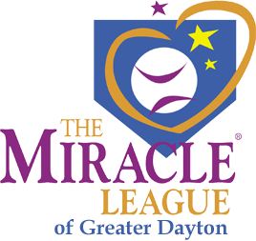

**If you would like your company logo or verbiage on the sign, please email it in a PDF file to:** [**Tepebill22@gmail.com**](mailto:Tepebill22@gmail.com) **as well as mailing in this form. If you have any questions, you may email those as well.**

**THANK YOU FOR YOUR SUPPORT!!!!**

HOLE SPONSOR $100.00

DRIVING RANGE SPONSOR $250.00

SPONSOR NAME

ADDRESS

CONTACT PERSON

PHONE NUMBER

E MAIL ADDRESS

***Make Checks Payable to: Michael's*** Believe ***Foundation 288 Tamarack Trail***

***Springboro, Ohio 45066***