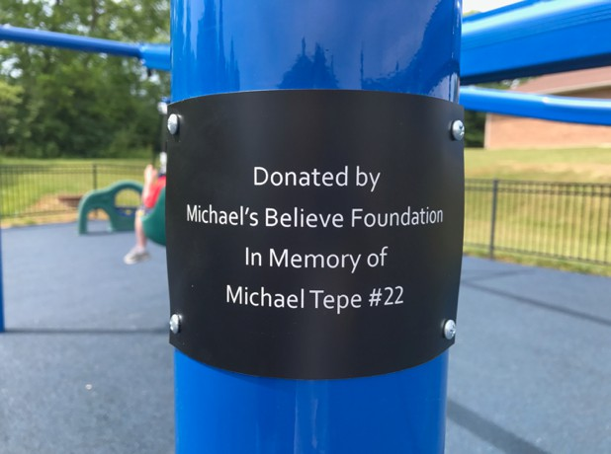Michael's Believe Foundation **11th Annual Golf Outing Monday June 16, 2025**

**This outing will take place at**

Heatherwoode Golf Club

88 Heatherwoode Boulevard in Springboro, Ohio.

Cost is $125.00 per golfer, which includes 18 holes of golf at a great golf course, driving range and a grill out afterwards. Other goodies and surprises will be included. There will be several skills games as well as split the pot, silent auction and door prizes. Check in will begin at 8:30 A.M. with a shotgun start at 10:00 A.M. We will be playing a Scramble format. Additional information and rules will be available at the golf course. All proceeds from this event benefit Miracle League of Warren County and Greater Dayton to help fund the playground, just behind Miracle Field, along with other improvements, as well as a Scholarship at Springboro High School

If you have any questions, please email me at

[**tepebill22@gmail.com**](mailto:tepebill22@gmail.com)

**You can also visit us on our website, Michaelsbelievefoundation.org**

**Please help us honor Michael Tepe and support a great cause.**

**Make Checks Payable to: Michael's** Believe **Foundation 288 Tamarack Trail**

**Springboro, Ohio 45066**

**Your spot will be guaranteed once payment is received. Please include your name and email address below:**

**PLAYER 1 EMAIL**

**PLAYER 2 EMAIL**

**PLAYER 3 EMAIL**

**PLAYER 4 EMAIL**