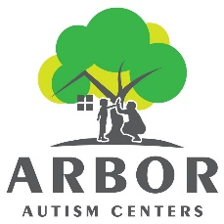 | Arbor Autism Centers  850 S. Hewitt Rd  Ypsilanti, MI 481097  Phone: 734-544-5561  Fax: 734-527-5981

Referral Form – please complete and fax to the number above
Please include a demographic/face sheet if patient section of form is not fully completed

Patient Information
Patient Name: |  |  |  |  |  |  | D.O.B.:
 | Last | First |  |  |  | M.I.
Address:
 | Street Address |  |  |  |  |  | Apartment/Unit #
 | City |  |  |  | State |  | ZIP Code
Phone: |  |  | Email

Diagnosis: (check all that apply) |  | Autism |  |  | Suspected Autism |  |  |  | Language Delay/Disorder |  |  | Incoordination |  |  | Feeding Difficulties
 |  | Other (please specify):

Patient is being referred for (please check all boxes that apply:
 | Physician Consult |  |  |  | OT Evaluation & Treatment
 |  | SLP Evaluation & Treatment | Feeding Evaluation & Treatment |  | ABA Evaluation & Treatment

Physician Information
PRINTED  Physician Name: |  |  |  |  |  | NPI #.:
 | Last | First
Address:
 | Street Address |  |  |  |  |  | Suite #
 | City |  |  |  | State |  | ZIP Code
Phone: |  |  | Email:

Physician’s Signature: |  | Date:

Additional
notes
or instructions:

