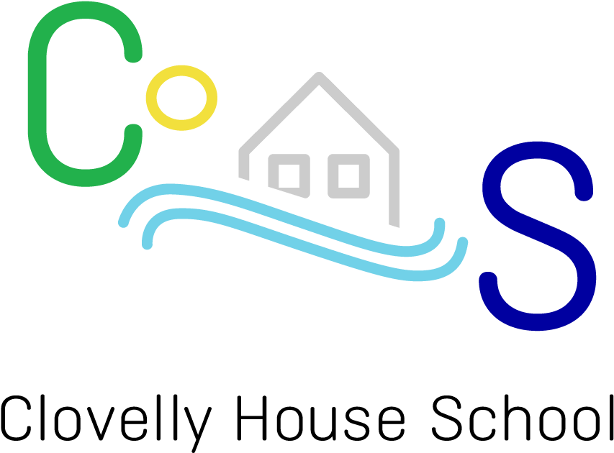
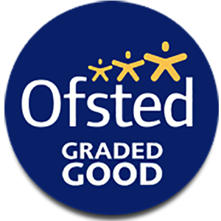
Small School, Big Hearts, Bright Futures
2026/27
www.clovellyhouse.co
PROSPECTUS
Welcome to Clovelly House School
Clovelly House School is an independent special school for girls and boys from 10-19 based in a rural setting in the East Midlands. We are split across two main sites -one near Thornton and another based in Enderby. The ethos is that of a countryside school and the pupils, who have social and emotional and other complex needs, have opportunities to learn the core subjects embedded in a wider curriculum.
Our Thornton site consists of 9 modular log cabins sited at the rear of the property situated in about 2/3 acre of well-stocked, secluded gardens. We use the cabins in a way that enables us to provide every student on site with their own ‘safe space’. This site is primarily suited for KS2/3 students, but we can cater for those in KS4 too.
Our Enderby site is situated opposite Enderby Leisure Centre and is designed for effective group learning in two large classrooms and smaller classrooms for individual/paired learning. Enderby is most suitable for KS4 students who can cope with more social interactions and enhanced focus towards Functional Skills and GCSE qualifications as well as a larger emphasis on future careers, employability and independence.
We offer a supportive environment and create opportunities for the young people to develop self-esteem and confidence through achieving measured steps of success.

Welcome
Clovelly House School is a small independent educational school located in the south-west Leicestershire, split across two sites. We cater for children between 10-19 years with an Educational Health Care Plan (EHCP) with the aim to learn, thrive and grow both academically and as individuals.
At Clovelly, we are a Small School, with Big Hearts who aim to give all our students Bright Futures. The teaching we deliver is second to none, as we structure our teaching around the National Curriculum as well as focusing our approaches to meet individual needs. We believe that every child deserves the opportunity to gain the skills, qualifications and knowledge to be able to be resilient and successful when entering adulthood.
Vision Statement
We are an independent SEN school for all genders from years 10 – 19. Our location is based in south-west Leicestershire which is split between two sites, one in a rural setting and another in the outskirts of Leicester. We have an ethos embedded across both sites that ensure that all pupils, who have social, emotional and other complex needs are granted opportunities to learn core subjects within a wider curriculum.
At Clovelly, pupils have access to a range of both academic and vocational subjects. These include: KS3 Maths, English and Science which can progress onto GCSE and functional skills qualifications. We also offer ASDAN qualifications in numerous subjects such as Food Technology and PSHE. Alongside these subjects, we offer opportunities to a woodland area, offer swimming sessions and access to gym facilities. Across both sites and all key stages, we aim to embed our careers programme to help build up the essential knowledge, behaviours and skills required to progress into the world of work.
In addition to the subjects we offer, we are proud to be proactive in offering a supportive and nurturing approach to help develop our students’ self-esteem and confidence whilst they succeed, thrive and grow holistically into adulthood.
At Clovelly House School, we are more than just a school, we are a family. Due to our overall size and unique layout of our sites, we are different to any other school that you will ever encounter which enables us to deliver a curriculum tailored to meet the individual needs of our young learners. Want to see for yourself? Come and book a visit with ourselves and see what we can do for your child.

Ethos
At Clovelly House School, we are proud to be a small, nurturing SEN School where every child is valued, respected and supported to thrive.
Our ethos is built around a strong commitment to student safety, well-being and inclusion. We believe that when children feel safe and understood, they are ready to learn, grow and achieve their full potential.
We provide a calm, structured and welcoming environment where positive behaviour is encouraged and celebrated. Every child receives personalised support to help them develop both academic skills and key life skills – equipping them for not only success in the classroom, but for independence and confidence beyond school.
Through close partnerships with families, carers and external professionals, we create a strong sense of community where every voice is heard, and every child can succeed. Our staff are passionate about helping pupils overcome barriers, build self-esteem and reach goals that are meaningful to them.
At Clovelly House School, we don’t just support learning, we build resilience, and we support lives.

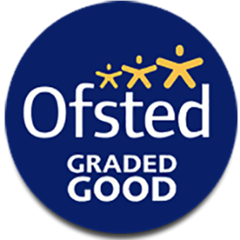
“There is a moral purpose of ensuring that every pupil is developed to be independent and take their place in society.” OFSTED, 2024

Our Core Values
T
Working together with others to reach a shared goal and using everyone's unique strengths to accomplish more together than anyone could alone.
Building confidence, taking responsibility, and making personal choices without constant help.
I

G
Learning new things, understanding your feelings, and practicing kindness to become a more confident and capable version of yourself.
E
understanding and sharing the feelings of another person. It means caring about how someone else feels and showing kindness

Treating others, yourself, and the world around you with kindness, care, and value
R

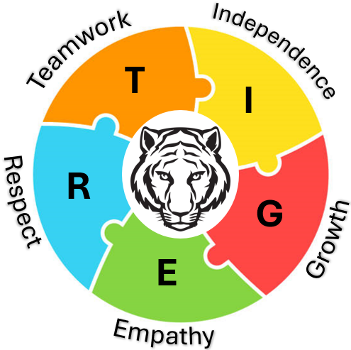

“Staff support pupils to manage their emotions. Pupils and staff build close positive relationships. This helps staff to work with pupils effectively and ensures that the school is a calm place.” OFSTED, 2024

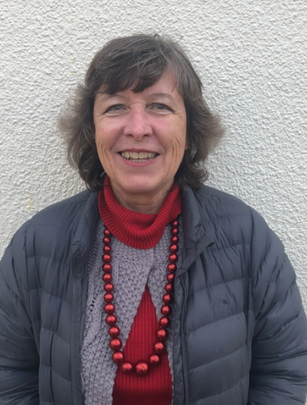
Meet Our Principal
Jennifer Collighan – Principal
Having been in special education working with Looked After Children since 2001, I took the opportunity in 2016 to search for premises to open a new provision. When Clovelly came up for sale, this allowed me to put my vision for a therapeutic school and children’s home in place. Initially, we only took children from the home, but as this grew, we registered for 10 children and started taking day scholars there from 2018.
We obtained a lease for Enderby in 2019 and decided to open a ‘moving on’ division as an annex to Clovelly. This was registered as an exams centre and the 10 pupils admitted to the Enderby site, were encouraged to take up exam routes.
During 2024/25 we have grown further and are now taking pupils on outreach at one of our three off-site provisions based at Nuneaton, Coalville and Oaks in Charnwood. This allows us to continue to provide bespoke adaptive education to additional pupils who struggle with learning in groups. We are very proud of our school, our staff and our children and are pleased to be able to evidence all the good work that we do. Please feel free to book a visit to our school where you will be welcomed.
We look forward to seeing you soon,
Many thanks,
Jennifer Collighan

Our SLT Team

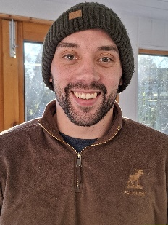
Ethan Hawkins - Head of School at Clovelly & Designated Safeguarding Lead
I am the Head of School at Clovelly House. I have vast experience in management and leadership and have been a teacher since 2017. I specialise in Science and PE and have a passion for ‘out of the box’ and innovative teaching to help engage all students. I am a big believer in giving every student the opportunity to learn, develop and grow both academically and as an individual. The idea of Clovelly House School being more than just a school and more of a ‘family’ is what I aim to deliver.


Neil Robinson – SENCO
I am the SENCO at Clovelly House School, where I have been working for 8 years. I am the art and design teacher and I have been the SENCO for 2 years now and a part of the Senior Leadership team. I play a role in liaising with parents and ensuring that the students’ needs are being met and this involves contacting and working with local authorities as well as arranging and updating EHCP’s. In addition to my role as a SENCO.

Our Curriculum Pathway
Our curriculum is designed specifically to offer a more individualised timetable for all students. This includes a combination of mandatory subjects in addition to an enhanced selection of vocational subjects. We aim to give opportunities to engage all students in projects according to their personal interests and abilities and will be supported to build self-confidence and self-esteem. Therefore, providing an environment for each young person to progress and achieve good outcomes. In addition to our academic subjects, we aim to help all our students on a holistic approach especially with managing their emotions and how to recognise triggers and develop self-regulation. We are extremely accepting of difficult situations, and we try and guide our students through recognising, understanding and managing the choices they make.
Year 7 and 8 Curriculum
Subjects | Year 7 | Year 8
ASDAN English / Beyond English
White Rose Maths
White Rose Science
ASDAN Key Steps
ASDAN Beliefs and Values
Food Technology
Sport
Woodland Therapy
Swimming | Optional | Optional

Year 9 – 13 Curriculum
Subjects | Year 9 | Year 10 | Year 11 | Year 12 | Year 13
ASDAN English / Beyond English
White Rose Maths
White Rose Science
ASDAN Key Steps
ASDAN Beliefs and Values
Food Technology |  | Optional | Optional | Optional | Optional
Sport
Woodland Therapy
GCSE Art
Level 1 Arts Award
Functional Skills English
Functional Skills Maths
GCSE English Language
GCSE English Literature
GCSE Mathematics
GCSE Science Single Science
GCSE Science Triple Science
ASDAN Careers and Experiencing Work
ASDAN Citizenship

Subjects | Year 9 | Year 10 | Year 11 | Year 12 | Year 13
ASDAN Living Independence
ASDAN History | Optional | Optional | Optional | Optional | Optional
ASDAN Sport and Fitness | Optional | Optional | Optional | Optional | Optional
ASDAN Enterprise | Optional | Optional | Optional | Optional | Optional
ASDAN Gardening | Optional | Optional | Optional | Optional | Optional
ASDAN Computing | Optional | Optional | Optional | Optional | Optional
ASDAN FoodWise | Optional | Optional | Optional | Optional | Optional
ASDAN Animal Care | Optional | Optional | Optional | Optional | Optional
ASDAN Football | Optional | Optional | Optional | Optional | Optional
ASDAN Languages | Optional | Optional | Optional | Optional | Optional
ASDAN Expressive Arts | Optional | Optional | Optional | Optional | Optional
ASDAN Land Studies | Optional | Optional | Optional | Optional | Optional
Swimming | Optional | Optional | Optional | Optional | Optional
“Every pupil has a highly bespoke curriculum plan for each subject. This considers their additional needs as well as appropriate strategies to help them to engage with their learning.” OFSTED, 2024

All of our subjects are tailored to meet the needs of our students.
English – In KS3 they build up the skills to move onto Functional Skills or GCSE qualifications. The develop reading, writing and oracy skills covering a broad scope of topics ranging from fictional and non fictional writing through to Shakespeare plays and poems. In KS4, the work is towards Functional Skill awards using online resources and in-depth teaching in group sessions from specialist tutors.
Maths – In KS3 we use White Rose as our teaching base which build up the skills to move onto Functional Skills or GCSE qualifications. We develop the skills and methods required for future academic studies and for social scenarios. In KS4, the work is towards Functional Skill awards using online resources and in-depth teaching in group sessions from specialist tutors.
Science – We have a specialist Science tutor to teach all lessons across both sites. In KS3, we use White Rose as our teaching base to help develop our students into gaining the basic scientific knowledge before entering KS4. In KS4 they focus on an AQA criteria which aims towards a GCSE qualification.

PSHE & Humanities – PSHE is our chance to cover important topics such as physical and mental health, growing and changing, personal safety (both physical and online), relationships and sex education, bullying and discrimination, money and careers. In humanities, we cover a vast range of topics from different cultures and religions, History, Geography and look deeper into world events, human beliefs and values.
“Most teachers have good subject knowledge and present information in a way that does not overload pupils” OFSTED, 2024

Sport – We have Sport specialist tutors at hand to deliver a range of difference sport and exercises which help to develop teamwork, confidence, motor skills such as fundamental movement skills and promote a healthy lifestyle.
Woodland – Our students have access to a woodland area in the local vicinity where they get to work together to develop important woodland skills such as building fires, cooking basic food and woodland reservation.
Food Technology – We offer our students the opportunity to learn about food safety and hygiene. To research recipes including ingredients required, method and allow them to make the dishes or snacks they are interested in.
Typical school day
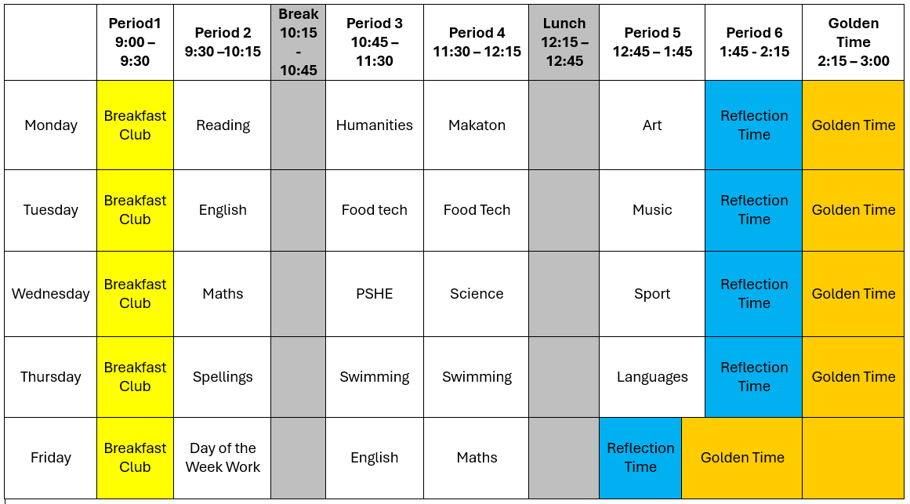
Our school hours are primarily 9am – 3pm, Monday to Thursday. Fridays are 9am – 2pm. Every student within our school have their own individualised timetable, an example of this is shown below

Safeguarding and Pastoral team

Neil Robinson
Deputy DSL
Jennifer Collighan
DSL
Ethan Hawkins
DSL

Here at Clovelly House School, safeguarding and keeping our students safe is at the centre of everything of everything we do. We have a strong Senior Leadership Team who manage all the safeguarding, welfare and attendance. We use various internal systems to log and monitor all key areas that can affect our students mental and physical well-being, and these are regularly collated and discussed within the safeguarding team meetings. As a school, we work closely with students and parents effectively to overcome any incidents or concerns. We also offer internal counselling on a weekly basis to all our students and have strong links with external support when required. Due to our increasing sense of belonging within our school, our students feel safe and supported enough to approach members of our staff with any problems they may be experiencing and with our tiered safeguarding team this enables effective results.
SEND and Inclusion
Neil Robinson
SENCO

Our SEND and inclusion team at Clovelly, are committed to ensuring that all our students can feel safe, accepted and supported throughout their learning journey with us. Our SENCO and Junior SENCO, utilise the EHCP’s regularly to ensure that every student has their own personal targets to meet and be reviewed every term. Our SEND also liaises effectively with external agencies such as the local authorities to ensure that our students needs are being met effectively. We try to support our students not just academically but also on a personal level helping our staff to teach our students holistically.

How to Apply
As a school, we can take up to a maximum of 20 students aged 10-19 across both sites (10 students per site). Each one of our students require an up-to-date Educational Health Care Plan (EHCP) upon application. Careful matching is then done to ensure that new students fit the profile of our school and will not disrupt the current students on roll or the smooth running of the school setting.
Referrals for our school come via the local authorities and the Senior Leadership team will consider whether the school will be able to provide an appropriate place for each student. If SLT believe that we can meet need and offer a place, the local authority is informed, and they make the final decision on the placement.
We recommend that if your EHCP is accepted that you come to visit our unique school via the details below.

Contact Us
CLOVELLY HOUSE SCHOOL (ENDERBY)
tHE BUNGALOW
MILL LANE
ENDERBY
LEICESTERSHIRE
LE19 4LG

Tel. 01455821253
CLOVELLY HOUSE SCHOOL (MAIN SITE)
cLOVELLY HOUSE SCHOOL
MERRYLEES ROAD
COALVILLE
LEICESTERSHIRE
LE67 1AP
Email. office@clovellyhouse.co
Principal: JCollighan@Clovellyhouse.co
Head of Clovelly: Schoolhead@Clovellyhouse.co

