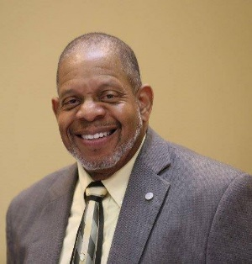The Reverend Dr. E. Alan Benson is Pastor of the St. Paul United Methodist Church of Georgetown, TX and also serves as a Clinical Chaplain for the Department of Veterans Affairs. Pastor Benson cares deeply about the personal and spiritual needs of people seeking to live the best life possible. He believes that Christians are called to “be the salt of the Earth” and his ministerial mission focuses on activating positive change because of the change Jesus Christ made in us. Dr. Benson accepts Jesus’ call to love our neighbors and therefore actively supports Peace and Justice initiatives in his community. Pastor Benson consistently reaches out to mentor and offer opportunities for persons sincerely desiring to serve their ministerial calling. He feels his participation in the Kingdom Men Ministries affords him the opportunity to expand upon his calling to mentor others.

Dr. Benson and his wife, Sis. Ora, provide care and counsel about life, love, and relationships to individuals and couples in these challenging times. Pastor Benson earned his Doctor of Ministry (D.Min.) Christian Nurture from Austin Presbyterian Theological Seminary and the Masters of Divinity (M.Div.) in Pastoral Theology & Pastoral Counseling from Brite Divinity School of Texas Christian University.

Dr. Benson authored Brand New Lives and The Cathedral Curriculum, a Biblically based Workshop for helping women escape the Cycles of Intimate Partner Violence to establish new lives free of Domestic Violence.