

Feb. 27 to March 1, 2026

To Whom It May Concern:

This letter is to inform you that _________________________, has the permission from his parent(s) to be excused from school from Friday, Feb. 27, to travel to Kelowna, BC. for a Club Volleyball tournament with his team. This is to inform you of the trip and if you could provide him with homework if you need to. They will be traveling by private vehicles to Kelowna.
Any questions, please feel free to contact her club coach Wayne Wong at 1-604-649-5338 or the coach at 604-339-1537.

Signed Signed
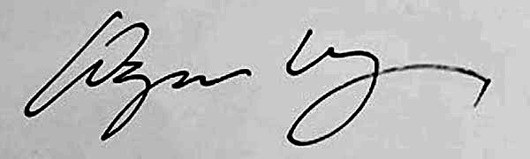 TZ

W.K.C. Wong Tiffany Zhou
President and Director Club Coach

I, Guardian or Parent of ___________________________ allow my daughter to miss school on Friday Feb. 27/26

Please allow him to miss your class.

Parent Name (Print): ______________________________

Parent Signature__________________________________ Date: _____________________

Period 1, ____________ Teacher signature: ________________________________

Period 2, ____________ Teacher signature: ________________________________

Period 3, ____________ Teacher signature: ________________________________

Period 4, ____________ Teacher signature: ________________________________

