Get Your HDTV Digital Antenna System
3.1 – CBS (KIMT) Mason City | 15.1 – PBS (KSMQ) Austin
3.2 – My 3.2 TV Mason City | 15.2 – PBS (KSMQ) Austin
3.3 – ION TV – Blue Bloods, Law & Order Etc. | 15.3 – PBS (KSMQ) Austin
3.4 – Antenna TV - TV How It Was Meant to Be – McHale’s Navy, Bewitched Etc. | 15.4 – PBS (KSMQ) Austin
6.1 – ABC (KAAL) Austin | 24.1 – IPTV1 (KYIN) Mason City
6.2 – THIS - TV Movies & HS Sports | 24.2 – IPTV2 (KYIN) Mason City
10.1 – NBC (KTTC) Rochester  10.2 – The CW (CW) Rochester | 24.3 – IPTV3 (KYIN) Mason City  24.4 – IPTV4 (KYIN) Mason City
10.3 – HandI - Heroes & Icons TV | 47.1 – FOX (KXLT) Rochester
10.4 – Court TV - Focus on crime-themed programs such as true crime documentary series, legal dramas, and coverage of prominent criminal cases  10.5 – Justice - Justice Network is a new first-of-its-kind multicast television network airing entertaining crime programming and making communities safer. | 47.2 – MeTV – Classic TV Shows  47.3 – Laff TV - Shows like Ellen, Spin City, Drew Carey Show and classic comedy movies.  47.4 – Escape - Movies & Series that are daring, sexy and anchored in stories of crime & mystery  47.5 – Quest - Provides factual, lifestyle, entertainment and other imported material
Purchase a system for $399.00 + tax Installed.
Lease to own Antenna System for $50 down & just $8.34/mo.
(Flexible Lease Billing: $25 every 3 months --or-- $48 every 6 months --or-- Annually - $95)You own the antenna after 60 months!!!
ADD TIVO BOLT OTA VOX DVR - $249.00
TiVo BOLT OTA VOX 1 TB DVR - Monthly Service Fees – 6.99 mo. Digital Video Recorder and Streaming Media Player* - Compatible only with HDTV Antennas

Advanced control features you can’t get with cable or satellite.
Using an HD antenna shouldn’t require you to sacrifice features or variety. That’s why Roamio OTA is packed with the most advanced control features TiVo has to offer—like SkipMode, QuickMode and OneSearch—but it also delivers must-have conveniences like a two-week program guide, the ability to Record four shows at once, and watch-and-control mobile capabilities. Get a premium experience at a cost you can afford.
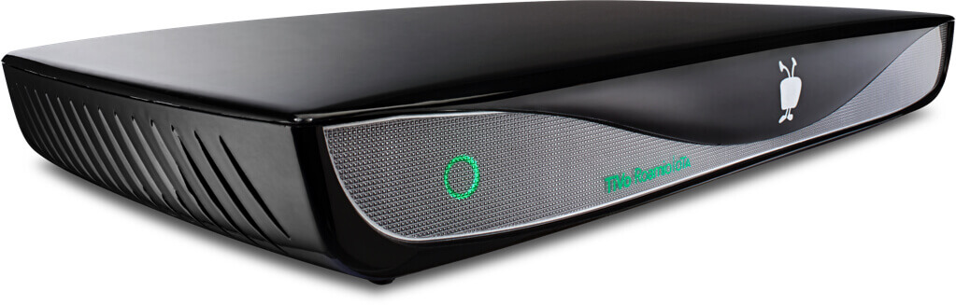
Purchase both TIVO DVR & Antenna System for $649.00
ADD TIVO Minis for multiple TVs
Access your TiVo DVR from any TV in your home by simply attaching a TiVo Mini VOX. It’s small, fast, 4K and requires no additional TiVO service fees!
$179.99 each (Service Included)
*Requires Broadband Internet Connection for streaming content.

