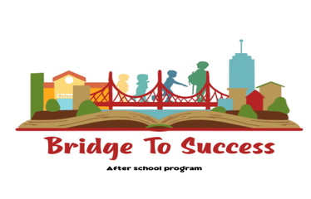 Enrollment Form

1st Child’s name: _____________________________________________________
Grade ____Birth _________
Does this child have an IFSP/IEP? Yes No
*If yes, please provide a copy of the plan so that we can support your child’s unique needs.

2nd Child’s name: ____________________________________________________
Grade ___Birth __________
Does this child have an IFSP/IEP? Yes No
*If yes, please provide a copy of the plan so that we can support your child’s unique needs.

3rd Child’s name: ____________________________________________________
Grade ____Birth _________
Does this child have an IFSP/IEP? Yes No
*If yes, please provide a copy of the plan so that we can support your child’s unique needs.

Parent/Guardian: ____________________________________________________________

Address: ___________________________________________________________

City ______________________________________State ____________________

Phone: _________________________(c) ______________________________(w)

Email: _____________________________________________________________

Parent/Guardian: ____________________________________________________________

Address: ___________________________________________________________

City ______________________________________State ____________________

Phone: _________________________(c) ______________________________(w)

Email: _____________________________________________________________

Please circle days student will attend:
Monday Tuesday Wednesday Thursday Friday
Please list time student will be picked up on Wednesday (early release day): _____________

*Providing a copy of your child’s educational program/plan helps our staff better accommodate their needs. Please review our inclusion policy as we have listed possible interventions to be implemented based on the students’ specific needs. Bridge To Success program welcomes all children and families, regardless of race, color, religion, national origin, gender, disability, or any other characteristic protected by law. We are committed to providing a safe, inclusive, and supportive environment where every child can thrive and participate fully in our activities. We celebrate diversity and believe that every child has the right to equal access to our program and resources.

