2022 Autumn Eagles/Knights
Soccer and Multi-Sports Camps

2022 Autumn Boys/Girls Ages: 4 – 14 www.eaglesknights.com

November 10th & 11th Eagles/Knights Soccer Camp

Eagles/Knights Multi-Sports Camp

Location: Morris Knolls High School Time: 9:00 am – 12:00 noon

Soccer Camp: This camp offers a challenging atmosphere for every soccer player while striving to enhance all aspects of their game. We provide a safe environment for learning with fun and improvements being our ultimate goal.

Multi-Sports Camp: Sports to be played, but not limited to the following:
Soccer, Flag-Football, Baseball, Softball, Tennis, Basketball, Volley-Ball, Pickle-Ball, Street Hockey, Wiffle-Ball, Frisbee, Kick-Ball, Bocce, Dodgeball, GaGa, Cornhole, 4-Square, Track & Field, etc.

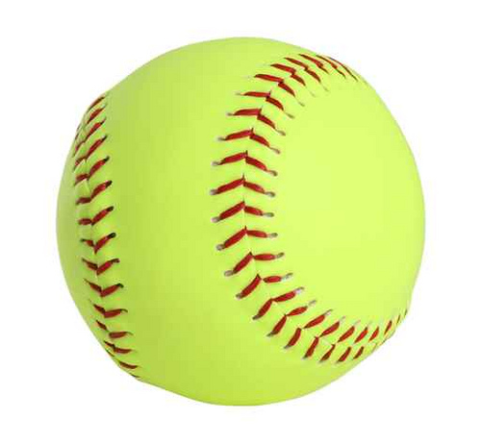 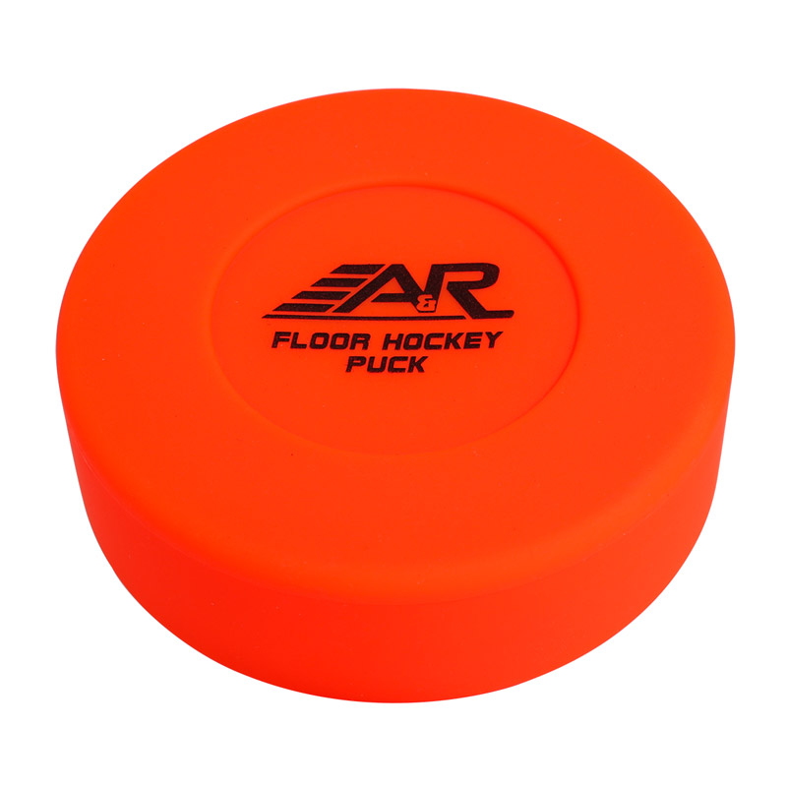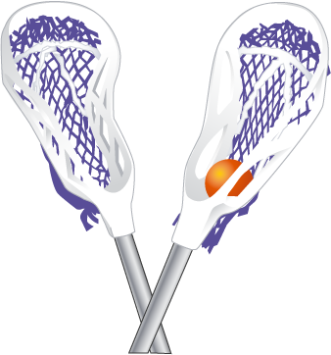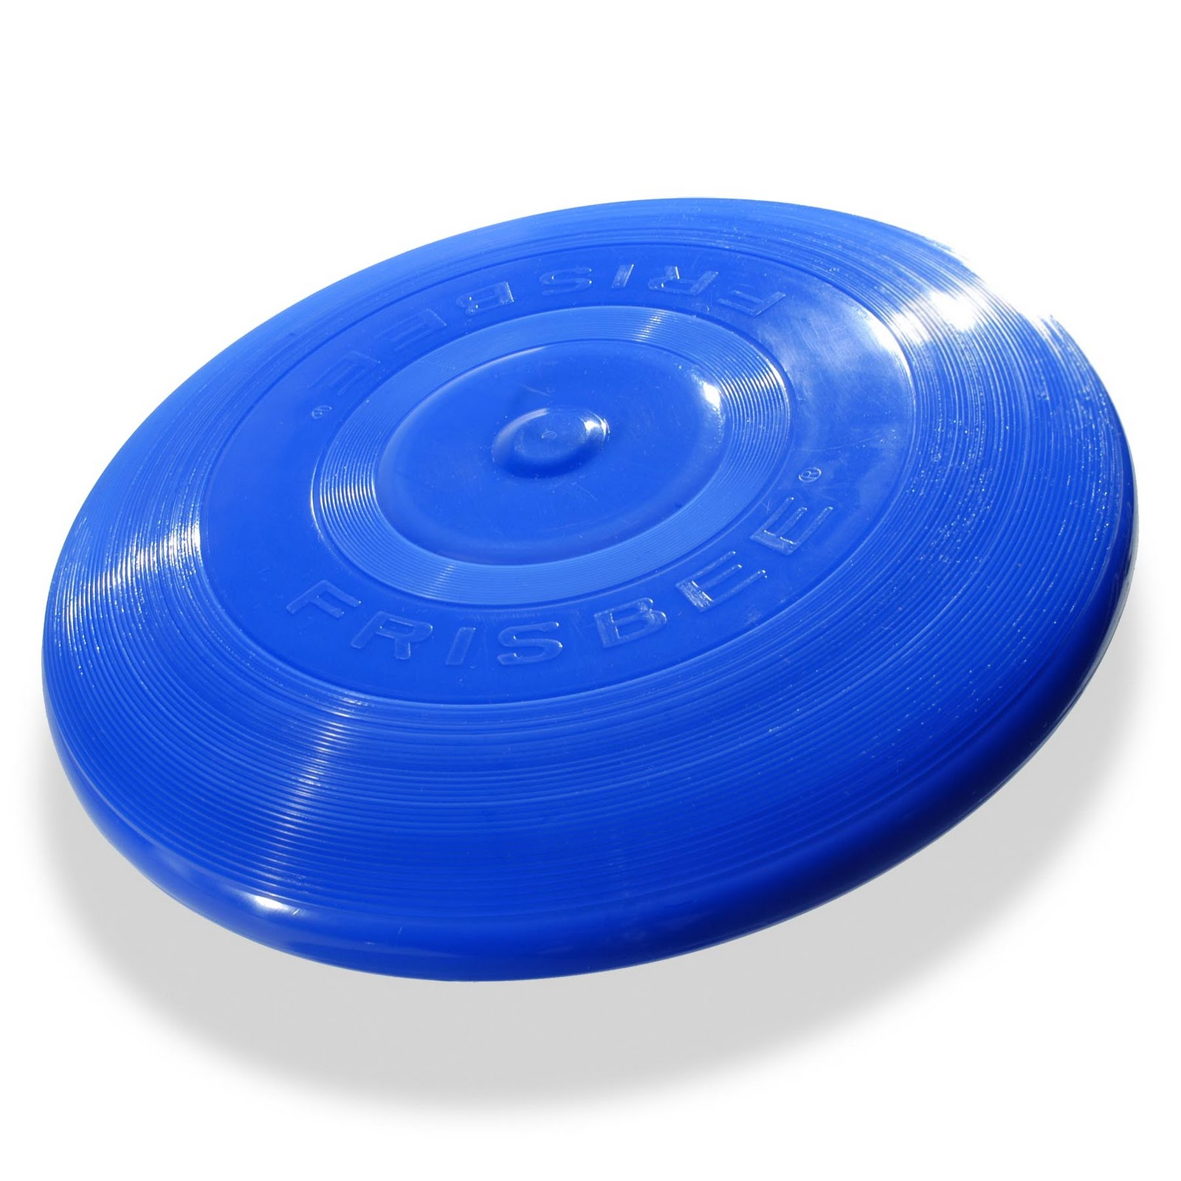
Camp Director: Mike Mugavero
Presently the Varsity Boys Soccer Coach and Varsity Boys Tennis Coach at Morris Knolls High School.
Send signed Registration Form and Checks payable to: “United Sports” 19 George Street Denville NJ 07834

Questions? Call/E-mail - Mike Mugavero 201-213-5229 mmugavero@hotmail.com

www.eaglesknights.com to register or use form below:

-------------------------------------------------------(Please detach & return for Camp)----------------------------------------

Circle option: Soccer Camp or Multi-Sports Camp

Circle option: 1-Day $45 2-Days $75

Age:___________ Boy/Girl (circle)
Name:___________________________________________
Address:__________________________________________
Town:______________________________ Zip:_________
Phone:________________ Emergency #_______________
Email:____________________________________________

Please list any and all medications, allergies, or misc. physical disabilities which we should be aware of: (more space – back)

I give my child/ward
______________________________________ permission to participate in the above activity (sports camp). I understand that the activity will be supervised and the Denville Township, Morris Knolls and United Soccer. Does not insure own risk. It is understood that this program is a physical activity and various injuries may occur. I also understand it is my responsibility to make sure the restraint is physically capable of participating in this program and a physical exam by a doctor is recommended.
I verify that the above stated address is the permanent residence of the above named restraint and that all the information stated above is, to the best of my knowledge, true and correct. Any intentional falsifying of information will result in automatic expulsion of my child/ward from the program and possible prosecution. I agree to abide by all rules, regulations, and policies as set forth by the Department of Parks and Recreation, the Recreation Committee, and the specific Sports Program Committee.

________________________________________________ (Parent/Guardian Signature) www.eaglesknights.com

