Summer 2022 Eagles/Knights
Soccer and Multi-Sports Camp

2022 Summer Boys/Girls Ages: 4 – 14 www.eaglesknights.com




Weeks: (1) June 27 – July 1


(2) July 4 – July 8

(3) July 11 – July 15



(4) July 18 – July 22


(5) July 25 – July 29

(6) Aug 1 – Aug 5



(7) Aug 15 – Aug 18 (HS Soccer Camp)

(8) Aug 22 – Aug 25 (Travel Team Camp)

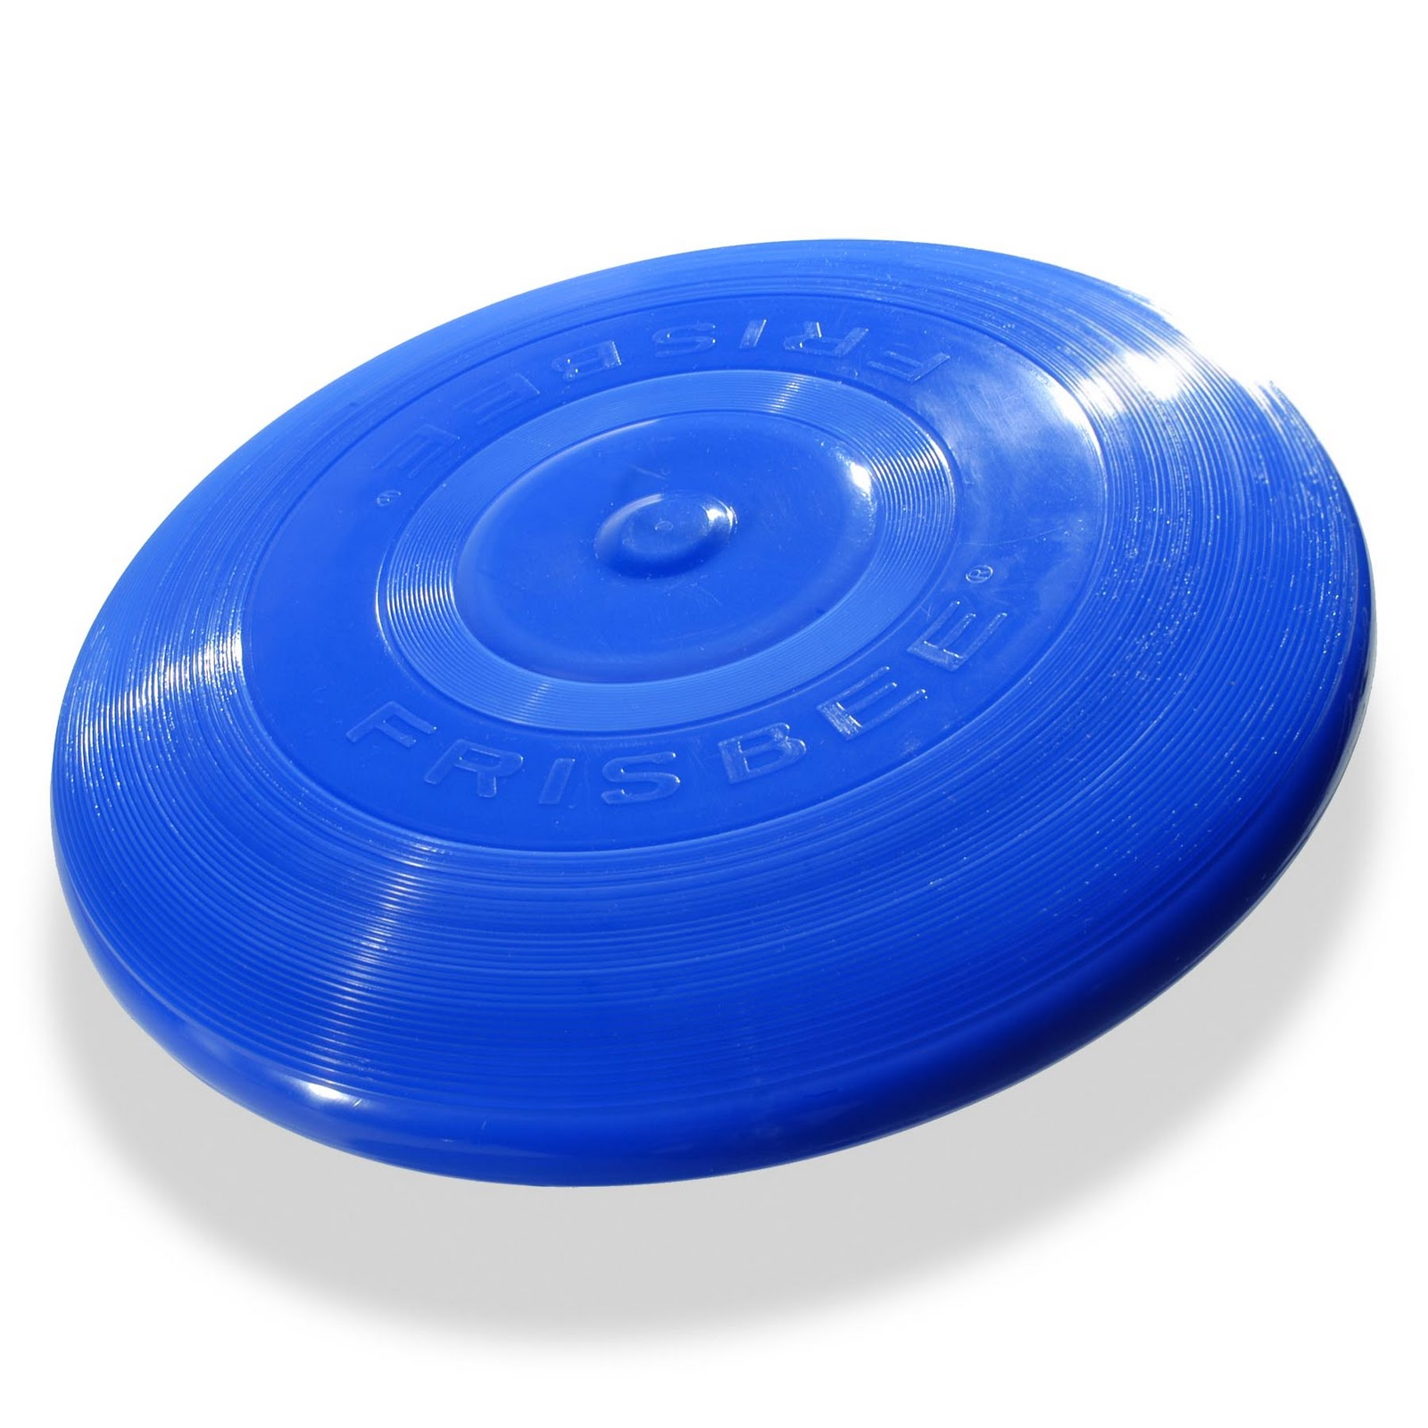
Location: Morris Knolls High School

Full Day (Mon-Fri) (9:00am – 3:00pm) $195

Half-Day(Mon-Fri) (9:00am – Noon) $160

HS (Mon-Thur) (8:00am – Noon) $160

Travel (Mon-Thur) (5:30pm - 8:30pm) $140

(Prorated days and times offered -email/call)

Soccer Camp: This camp offers a challenging atmosphere for every soccer player while striving to enhance all aspects of their game. We provide a safe environment for learning with fun and improvements being our ultimate goal.

Multi-Sports Camp: Sports to be played, but not limited to the following:
Soccer, Flag-Football, Baseball, Softball, Tennis, Basketball, Volley-Ball, Pickle-Ball, Street Hockey, Wiffle-Ball, Frisbee, Kick-Ball, Ga-Ga, Bocce, Croquet, Badminton, Cornhole, 4-Square, Track & Field, etc.

Camp Director: Mike Mugavero
Presently the Varsity Boys Soccer Coach at Morris Knolls High School. Earned “Coach of the Year” Morris County, NJAC Conference, and NJ High School State in 2018. As coach, Morris Knolls won the North 1 Group 4 State Championship in 2018. He was an All-State Player at Morris Knolls in the 1980s.
He played Division I Soccer at the University of Massachusetts and coached Division I at Stetson University. He has his USSF “C” and NSCAA “National” Licenses and has coached ODP. He also played Professionally in the USISL for the Orlando Lions. Coach Mugavero coached a Morris Knolls player who earned “USC ALL – American” & NJ High School “Player of the Year” Honors in 2017 & 2018
Send signed Registration Form and Checks payable to: “United Sports” 19 George Street Denville NJ 07834

Questions? Call/E-mail - Mike Mugavero 201-213-5229 mmugavero@hotmail.com

www.eaglesknights.com to register or use form below:

-------------------------------------------------------(Please detach & return for Camp)----------------------------------------

2022 Eagles/Knights Soccer and Multi-Sports Camp

Circle option: Soccer Camp or Multi-Sports Camp or HS Camp or Travel Camp

Circle option: Full Week ($195) or Half-day Week ($160)

HS Camp ($160) or Travel ($140)

Circle Options:
- June 27th - July 1st
- July 4th – July 8th
- July 11th – July 15th
- July 18th – July 22nd
- July 25th – July 29th
- Aug 1st – Aug 5th
- Aug 15th – Aug 18th (HS Soccer Camp)
- Aug 22nd – Aug 25th (Travel Team Soccer Camp)

Age:___________ Boy/Girl (circle)
Name:___________________________________________
Address:__________________________________________
Town:______________________________ Zip:_________
Phone:________________ Emergency #_______________
Email:____________________________________________

Please list any and all medications, allergies, or misc. physical disabilities which we should be aware of: (more space – back)

___________________________________________________________________________________________________________________________

I give my child/ward
______________________________________ permission to participate in the above activity (sports camp). I understand that the activity will be supervised and the Denville Township, Morris Knolls and United Soccer. Does not insure own risk. It is understood that this program is a physical activity and various injuries may occur. I also understand it is my responsibility to make sure the restraint is physically capable of participating in this program and a physical exam by a doctor is recommended.
I verify that the above stated address is the permanent residence of the above named registered and that all the information stated above is, to the best of my knowledge, true and correct. Any intentional falsifying of information will result in automatic expulsion of my child/ward from the program and possible prosecution. I agree to abide by all rules, regulations, and policies as set forth by the Department of Parks and Recreation, the Recreation Committee, and the specific Sports Program Committee.

________________________________________________ (Parent/Guardian Signature) www.eaglesknights.com

