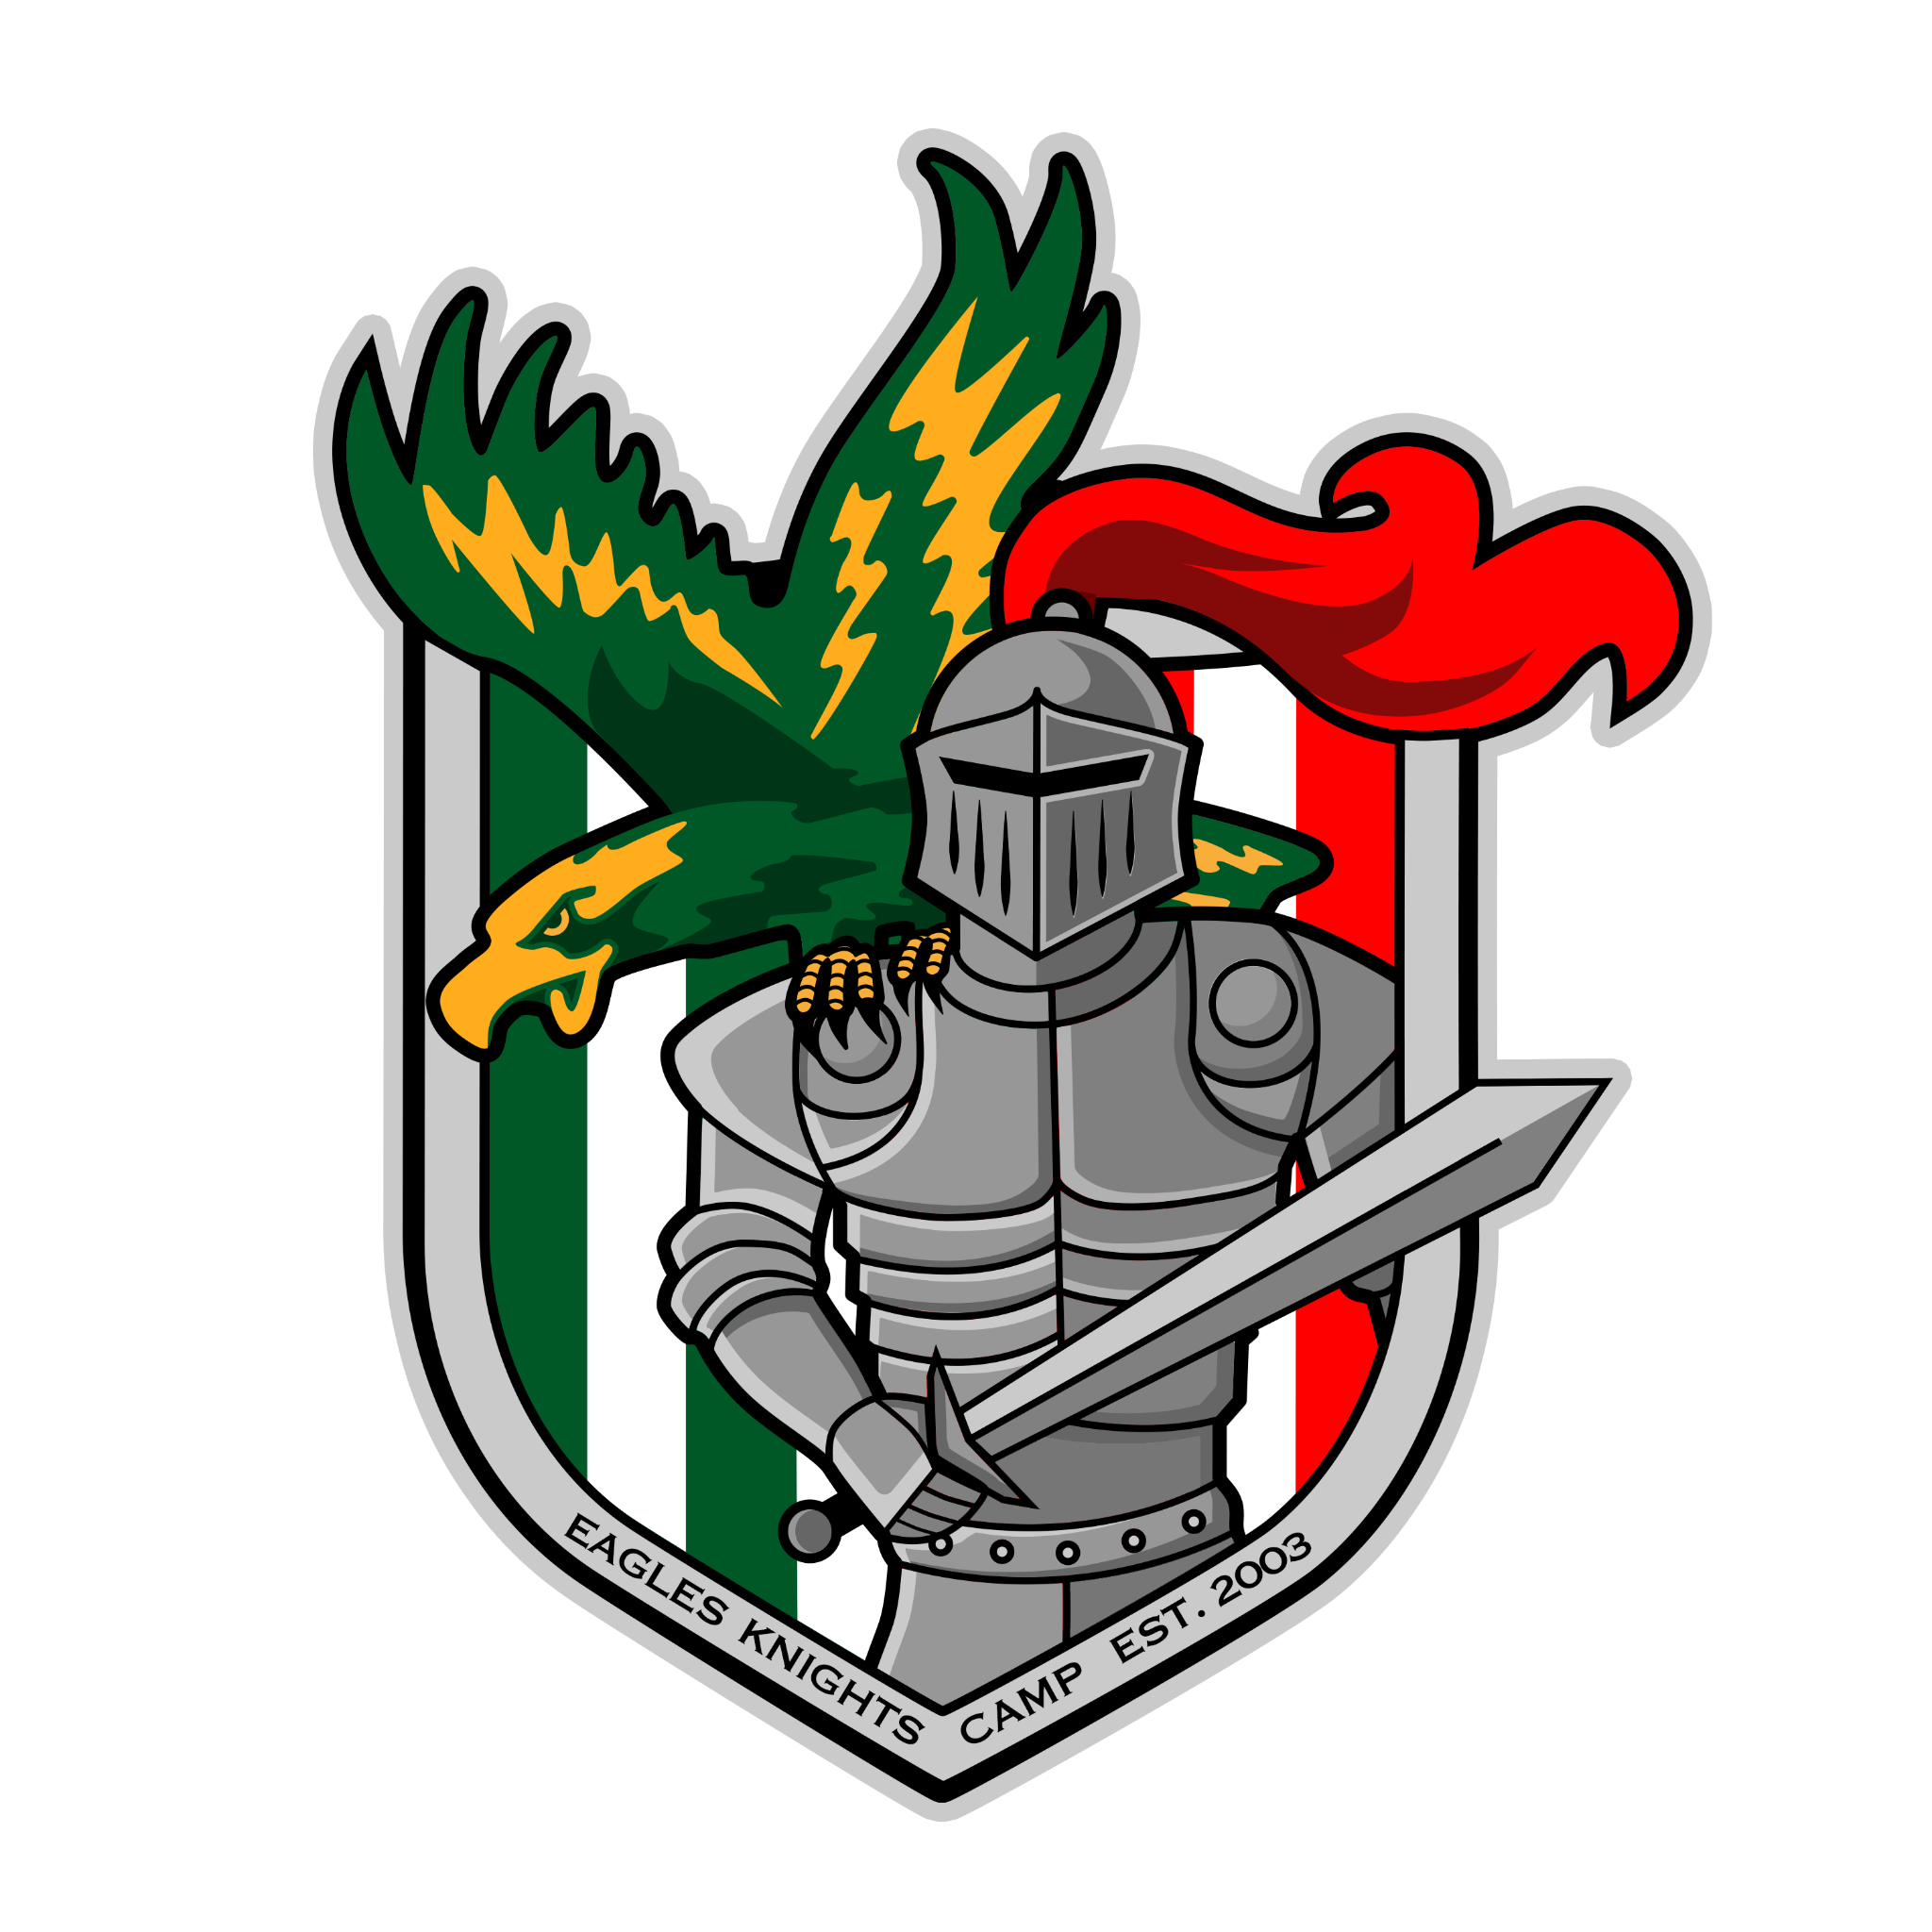
Summer 2026 Eagles/Knights
Soccer and/or Multi-Sports Camps
2026 Summer Boys/Girls Ages: 4 – 14 www.eaglesknights.com




Weeks: (1) June 29 - July 2

(2) July 6 - July 9
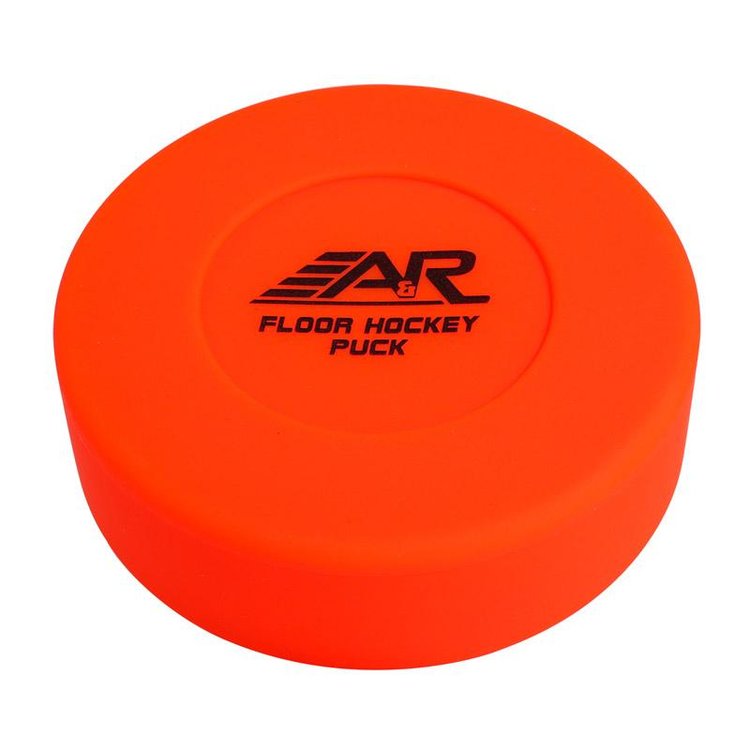
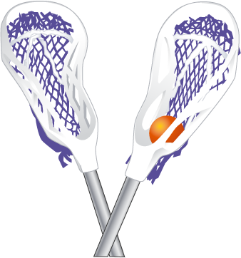
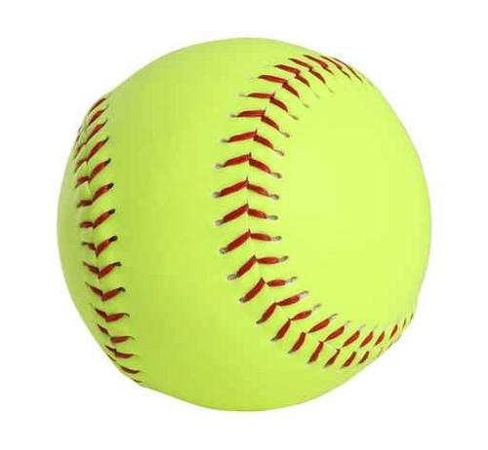
(3) July 13 - July 16
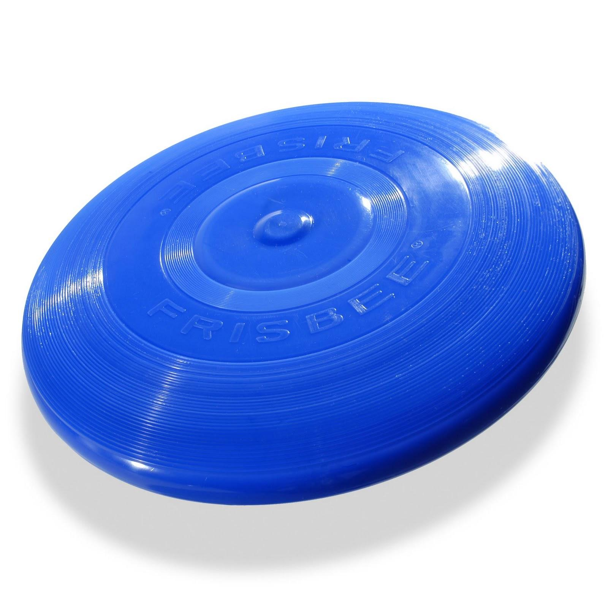

(4) July 20 - July 23
(5) July 27 - July 30
(6) Aug 3 - Aug 6

(7) Aug 10 - Aug 13
(8) Aug 17 - Aug 20

Location: Morris Knolls High School

Full Day (Mon-Thu) (9:00am – 2:00pm) ($200)
Half-Day (Mon-Thu) (9:00am – Noon) ($140)
Pre care: 8:00am - 9:00am - ($40)

**Prorated days (Drop-ins) and times offered - email/call**

Soccer Camp: This camp offers a challenging atmosphere for every soccer player while striving to enhance all aspects of their game. We provide a safe environment for learning with fun and improvements being our ultimate goal.

Multi-Sports Camp: Sports to be played, but not limited to the following:
Soccer, Flag-Football, Baseball, Softball, Tennis, Basketball, Volley-Ball, Pickle-Ball, Street Hockey, Wiffle-Ball, Frisbee, Kick-Ball, Ga-Ga, Bocce, Croquet, Badminton, Cornhole, 4-Square, Track & Field, etc.

Camp Director: Mike Mugavero
Presently the Varsity Boys Soccer Coach at Morris Knolls High School. Earned “Coach of the Year” Morris County, NJAC Conference, and NJ High School State in 2018. As coach, Morris Knolls won the North 1 Group 4 State Championship in 2018. He was an All-State Player at Morris Knolls in the 1980s.
He played Division I Soccer at the University of Massachusetts and coached Division I at Stetson University. He has his USSF “C” and NSCAA “National” Licenses and has coached ODP. He also played professionally in the USISL for the Orlando Lions. Coach Mugavero coached a Morris Knolls player who earned “USC ALL – American” & NJ High School “Player of the Year” Honors in 2017 & 2018
Send signed Registration Form and Checks payable to: “United Sports” 19 George Street Denville NJ 07834

Questions? Call/E-mail - Mike Mugavero 201-213-5229 mmugavero@hotmail.com

www.eaglesknights.com to register or use form below:

-------------------------------------------------------(Please detach & return for Camp)----------------------------------------

2026 Eagles/Knights Soccer and/or Multi-Sports Camp

Circle option: Soccer Camp or Multi-Sports Camp

Circle option: Full Week ($200) or Half-day Week ($120)

Circle Options:
- June 29 - July 2
- July 6 - July 9
- July 13 - July 16
- July 20 - July 23
- July 27 - July 30
- Aug 3 - Aug 6
- Aug 10 - Aug 13
- Aug 17 - Aug 20

Age:___________ Boy/Girl (circle)
Name:___________________________________________
Address:__________________________________________
Town:______________________________ Zip:_________
Phone:________________ Emergency #_______________
Email:____________________________________________

Please list any and all medications, allergies, or misc. physical disabilities which we should be aware of: (more space – back)

___________________________________________________________________________________________________________________________

I give my child/ward
______________________________________ permission to participate in the above activity (sports camp). I understand that the activity will be supervised and the Denville Township, Morris Knolls and United Soccer. Does not insure own risk. It is understood that this program is a physical activity and various injuries may occur. I also understand it is my responsibility to make sure the restraint is physically capable of participating in this program and a physical exam by a doctor is recommended.
I verify that the above stated address is the permanent residence of the above named registered and that all the information stated above is, to the best of my knowledge, true and correct. Any intentional falsifying of information will result in automatic expulsion of my child/ward from the program and possible prosecution. I agree to abide by all rules, regulations, and policies as set forth by the Department of Parks and Recreation, the Recreation Committee, and the specific Sports Program Committee.

________________________________________________ (Parent/Guardian Signature) www.eaglesknights.com

