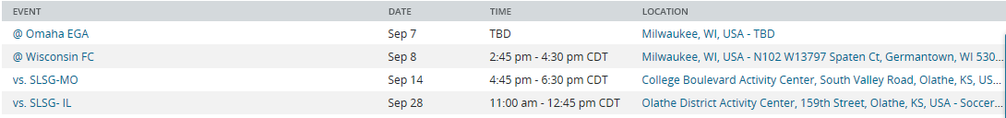
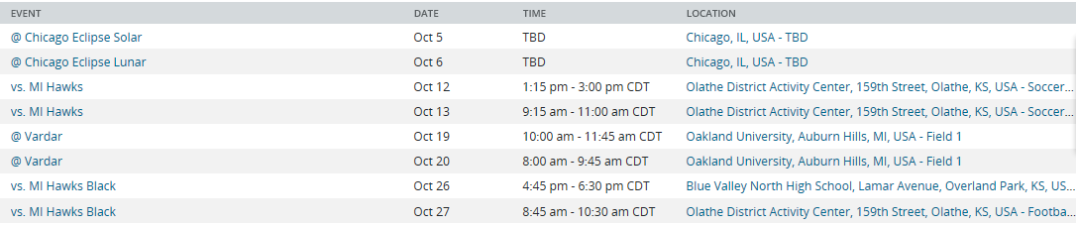
2021 KC Athletics ECNL 2003 #6 Forward/Mid

