**Delta Quilters Guild**

**2025-2026**

**Affiliate Membership**

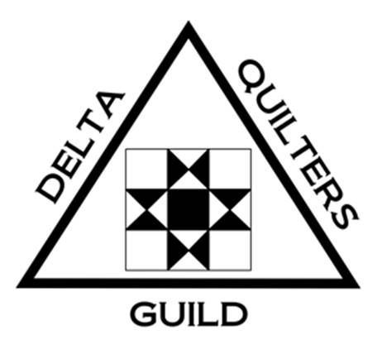

Delta Quilters Guild encompasses East Contra Costa County, with 130 current members representing communities from Concord and Martinez to Bethel Island and Discovery Bay. Our members share a love for the art of quilting as well as other fabric arts. They enjoy sharing their

expertise, resources, and of course, useful information about businesses related to their quilting!

We invite you to become an Affiliate Member of Delta Quilters so our members can recognize you as a supporter of their guild.

Affiliate Members will receive the benefit of business recognition through a business card (or other business card size ad) included in three forms of communication with all members:

* **Roster of members** that includes all current members

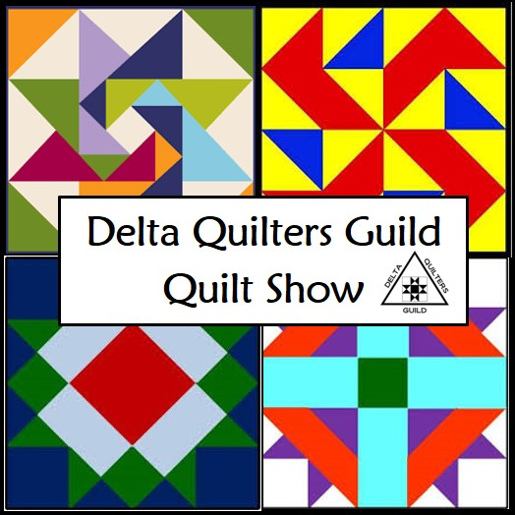

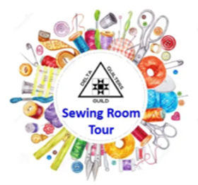

* **Guild Website** with a direct link to your business
* **Monthly Newsletter** emailed to all guild members and affiliates

Submit shows / classes by the 15th of each month to be published

in next newsletter. It needs to be a very brief description.

For example: Delta Quilters Guild Show August 9-10, 2025

In addition to this ongoing communication with all members,

Affiliate Members receive other benefits:

* **Sewing Room Tour** – Free space to demonstrate topic

of your choice and to be a Vendor

Annual Affiliate Membership is $20 for the benefits mentioned above. We hope you will join us and look forward to building a relationship between guild members and our local businesses to work together. Our membership drive is May 1st through June 18th. Please find an application form attached.

We hope to hear from you!

Sincerely,

*Delta Quilters Guild*