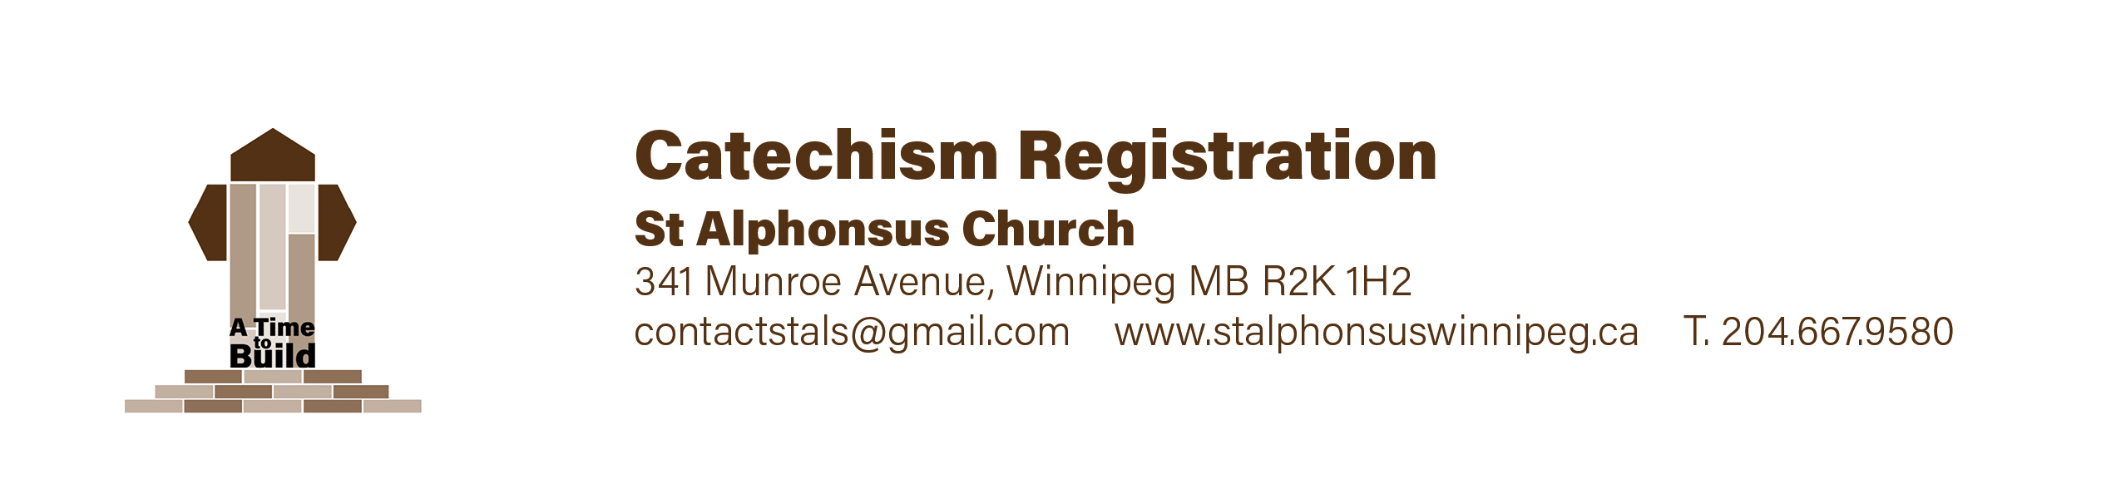
August 2023,

Dear Parents and Students,

Rejoice in the Lord always! Again I say rejoice! (Phil. 4:4)
I hope that you enjoyed the summer break! Soon catechism begins a new season.
See below for the schedule and other details.

SCHEDULE: Catechism begins Saturday, September 23 and concludes May 11, 2024.
Catechism is held at our school between 10 a.m. and 11:15 am each Saturday morning.
(Please note that if your child attends our school, then they do not have to attend the Saturday catechism).

LEVELS: From grade one to grade six. (Grade one is homeschool).
We also accept grade seven and eight students if they have not yet been confirmed.

SACRAMENTS: It is required that your child have completed two years of catechism before they can receive either First Communion or Confirmation. First Reconciliation takes place during grade two and First Communion takes place the following year (usually in grade three). Confirmation usually takes place during grade six.
Please speak with myself, Fr. Greg, if you are not sure and need some clarity.

I GIVE YOU MY JOY, SO THAT YOUR JOY BE COMPLETE (John 15.11).
Jesus offers your family joy! But remember that this requires discipline.
Please pray and reflect on the commitment you need to make such that God’s Spirit works in your lives. Please come to Mass with your children Sunday by Sunday…and pray at home with them. Catechism will not strengthen your child’s faith unless you are praying with them both at home and at church.

Sincerely in our Lord Jesus Christ,
Fr. Greg Mulligan,
Pastor 204 782 3135

St. Alphonsus Catechism Program Calendar 2023-2024

September 2023
23 | Catechism Begins | 10:00 – 11:30 am | School
30 | Catechism | 10:00 – 11:30 am | School

October 2023
7  14 | NO CLASSES – THANKSGIVING WEEKEND  Catechism | ---------------------  10:00 – 11:30 am | School
21 | Catechism | 10:00 – 11:30 am | School
28 | Catechism | 10:00 – 11:30 am | School

November 2023
4 | Catechism | 10:00 – 11:30 am | School
11 | NO CLASSES – REMEMBRANCE DAY LONGWEEKEND | ---------------------
18 | Catechism | 10:00 – 11:30 am | School
25 | Catechism | 10:00 – 11:30 am | School

December 2023
2 | Catechism | 10:00 – 11:30 am | School
9  16 | Catechism  Catechism plus potluck | 10:00 – 11:30 am  10:00 – 12:30 am | School  School/Hall
23 | NO CLASSES Today UNTIL JAN. 6 – Christmas Break | ---------------------

January 2024
6 | Catechism | 10:00 – 11:30 am | School
13 | Catechism | 10:00 – 11:30 am | School
20  27 | Catechism  Catechism | 10:00 – 11:30 am | School

February 2024
3 | Catechism | 10:00 – 11:30 am | School
10 | Catechism | 10:00 – 11:30 am | School
17 | NO CLASSES – LOUIS RIEL WEEKEND | ----------------
24 | Catechism | 10:00 – 11:30 am | School

March 2024
2 | Catechism | 10:00 – 11:30 am | School
9 | Catechism | 10:00 – 11:30 am | School
16 | Catechism | 10:00 – 11:30 am | School
23  29  30 | NO CLASSES – SPRING BREAK  Good Friday - Stations of the Cross for families  NO CLASSES – Holy Saturday | ------------------  11 am  ------------------ | Church

April 2024
6 | Catechism | 10:00 – 11:30 am | School
13 | Catechism | 10:00 – 11:30 am | School
20 | Catechism | 10:00 – 11:30 am | School
27 | Catechism | 10:00 – 11:30 am | School

May 2024
4 | Catechism | 10:00 – 11:30 am | School
11 | Catechism – Last Class plus pizza & fun ! | 10:00 – 12:30 am | School/Hall
18 | VICTORIA DAY WEEKEND | ------------------

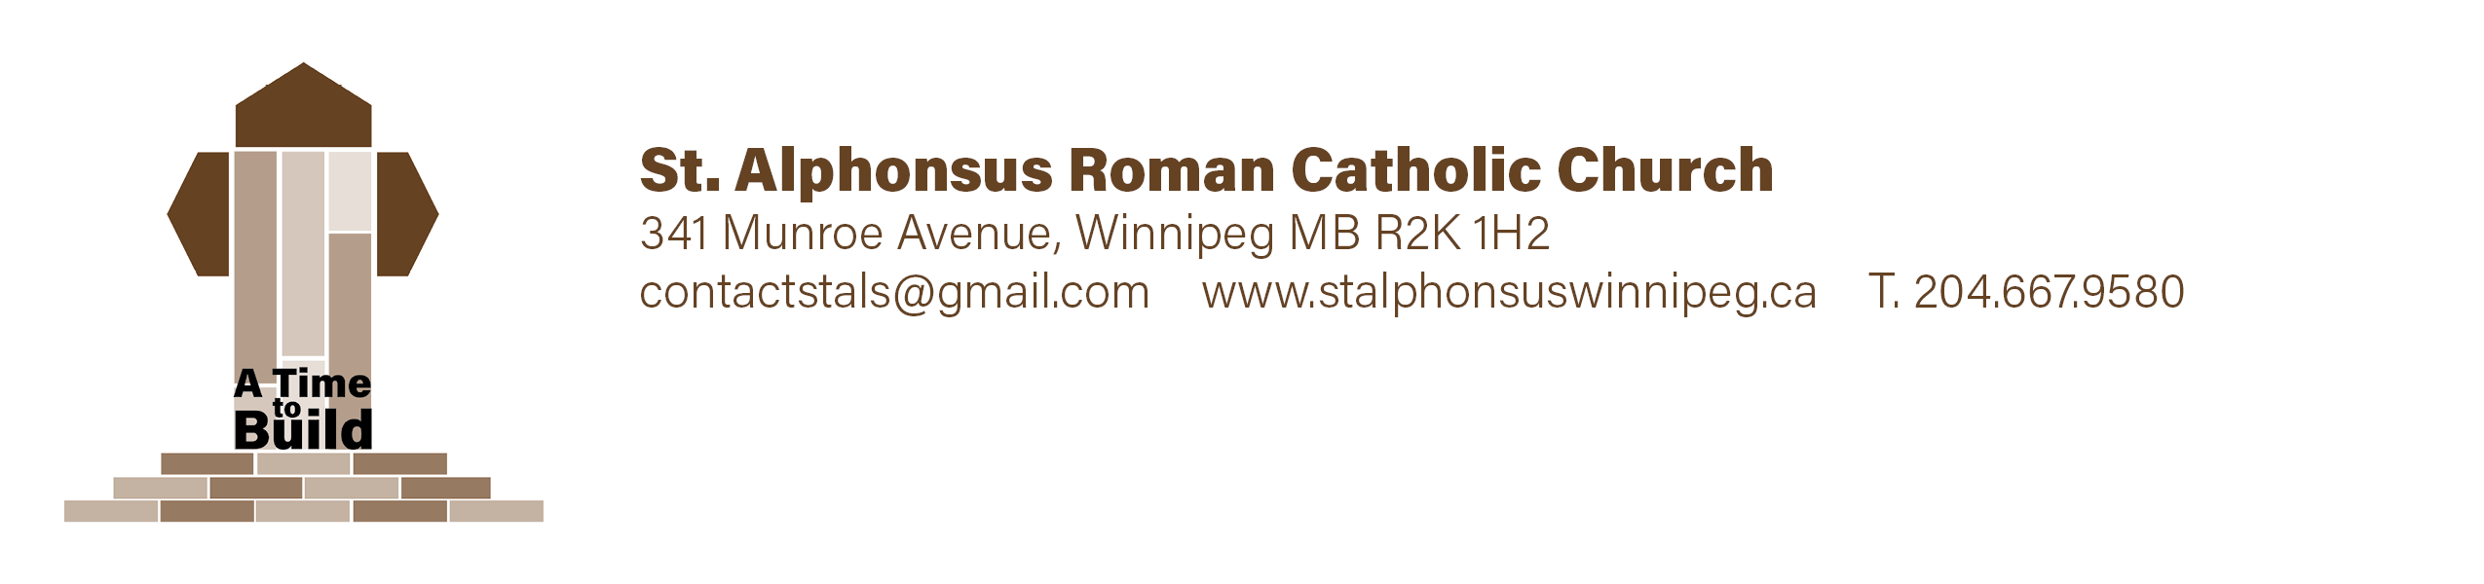

Catechism Family Registration Form
Student First Name Student Surname Grade

________________________________ _________________________________ ______

________________________________ _________________________________ ______

________________________________ _________________________________ ______

________________________________ _________________________________ ______

Allergies & Medical Concerns Emergency Contact Name & Phone Number

Parent/Guardian Information
First Name _________________________________ Surname _________________________________

Relation to Student(s) _______________________ Email ____________________________________
Phone # ________________________________ Cell # __________________________________

Address __________________________________________________ Postal Code _________________

First Name _________________________________ Surname _________________________________

Relation to Student(s) _______________________ Email ____________________________________
Phone # ________________________________ Cell # __________________________________

Address __________________________________________________ Postal Code ________________

Catechism Family Registration Form

Photo Authorization: Please check one of the following options

______ I give St.Alphonsus Parish permission to use my child’s photo on our parish Facebook Page, bulletin, or website
______ I do not give St.Alphonsus Parish permission to use my child’s photo on our parish Facebook page, bulletin, or website

Parent/Guardian Signature __________________________

Reminder

- Use the Munroe entrance of the school and remove all outdoor footwear and leave at
the Munroe entrance

Payment Information $75/per child (Maximum $180 per family)
Cash or cheques accepted
Cheques payable to St.Alphonsus Parish.

Office Use
Amount __________________ Chq#________ Cash________
Date Received___________________________ Authorization _________________________________
Notes: ________________________________________________________________________________
_______________________________________________________________________________________

