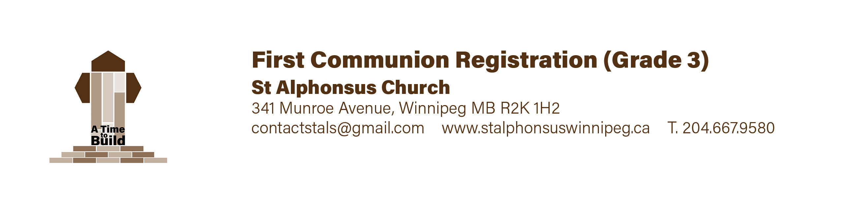
August 2023,

Dear Parents and Students,

Rejoice in the Lord always! Again I say rejoice! (Phil. 4:4)
I hope that you enjoyed the summer break! Soon catechism begins a new season.
See below for the schedule and other details.

SCHEDULE: Catechism begins Saturday, September 23 and concludes May 11, 2024.
Catechism is held at our school between 10 a.m. and 11:15 am each Saturday morning.
(Please note that if your child attends our school, then they do not have to attend
the Saturday catechism).

LEVELS: From grade one to grade six. (Grade one is homeschool).
We also accept grade seven and eight students if they have not yet been confirmed.

SACRAMENTS: It is required that your child have completed two years of catechism before they can receive either First Communion or Confirmation. First Reconciliation takes place during grade two and First Communion takes place the following year (usually in grade three). Confirmation usually takes place during grade six.
Please speak with myself, Fr. Greg, if you are not sure and need some clarity.

I GIVE YOU MY JOY, SO THAT YOUR JOY BE COMPLETE (John 15.11).
Jesus offers your family joy! But remember that this requires discipline.
Please pray and reflect on the commitment you need to make such that God’s Spirit works in your lives. Please come to Mass with your children Sunday by Sunday…and pray at home with them. Catechism will not strengthen your child’s faith unless you are praying with them both at home and at church.

Sincerely in our Lord Jesus Christ,
Fr. Greg Mulligan,
Pastor 204 782 3135

St. Alphonsus Catechism Program Calendar 2023-2024

September 2023
23 | Catechism Begins | 10:00 – 11:30 am | School
30 | Catechism | 10:00 – 11:30 am | School

October 2023
7  14 | NO CLASSES – THANKSGIVING WEEKEND  Catechism | ---------------------  10:00 – 11:30 am | School
21 | Catechism | 10:00 – 11:30 am | School
28 | Catechism | 10:00 – 11:30 am | School

November 2023
4 | Catechism | 10:00 – 11:30 am | School
11 | NO CLASSES – REMEMBRANCE DAY LONGWEEKEND | ---------------------
18 | Catechism | 10:00 – 11:30 am | School
25 | Catechism | 10:00 – 11:30 am | School

December 2023
2 | Catechism | 10:00 – 11:30 am | School
9  16 | Catechism  Catechism plus potluck | 10:00 – 11:30 am  10:00 – 12:30 am | School  School/Hall
23 | NO CLASSES Today UNTIL JAN. 6 – Christmas Break | ---------------------

January 2024
6 | Catechism | 10:00 – 11:30 am | School
13 | Catechism | 10:00 – 11:30 am | School
20  27 | Catechism  Catechism | 10:00 – 11:30 am | School

February 2024
3 | Catechism | 10:00 – 11:30 am | School
10 | Catechism | 10:00 – 11:30 am | School
17 | NO CLASSES – LOUIS RIEL WEEKEND | ----------------
24 | Catechism | 10:00 – 11:30 am | School

March 2024
2 | Catechism | 10:00 – 11:30 am | School
9 | Catechism | 10:00 – 11:30 am | School
16 | Catechism | 10:00 – 11:30 am | School
23  29  30 | NO CLASSES – SPRING BREAK  Good Friday - Stations of the Cross for families  NO CLASSES – Holy Saturday | ------------------  11 am  ------------------ | Church

April 2024
6 | Catechism | 10:00 – 11:30 am | School
13 | Catechism | 10:00 – 11:30 am | School
20 | Catechism | 10:00 – 11:30 am | School
27 | Catechism | 10:00 – 11:30 am | School

May 2024
4 | Catechism | 10:00 – 11:30 am | School
11 | Catechism – Last Class plus pizza & fun ! | 10:00 – 12:30 am | School/Hall
18 | VICTORIA DAY WEEKEND | ------------------
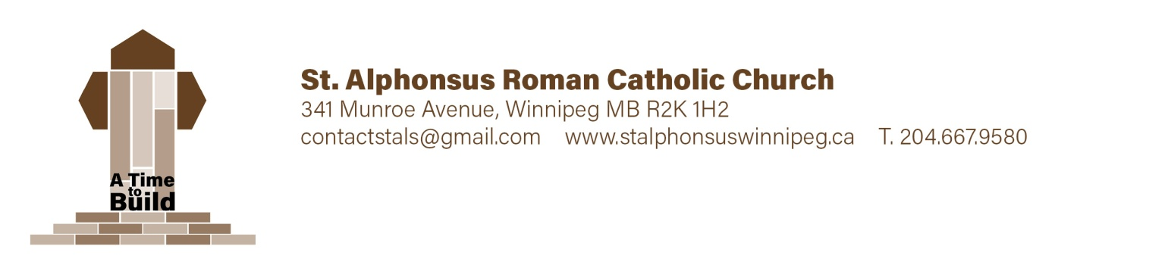

First Communion Registration - Child Information

Surname ___________________________Given Name(s) ____________________________Grade ________

Current Address ____________________________________________________________________________

Birth: Date (yr ____, mm _____ dd ____ ) City ___________________ Country ________________

Baptism: Date (yr ____, mm _____ dd ____ ) City ___________________ Country ________________

Name of Church ______________________________________ Diocese _________________________

Child was baptized (check one) Roman Catholic ______ Ukrainian Catholic ______ Other ______

If “Other”, please describe _______________________________________________________________

Candidate attends (check one) St. Al’s Catechism ________ St. Al’s School _______ Other ________

If “Other”, please describe _______________________________________________________________
On occasion the children may be offered snacks or treats. Allergies/health concerns: _________________
______________________________________________________________________________________

Photo Release:
Yes, I understand photos of myself and/or my child may be used in parish media ____________
No, photos of myself and/or my child may not be used in parish media ____________

Parent/Guardian Name ______________________ Signature ____________________________

First Communion Registration Family & Contact Info

Birth Father: Surname ___________________________ Given Name(s) ___________________________

Address ______________________________________________________ Postal Code _________________

Phone # ____________________ Alt. # ____________________ Email _______________________________

Baptized: Roman Cath. ____ Ukrainian Cath. ____ Other ____ Church of Attendance ____________________

Spouse: Maiden Name ________________________ Given Name ______________________________

Birth Mother:

Maiden _____________________ Given Name(s) _______________________ Surname _________________

Address ______________________________________________________ Postal Code _________________

Phone # ____________________ Alt. # ____________________ Email _______________________________

Baptized: Roman Cath. ____ Ukrainian Cath. ____ Other ____ Church of Attendance ____________________

Legal Guardian: Surname ______________________________ Given Name(s) _______________________

Address ______________________________________________________ Postal Code _________________

Phone # ____________________ Alt. # ____________________ Email _______________________________

Please send all correspondence to Father _____ Mother _____ Legal Guardian _____

Your registration is not complete without a
- Photocopy of your child's birth certificate _____________
- Photocopy of your child's baptism certificate __________
Please ensure all contact information especially email is filled out correctly as this is the primary form of contact. If this will be a problem for you, please state an alternate method of communication.

Payment Information: $75./child* Payable by cash or cheque (to St Alphonsus Church)
* Maximum $180 per family
Office Use: Date ____________________ Received by _____________________Amount ____________

Chq # _______ Cash _____ Notes: ________________________________________________________

