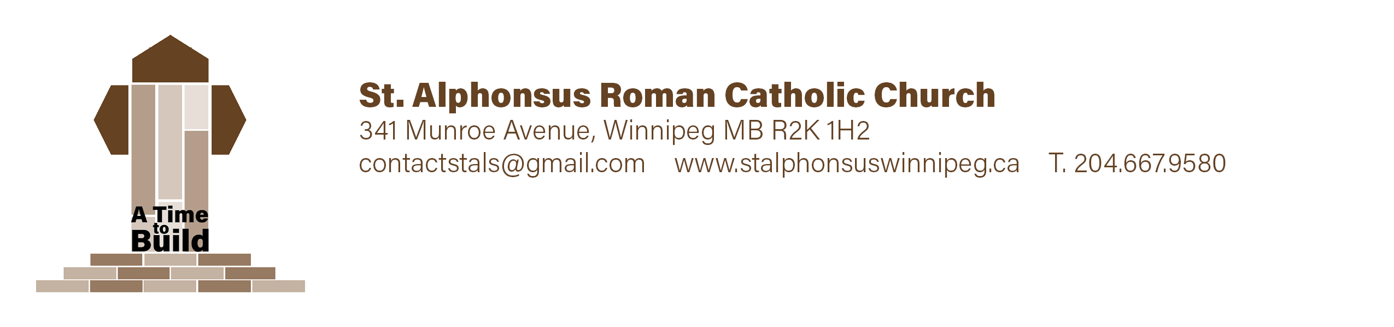

Catechism Family Registration Form
Student First Name Student Surname Grade

________________________________ _________________________________ ______

________________________________ _________________________________ ______

________________________________ _________________________________ ______

________________________________ _________________________________ ______

Allergies & Medical Concerns Emergency Contact Name & Phone Number

Parent/Guardian Information
First Name _________________________________ Surname _________________________________

Relation to Student(s) _______________________ Email ____________________________________
Phone # ________________________________ Cell # __________________________________

Address __________________________________________________ Postal Code _________________

First Name _________________________________ Surname _________________________________

Relation to Student(s) _______________________ Email ____________________________________
Phone # ________________________________ Cell # __________________________________

Address __________________________________________________ Postal Code ________________

Catechism Family Registration Form

Photo Authorization: Please check one of the following options

______ I give St.Alphonsus Parish permission to use my child’s photo on our parish Facebook Page, bulletin, or website
______ I do not give St.Alphonsus Parish permission to use my child’s photo on our parish Facebook page, bulletin, or website

Parent/Guardian Signature __________________________

Reminder

- Use the Munroe entrance of the school and remove all outdoor footwear and leave at
the Munroe entrance

Payment Information $75/per child (Maximum $180 per family)
Cash or cheques accepted
Cheques payable to St.Alphonsus Parish.

Office Use
Amount __________________ Chq#________ Cash________
Date Received___________________________ Authorization _________________________________
Notes: ________________________________________________________________________________
_______________________________________________________________________________________

