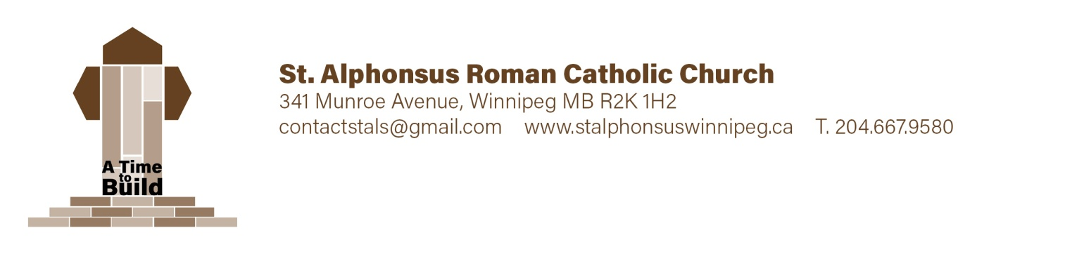

**First Reconciliation Registration -** *Child Information*

Surname ___________________________Given Name(s) ____________________________Grade ________

Current Address ____________________________________________________________________________

**Birth:** Date (yr ____, mm _____ dd ____ ) City ___________________ Country ________________

**Baptism:** Date (yr ____, mm _____ dd ____ ) City ___________________ Country ________________

Name of Church ______________________________________ Diocese _________________________

Child was baptized **(check one)** Roman Catholic ______ Ukrainian Catholic ______ Other ______

If “Other”, please describe _______________________________________________________________

Candidate attends **(check one)** St. Al’s Catechism ________ St. Al’s School _______ Other ________

If “Other”, please describe _______________________________________________________________

On occasion the children may be offered snacks or treats. Allergies/health concerns: _________________

______________________________________________________________________________________

**Photo Release:**

Yes, I understand photos of myself and/or my child may be used in parish media ____________

No, photos of myself and/or my child may not be used in parish media ____________

Parent/Guardian Name ______________________ Signature ____________________________

**First Reconciliation Registration** *Family & Contact Info*

**Birth Father:** Surname ___________________________ Given Name(s) ___________________________

Address ______________________________________________________ Postal Code _________________

Phone # ____________________ Alt. # ____________________ Email _______________________________

Baptized: Roman Cath. ____ Ukrainian Cath. ____ Other ____ Church of Attendance ____________________

Spouse: Maiden Name ________________________ Given Name ______________________________

**Birth Mother:**

Maiden _____________________ Given Name(s) _______________________ Surname _________________

Address ______________________________________________________ Postal Code _________________

Phone # ____________________ Alt. # ____________________ Email _______________________________

Baptized: Roman Cath. ____ Ukrainian Cath. ____ Other ____ Church of Attendance ____________________

**Legal Guardian:** Surname ______________________________Given Name(s) _______________________

Address ______________________________________________________ Postal Code _________________

Phone # ____________________ Alt. # ____________________ Email _______________________________

**Please send all correspondence to Father _____ Mother _____ Legal Guardian _____**

**Your registration is not complete without a**

* Photocopy of your child's birth certificate _____________
* Photocopy of your child's baptism certificate __________

Please ensure all contact information especially email is filled out correctly as this is the primary form of contact. If this will be a problem for you, please state an alternate method of communication.

**Payment Information*:* $75./child* Payable by cash or cheque (to St Alphonsus Church)  
 * Maximum $180 per family**

Office Use: Date ____________________ Received by _____________________Amount ____________

Chq # _______ Cash _____ Notes: ________________________________________________________