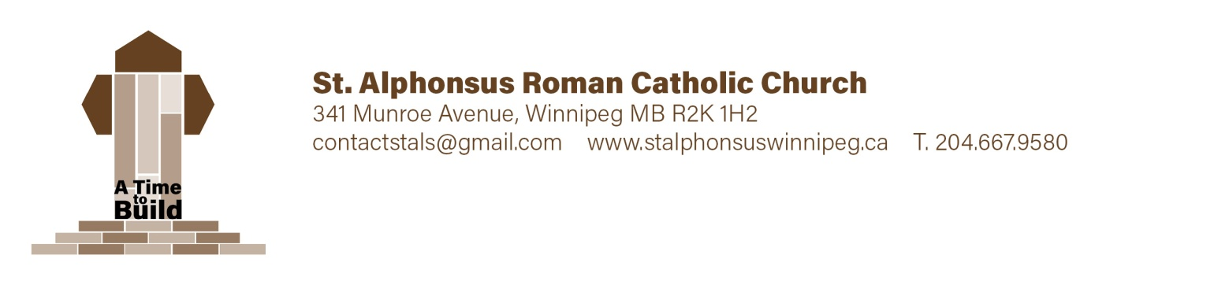

**First Communion Registration -** *Child Information*

Surname ________________________ Given Name(s) _________________ Grade: ______________

Current Address _____________________________________________________________________

__________________________________________________________________________

**Birth:** Date (yr ____, mm ____, dd _____ ) City _____________ Country _____________________

**Baptism:** Date (yr _______ mm ______ dd ______ ) City _____________ Country ___________________

Name of Church ______on file____________________ Diocese _________________________

Child was baptized **(check one)** Roman Catholic __x____ Ukrainian Catholic ______ Other ______

If “Other”, please describe _______________________________________________________________

Candidate attends **(check one)** St. Al’s Catechism ________ St. Al’s School _______ Other ________

If “Other”, please describe _______________________________________________________________

On occasion the children may be offered snacks or treats. Allergies/health concerns: _________________

______________________________________________________________________________________

**Photo Release:**

Yes, I understand photos of myself and/or my child may be used in parish media __x__________

No, photos of myself and/or my child may not be used in parish media ____________

Parent/Guardian Name ______________________ Signature ____________________________

**First Communion Registration** *Family & Contact Info*

**Birth Father:** Surname _____________________ Given Name(s) _________________________________________

Address _______________________________________________________________________________________

Phone # ______________________ Alt. # ____________________ Email __________________________________

Baptized: Roman Cath. _______ Ukrainian Cath. ____ Other ____ Church of Attendance ____________________

x

Spouse: Maiden Name __________________________ Given Name _________________________________

**Birth Mother:**

Maiden ________________________ Given Name(s) _____________________ Surname ________________________

Address ________________ _____________________________________________ Postal Code _________________

Phone # _____________________ Alt. # ______________________ Email ___________________________

Baptized: Roman Cath. _x______ Ukrainian Cath. ____ Other ____ Church of Attendance ____________________

**Legal Guardian:** Surname _______see Deborah_______________________Given Name(s) _______________________

Address ______________________________________________________ Postal Code _________________

Phone # ____________________ Alt. # ____________________ Email _______________________________

**Please send all correspondence to Father _____ Mother _ ___ Legal Guardian _____**

**\* Your registration is not complete without a**

* Photocopy of your child's birth certificate ____________
* Photocopy of your child's baptism certificate __________

Please ensure all contact information especially email is filled out correctly as this is the primary form of contact. If this will be a problem for you, please state an alternate method of communication.

**Payment Information*:* $75./child* Payable by cash or cheque (to St Alphonsus Church)  
 * Maximum $150 per family**

Office Use: Date ____________________ Received by _____________________Amount ____________

Chq # _______ Cash _____ Notes: ________________________________________________________