**2019 Coast League Gross Playoffs**

**Divisional (updated 6/18/19)**  **Final Coast League Gross Champion**

**Shady Canyon**

**Old Ranch**

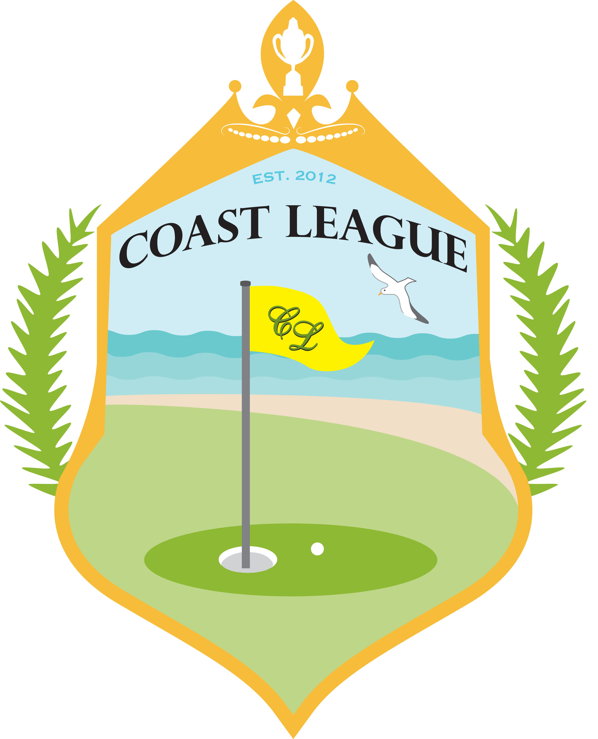

**Sea Cliff**

**Coto De Caza 134.5 Points**

**(24.5 Gross Match Points**

**Over 2 days)**

**156.5 Match points**

**SHADY CANYON**

**117.5 Match points**

**Coto De Casa**

**151 Match points**

**Coto De Caza**