Plane Around, LLC
Retrofit 180 Door Latch Instructions

Before beginning installation, please read through entire instructions.
The Concept- This mechanism has three functions when properly installed: It pulls the door in, it assists the pins to latch the door and it maintains tightness on the door seal. In order to accomplish this you have to time the pushrods when they exit the door and engage the cabin. On the 180 degree kits you can adjust the cam to pull the door with the first 0 to 30 degrees on the handle. During this first 0 to 30 degrees of handle movement, the door pins are moving inside the door structure. They can exit the door when you want them to depending on their lengths. Keep this in mind when you are cutting your pushrods. Make sure you have at least what Vans recommends for pin length and cabin structure penetration. The instructions show my specific lengths. You will be cutting your aft pushrod and connecting the supplied mid-pushrod together with a mid-rack gear. The mid-rack gear will be turning the mechanism.
Step 1.0 Preparing the pushrods: Remove the door; remove the inside handle mechanism and both Vans UHMW pin blocks. See Figure A.
Step 1.1 Remove the safety wire holding the pin on the pushrods to the rack gear joints.
Step 1.2 Pull out both door pushrods.
Step 1.3 Find the 5-5/8 inch pushrod (with lightening holes drilled in the side) in the PlaneAround bag. This push rod will be referred to as the “middle pushrod”. The pushrod in figure B was taken before I started drilling side holes. See Figure B
You will use the same connection method for all joints on the pushrods which is pins and safety wire. However, leave the safety wire off until final assembly.
Step 1.4 Connect the forward end of the aft pushrod to the included mid rack (rack included in the gearbox in the kit) lining up to the 1/8th inch holes See Figure B. The teeth of the mid rack gear will face down.
Step 2 Cutting slot for gearbox: Measuring from the interior front corner of the door, make a mark at 18-3/8 inch. This will be the center of the gearbox slot. See figure C.
Step 2.1 Cut a 13/16 inch by 2-3/16 inch slot on the bottom of your door centered on the 18-3/8 mark (just enough to slide in your gearbox against the interior skin). Do not cut into the exterior skins See Figures D & E.
Step 2.2 Measuring from the interior skin, mark a center drill hole 29/32 inch up from the bottom of the door. See Figure E.
Step 2.3 Using the mark from step 2.2, drill a 1/2 inch hole with a step drill for the shaft. Slot the fiberglass from the 1/2 inch hole to the bottom of the door to join the slot. See Figure E. Now you can see how the assembly will slide up into place.
Step 2.4 Pull the top cover off of the gearbox and keep the shaft and gear in it. Clamp it in place over the mounting location to mark the new screw holes. Match drill #12 holes through the interior fiberglass using gold #12 clecos to keep in place as you drill. Be careful not to drill through the exterior skin
Step 2.5 Mix some structural epoxy/fiber mix and reinforce the inner joints of the slot on both sides and glue the structural fiberglass blocks (provided in the kit) into place: these should be as close to the bottom of the door as possible and out of the way so there is no interference when the pushrods are moving. Allow epoxy to dry completely before moving on to next steps.

Note: Imagine the cam will be pulling in on the door in this area. If you adjust the cam too tight there may be undue stress on the door skins. Be careful not to leave any glue in the area where you will be sliding the gearbox back in. A file works great for relieving any tight corners. The bottom slot can be filled in or fiberglassed later to close up this slot and have a clean look. Keep in mind if you had to pull this assembly out in the future you would have to cut this area free to pull the gearbox out so build it up accordingly to your preference. Mine has been in for 11+ years with no trouble
Step 2.6 Countersink the four holes on the interior skin for the included MS24694 screws
Step 2.7 Put the top cover back on the gearbox removed in step 2.4. Slide in the gearbox and screw it in place. Delrin is a great material but don’t over tighten the screws; Lock tight the screws.
Step 3 Delrin door pin blocks: Starting on the aft pin block, open the exit holes in the fiberglass door corners with a step drill to 11/16 inch or larger to accommodate the new pin blocks. The door pin blocks come in the kit a little oversized to fit the various built doors. After sanding the pin blocks to fit in the area, match drill the holes from the exterior skin through the block. Now do the same to the forward pin block. Make sure all sides fit flush with the door for better sealing. Remove Delrin pin blocks for the next steps.
Step 4 Installing the door pushrods: Start with the long aft pushrod connected to the mid rack with a pin and safety wire (from Step 1.4). Look into the open hole and spot the opening in the gearbox that receives the middle rack. Remember to keep the teeth down while sliding in the pushrod. You can turn the cam shaft to help pull the middle rack through. It also helps to have someone hold the door to use gravity to line up the slot.
Step 5 Handle assembly: Look at the new handle racks provided. You will be using the rack with 1/8’ holes on each end first. This rack will be called the lower handle rack and the beveled rack will be called the upper handle rack and they should be labeled. Join the lower handle rack with the middle pushrod using a 1/8” clevis pin and safety wire.
Step 5.1 Place the Vans UHMW handle block (Vans part # C-1006C) in the handle recess. Slide the middle pushrod toward the gearbox and place the middle pushrod and lower handle rack over the Vans UHMW handle block. See Figure F.
Step 5.2 Measure up 1-3/4 inch from the bottom of the interior skin and 2-9/16 from the front of the bottom slot. Drill a 3/8 inch hole. This hole will allow enough room to pin the assembly in the next step. See Figure G.
Note: If preferred, you can fiberglass, fill or put a removable cap and upholster over this hole later.
Step 5.3 While looking through the 3/8 inch hole, push or pull the aft pin and gear assembly to spot the 3/16 inch hole in the forward end of the middle rack. Once holes are aligned, join the middle pushrod with the middle rack using the quick release pin supplied in the kit. Once pin is in place, move the pushrod assembly as forward as possible so the pushrod is around a 1/16 from hitting the Vans UHMW handle block. See Figure H.
Step 5.4 Connect the forward pushrod with the upper handle rack with the bevel facing the elbow cavity using the pin and safety wire. The bevel is made for the rack to go as far as possible in the elbow cavity.
Step 5.5 From the front pushrod opening in the door, slide the upper handle rack in place with the bevel facing up and slide it aft until the wedge hits the fiberglass elbow cavity See Figure I. Grab the handle assembly with the spur gear and push it onto the Vans UHMW handle block with the handle facing aft, paralleling the bottom of the door. Make sure the gear racks don’t move too far out of place but enough for gear engagement. Screw the handle assembly into place.
Step 6 Timing: Move the handle to the forward locked position. The pushrods should protrude from the door. Make sure the ends of the pushrods are smooth and de-burred for the pin blocks even though we will be cutting them again.
Step 6.1 Slide the Delrin door pin blocks over the pushrods and bolt in place. Mark the pushrods where they exit the Delrin blocks in the forward locked position. Be sure to mark the pushrods with something that won’t rub off easily. Also make sure you have full 180 degrees of travel. If not, reposition the handle rack gears for complete travel.
Step 6.2 Move the handle in the aft position parallel to the bottom of the door. Mark the handle rack gears at the Vans UHMW handle block where they enter. This will help timing during reassembly. See Figure I and J.
Step 6.3 Take off the door pin blocks and remove handle assembly. Remove forward pushrod; remove 3/16 quick release pin from 3/8 inch hole and remove aft pushrod.
Note: Twisting the cam shaft will help with the removal.
Step 6.4 If you are using PlaneAround pins and pin guides you will need to measure 5/8 inches inside the mark made in Step 6.1 and cut the pushrods. Repeat this step for both aft and forward pushrods.
Note: This will leave 1-3/8 inch of pin extending out of the door when door is latched. Plane Around door pins are 2 inches.
Note: If using Vans pushrods with no pins, you will measure 1-3/8 inch out from the mark made in Step 6.1 and cut the pushrods. Re-bevel the pushrod ends to mimic Vans original design.
Note: If using other manufactured pins, make sure you have at least 1-1/4 inch extension in the closed latch position.
Step 6.5 If using PlaneAround door pins, thread the ends of the pushrods 5/16-24 at least one inch deep. Use some Locktite (after reading pin and guides instructions) and screw in the threads
Step 7 Reassembling the door: Insert the aft pushrod assembly through the aft pushrod hole and slide through gearbox assembly (See Step 4)
Step 7.1 While looking through the 3/8 inch hole, push or pull the aft pin and gear assembly to spot the 3/16 inch hole in the forward end of the middle rack. Once holes are aligned, join the middle pushrod with the middle rack using the quick release pin supplied in the kit. If you want use .020 safety wire to wrap around the head of the pin, push the pin in to join the pushrod and the rack and feed the safety wire towards the handle hole then wrap around the pushrod and feed back to the 3/8” hole, twist the safety wire and pigtail. This will hold the pin in if for some reason the spring ball fell out. Haven’t heard of this happening but up to the builder.
Step 7.2 Insert forward pushrod assembly through the forward pushrod hole and align the marks from Step 6.2 on the handle rack gears to the Vans UHMW handle block.
Step 7.3 Take door handle assembly and place it in the aft open position and permanently remount the handle.
Step 7.4 Reinstall Delrin pin blocks.
Step 7.5 Hinge the door on the airplane
Step 8 Fitting the cam and door block: Push the PlaneAround cam over the cam shaft while the door is closed and the handle is in the open position. Set the cam so the bottom is parallel to the cabin door lip See Figure K, shut the door and check rotation of the cam.
Step 8.1 The cabin block position is up to the builder depending on your configuration such as armrests, upholstery, cabin lip thickness and seal thickness. Some cabin lips may need to be modified due to variables in construction and thickness. Once you decide on your cabin block location, clamp the Delrin block onto preferred location. Temporarily install the cam and tighten set screw. Adjust the location of the cam on the shaft as necessary while pushing in on the middle of the door while latched closed. You will want to check the middle exterior of the door to make sure it is flush to the aircraft skin.
Note: There is a lot of mechanical advantage with this cam mechanism. You can easily put too much force on the door; don’t over do it. Too much force could separate door skins at the gearbox location.
Step 8.2 Once satisfied with cam and door block location mark the cam shaft where it extends out of the cam, cut shaft at marked location and deburr.
Step 8.3 Permanently install the cam by drilling 1/8th inch hole through the cam pilot hole, through the shaft and out the other side of the cam. Make sure to drill straight and parallel. Push the supplied 1/8th inch roll pin through the new hole.
Note: Vice grips with no teeth or soft teeth work well for inserting roll pin.
Step 8.4 Mark the block location and match drill the holes. Drill one hole, bolt it and match drill the other hole, disassemble and de-burr the holes and permanently mount the block.
Step 8.5 Install the magnets and proximity switches per Van’s instructions. Epoxy works great for the magnets.

Figure A:
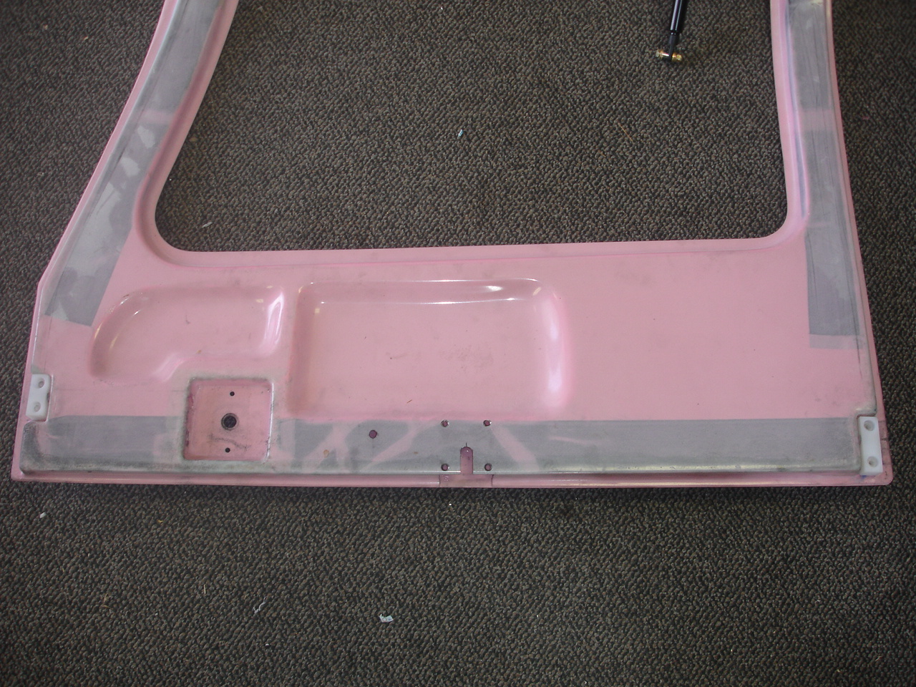

Figure B:
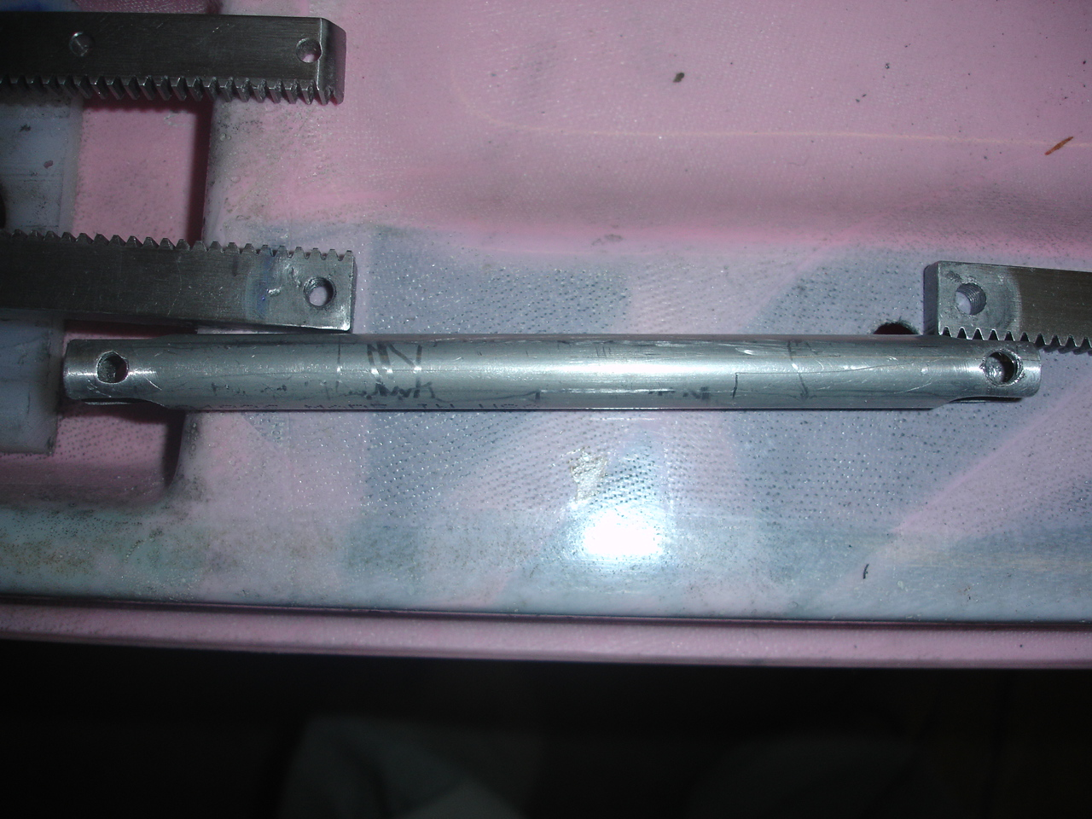

Figure C:
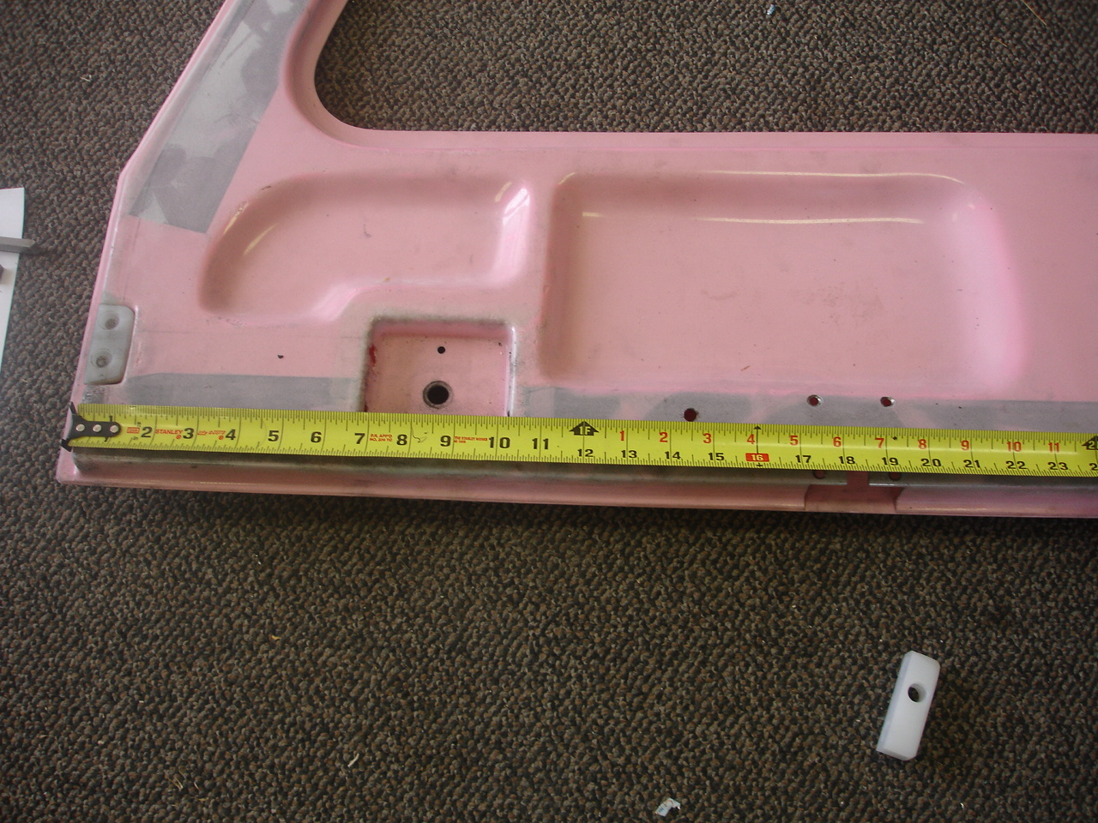

Figure D:
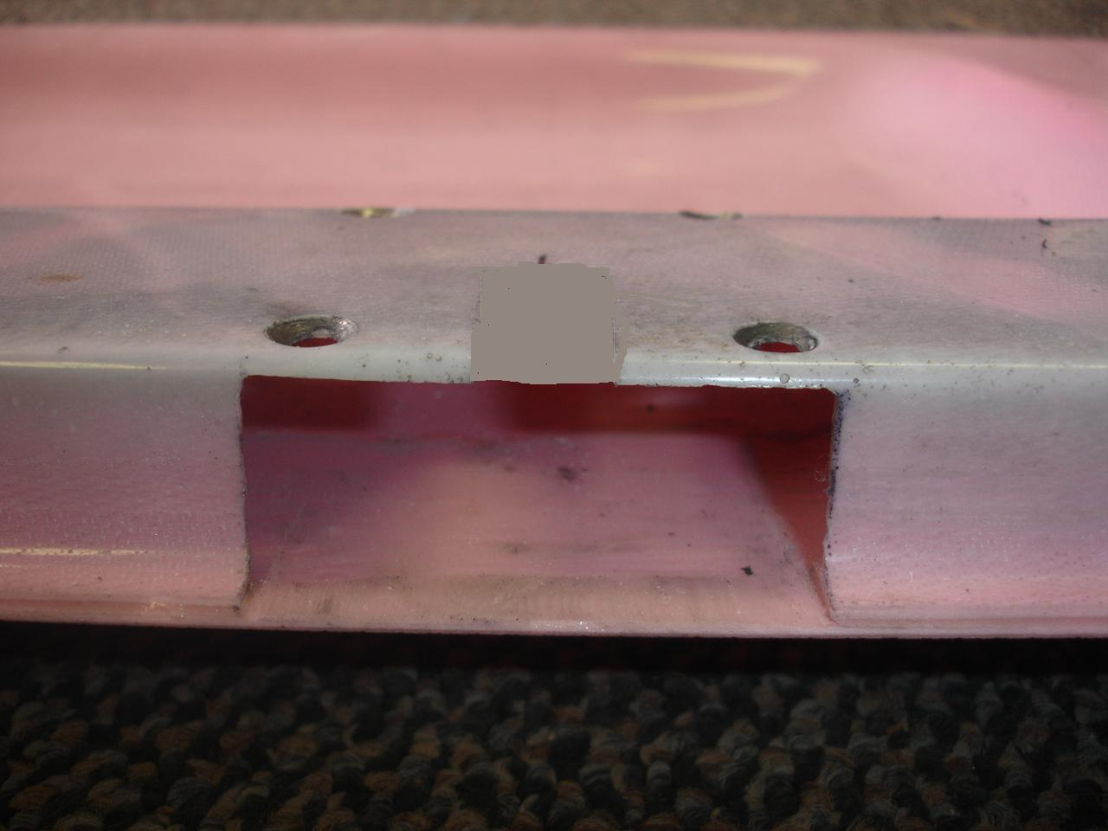

Figure E:
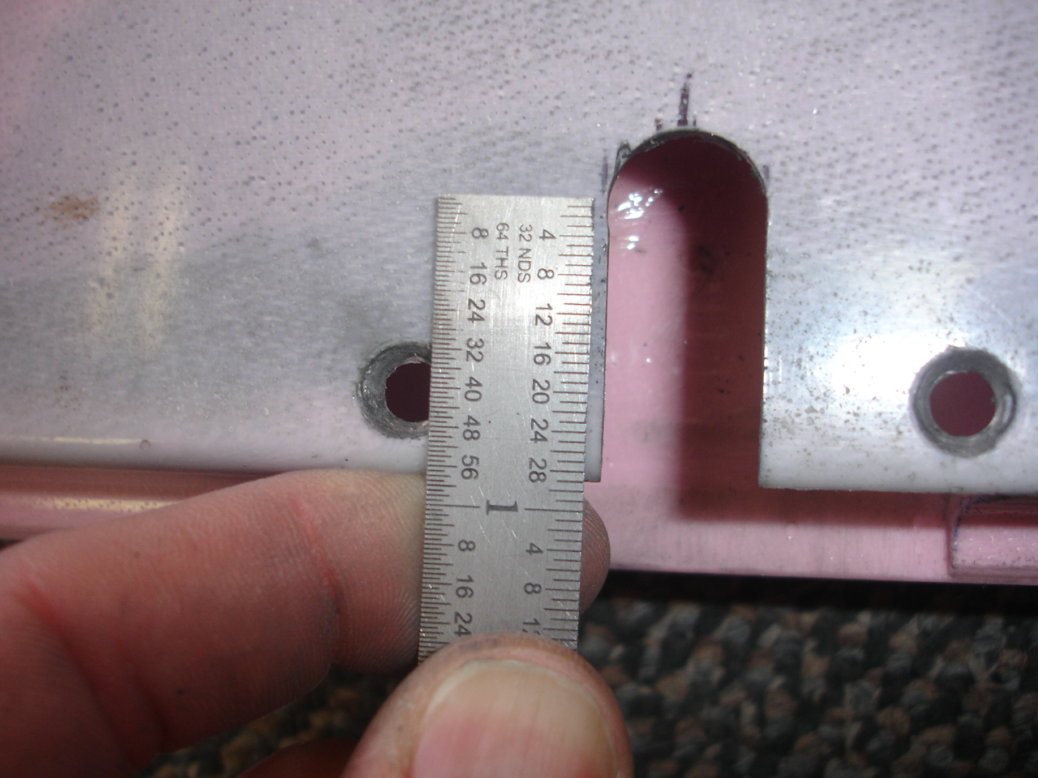
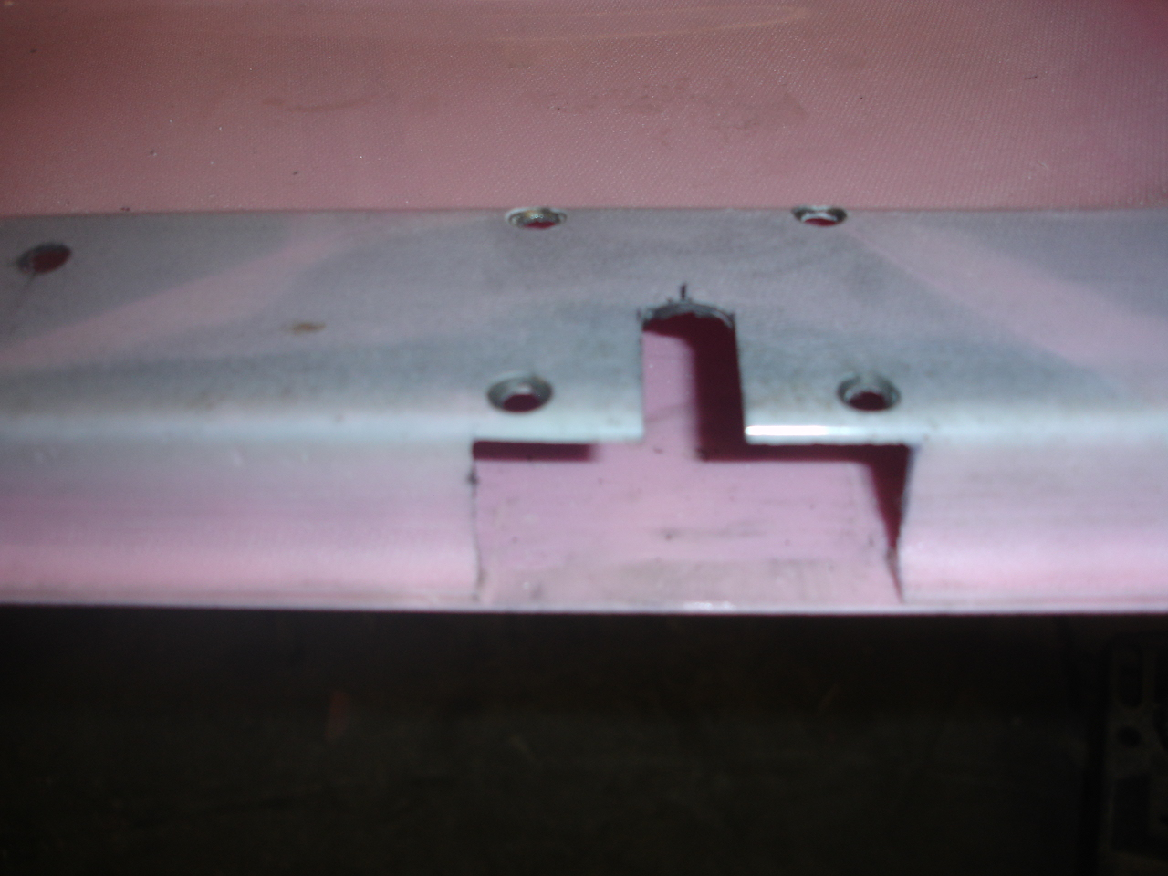

Figure F:
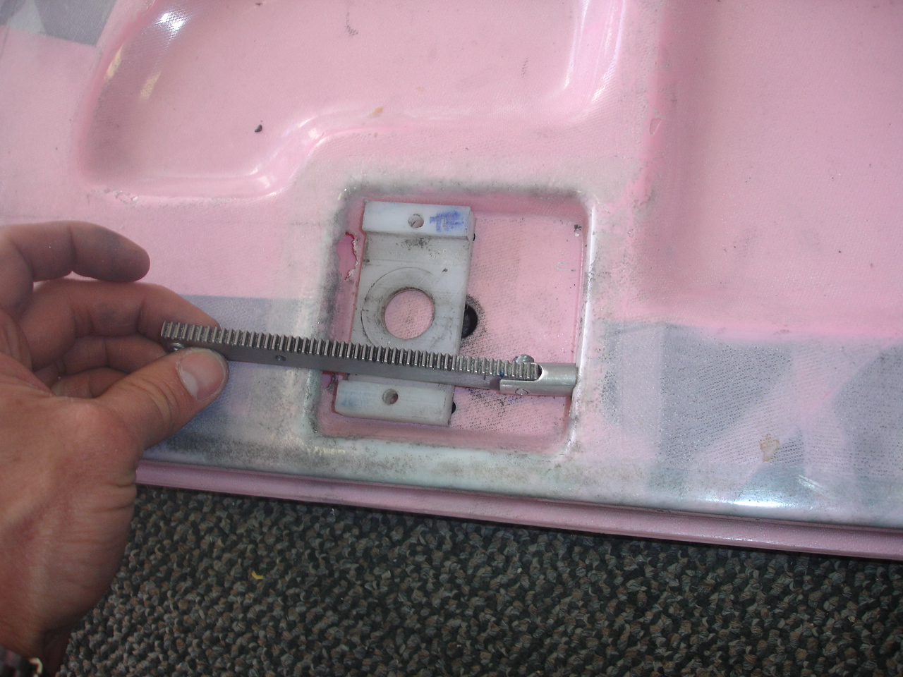

Figure G:
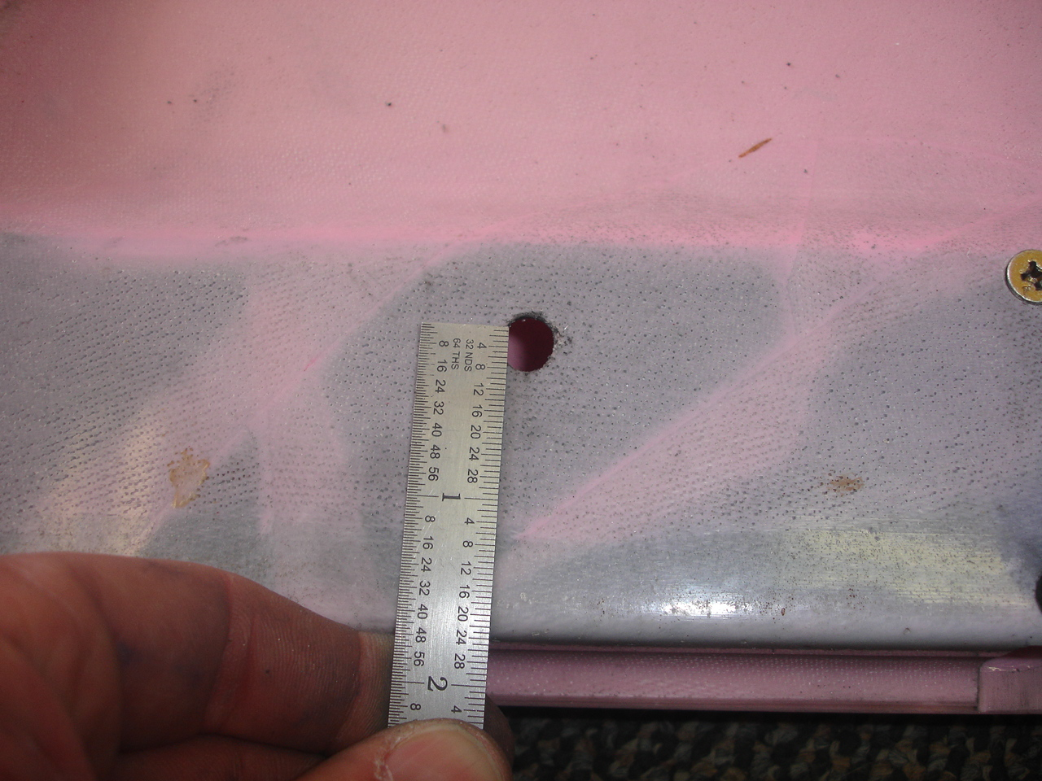

Figure H:
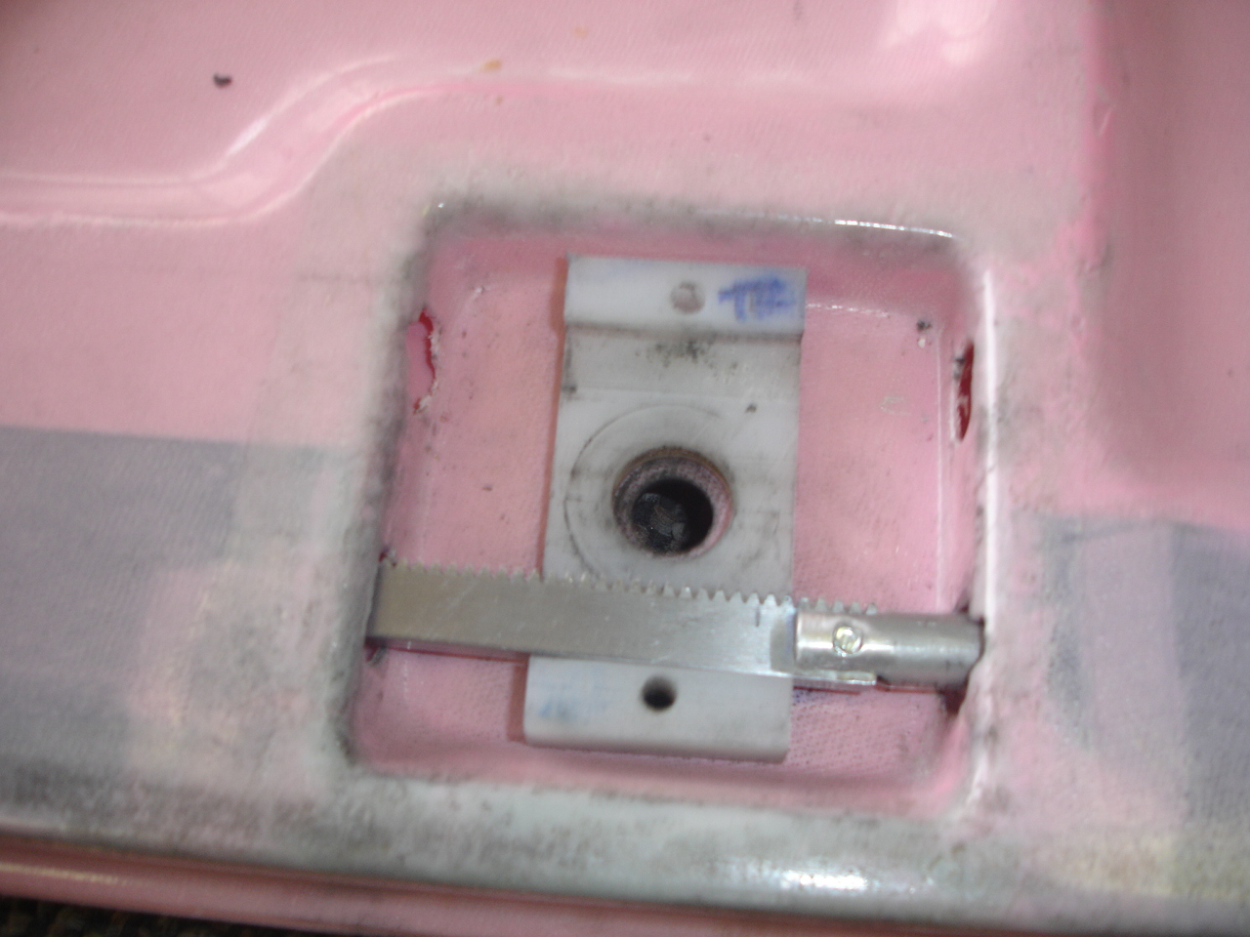

Figure I:
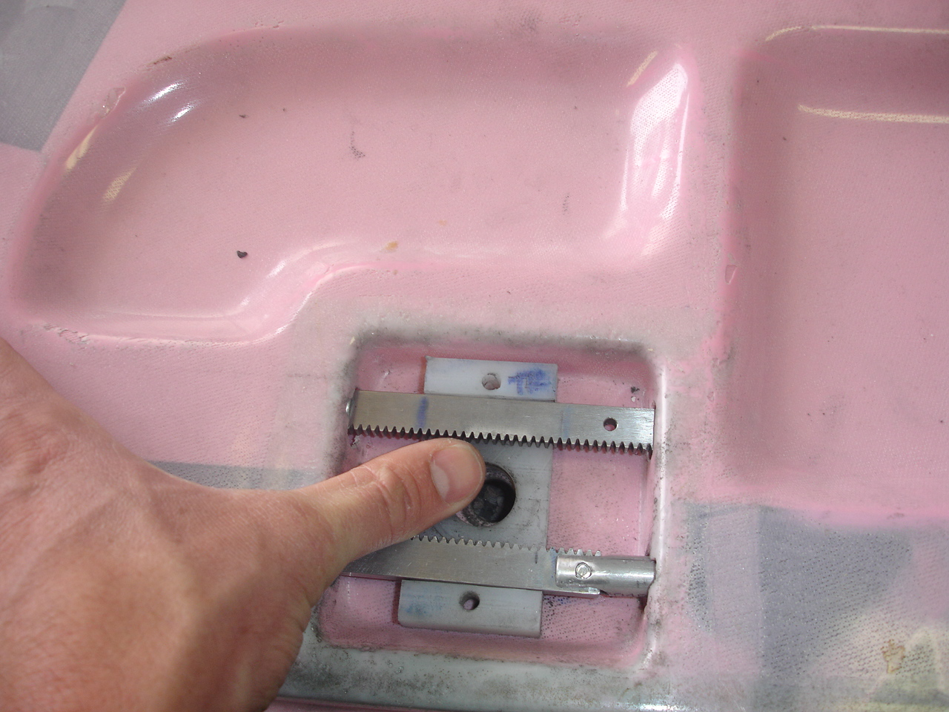

Figure J:
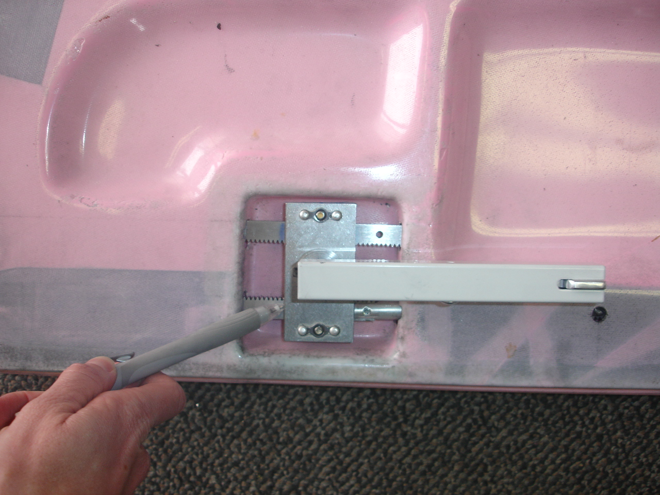

Figure K:
