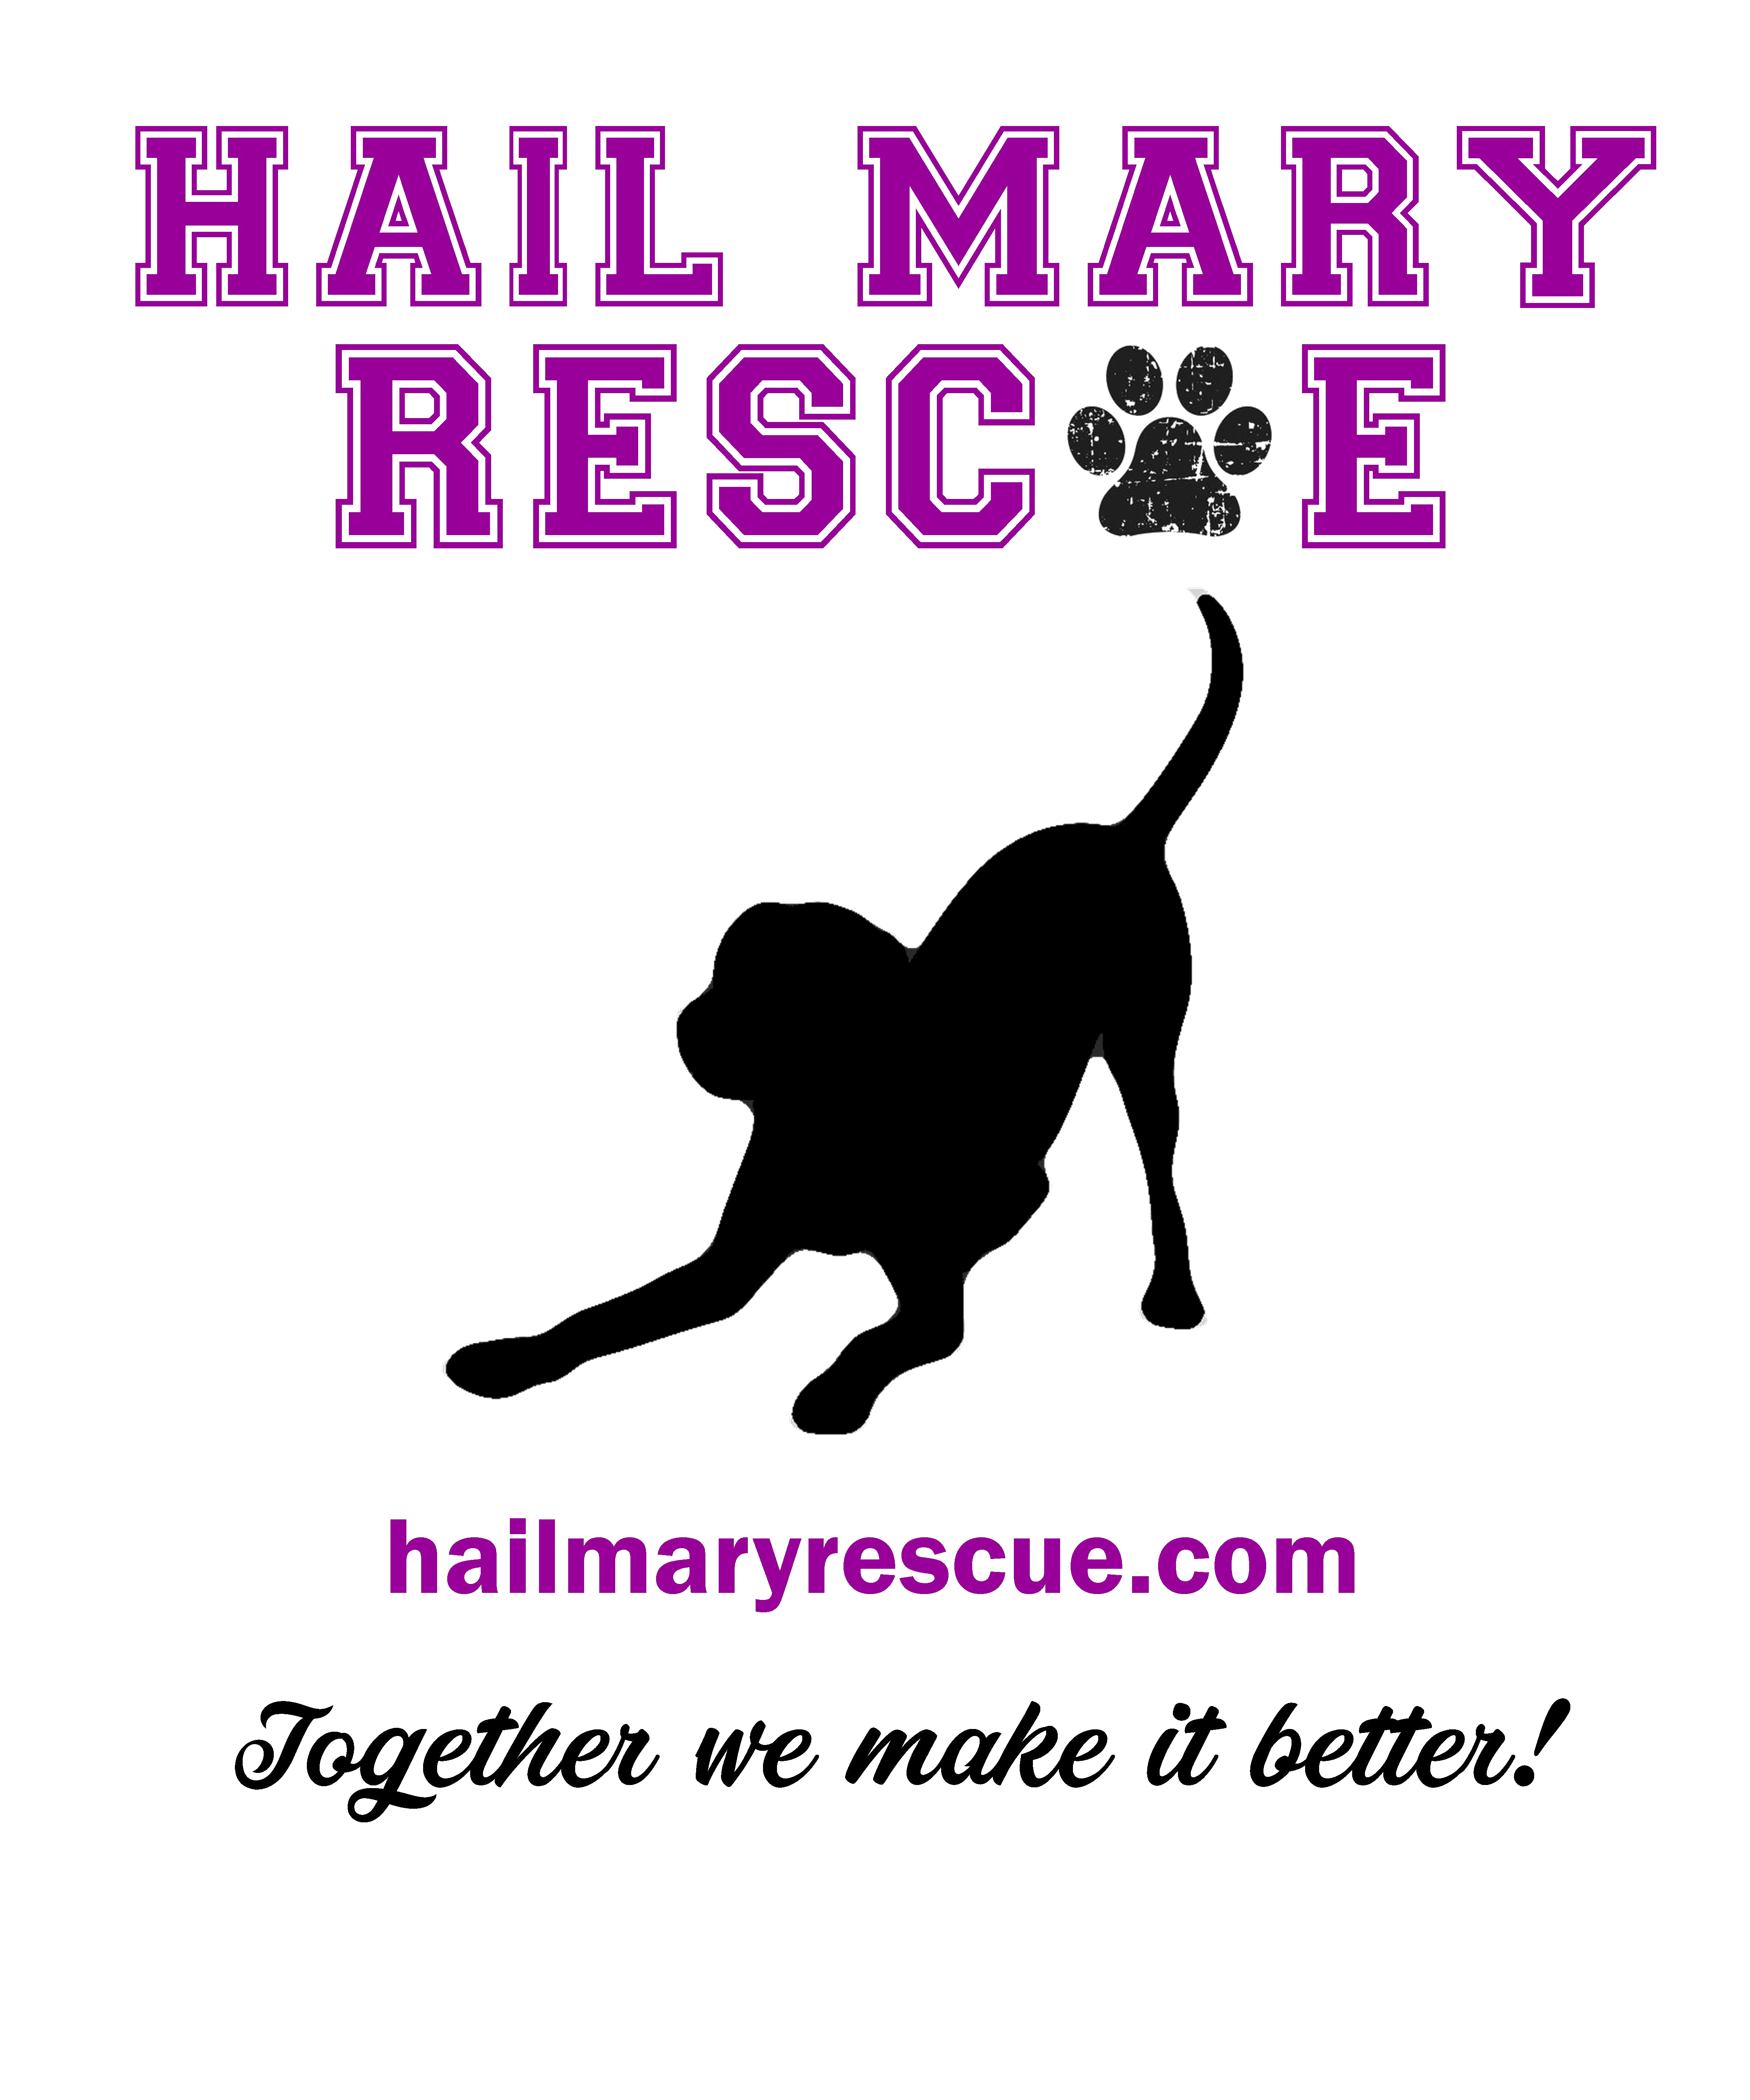
FOSTER GUIDELINES
Foster parents and families form the backbone of the work we do. We cannot exist as a rescue if people are not willing to bring needy animals into their homes while we search for permanent homes for them. Fosters have my undying gratitude and my deepest respect and admiration. There are never enough foster homes to go around, so each is precious to Hail Mary Rescue (HMR) and the animals we are trying to save.
To make your fostering experience as positive as possible for you, your family and your furry charge, please commit the following to memory before bringing him/her home:
1. All foster animals will be rotated among fosters every three to four weeks at Mary’s discretion and/or go once a month to be evaluated.

2. Hail Mary Rescue tags must be worn while in the foster’s care.

3. Arrange to introduce the new animal to your own pet(s), if you have them, outside on neutral territory. Once inside, it is best to situate the foster animal in a crate at first and introduce him/her gradually to other household members. Do not try to make the foster an immediate part of your family. Let him/her settle into the new place and help him/her learn the rules of the house as soon as possible. Never let the foster take over and place your own animals at risk or under stress.

4. Use a training collar to walk a foster so he/she cannot slip from the collar and run off. A dog can easily slip out of a flat collar, which should be worn for identification purposes only. The training collar should be used only for walking and training and should be removed after the session. Keep the training collar attached to the leash at all times. If you need instructions on how the collar is to be worn, please check with Mary Morvant.

5. Become familiar with the adoption contract. Please keep some clean applications on hand or have the capacity to print them from the website-to give to promising prospects, or just in case you will be handling the adoption yourself. Make sure you have a copy of the most current form.

6. If you find a prospective adopter for your foster on your own, please make them aware of the application process, as well as Hail Mary Rescue’s adoption donation. HMR screens applicants very carefully. Have the perspective adopter visit www.hailmaryrescue.com to fill out the “Adoption Application” form or request a hard copy if they do not own a computer. Let them know that the application will be evaluated by our Adoption Coordinator. The evaluation includes a veterinary check for all animals the prospective adopter owns or has owned. If approved by HMR, the application will be forwarded to the foster to contact the applicant. Once approved for this first step, a home visit is scheduled. If the adoption is finally approved, a contract is signed, and an adoption fee is paid by the adopters.

7. If necessary, HMR can lend you a crate, a collar and/or leash. Whenever you transport an animal, make certain you have him/her on a leash, with a secure training and flat collar. If you plan to foster on a regular basis, it would be a great help to HMR if you could get a crate of your own. Make sure the animal has ample room to move around when choosing the proper size. Confine all animals being transported in vehicles either with harnesses or in crates. This may not seem like the best choice for the animals, but it is essential for your safety and theirs. Accidents can and do happen when animals are loose in the car. People and animals can and do die.

8. Hail Mary Rescue typically provides food, treats and chew toys for foster animals, if needed.

9. Fosters may also be asked to participate in transporting animals or assisting in house checks. HMR will provide the necessities if the foster cannot do so.

10. If your foster animal becomes ill or gets hurt, NO ONE is authorized to bring an animal to a veterinarian’s office.

Our procedure: Contact one of the person’s listed below beginning with Mary.
- President - Mary Morvant ………………….985.414.5146
- VP - Faye Adams …………………………….985.438.0667
- Board Member - Ginger Laiche………….…985.688.8522

11. Be very familiar with the regulations and policies of HMR. Most of all, remember that no one can be approved until their application is deemed acceptable, the vet check is satisfactory, and a home visit is completed – in that order. If the adopters are approved, the adoption contract must be signed – by all the adopter(s) and a HMR representative – with all information carefully filled out and checked by you, as the representative. Our adoption fee is $125, paid upon completion of contract and refundable within the first 14 days of contract date if it is not a good match. Do not turn any animal over without the signed paperwork and appropriate fee in hand.

12. Questions, concerns, comments, ideas should be directed to HMR officers.
Remember that you are the foster, not the owner. Not all people want their dogs on the furniture or sleeping in their bed. Develop a healthy routine for the dog while in your care. Crate while you are away, sleeping, or too busy to watch. Feed approved dog food by HMR. If you will have the dog for any length of time and would like advice on training or where to bring feel free to contact a HMR Rep.

13. If a foster animal begins to show aggressive behavior or bites anyone call Mary Morvant immediately.

Disclaimer: Hail Mary Rescue reserves the right to accept or decline any person as a foster for any reason. The final decision on all fosters is up to the vote of the board of directors.

