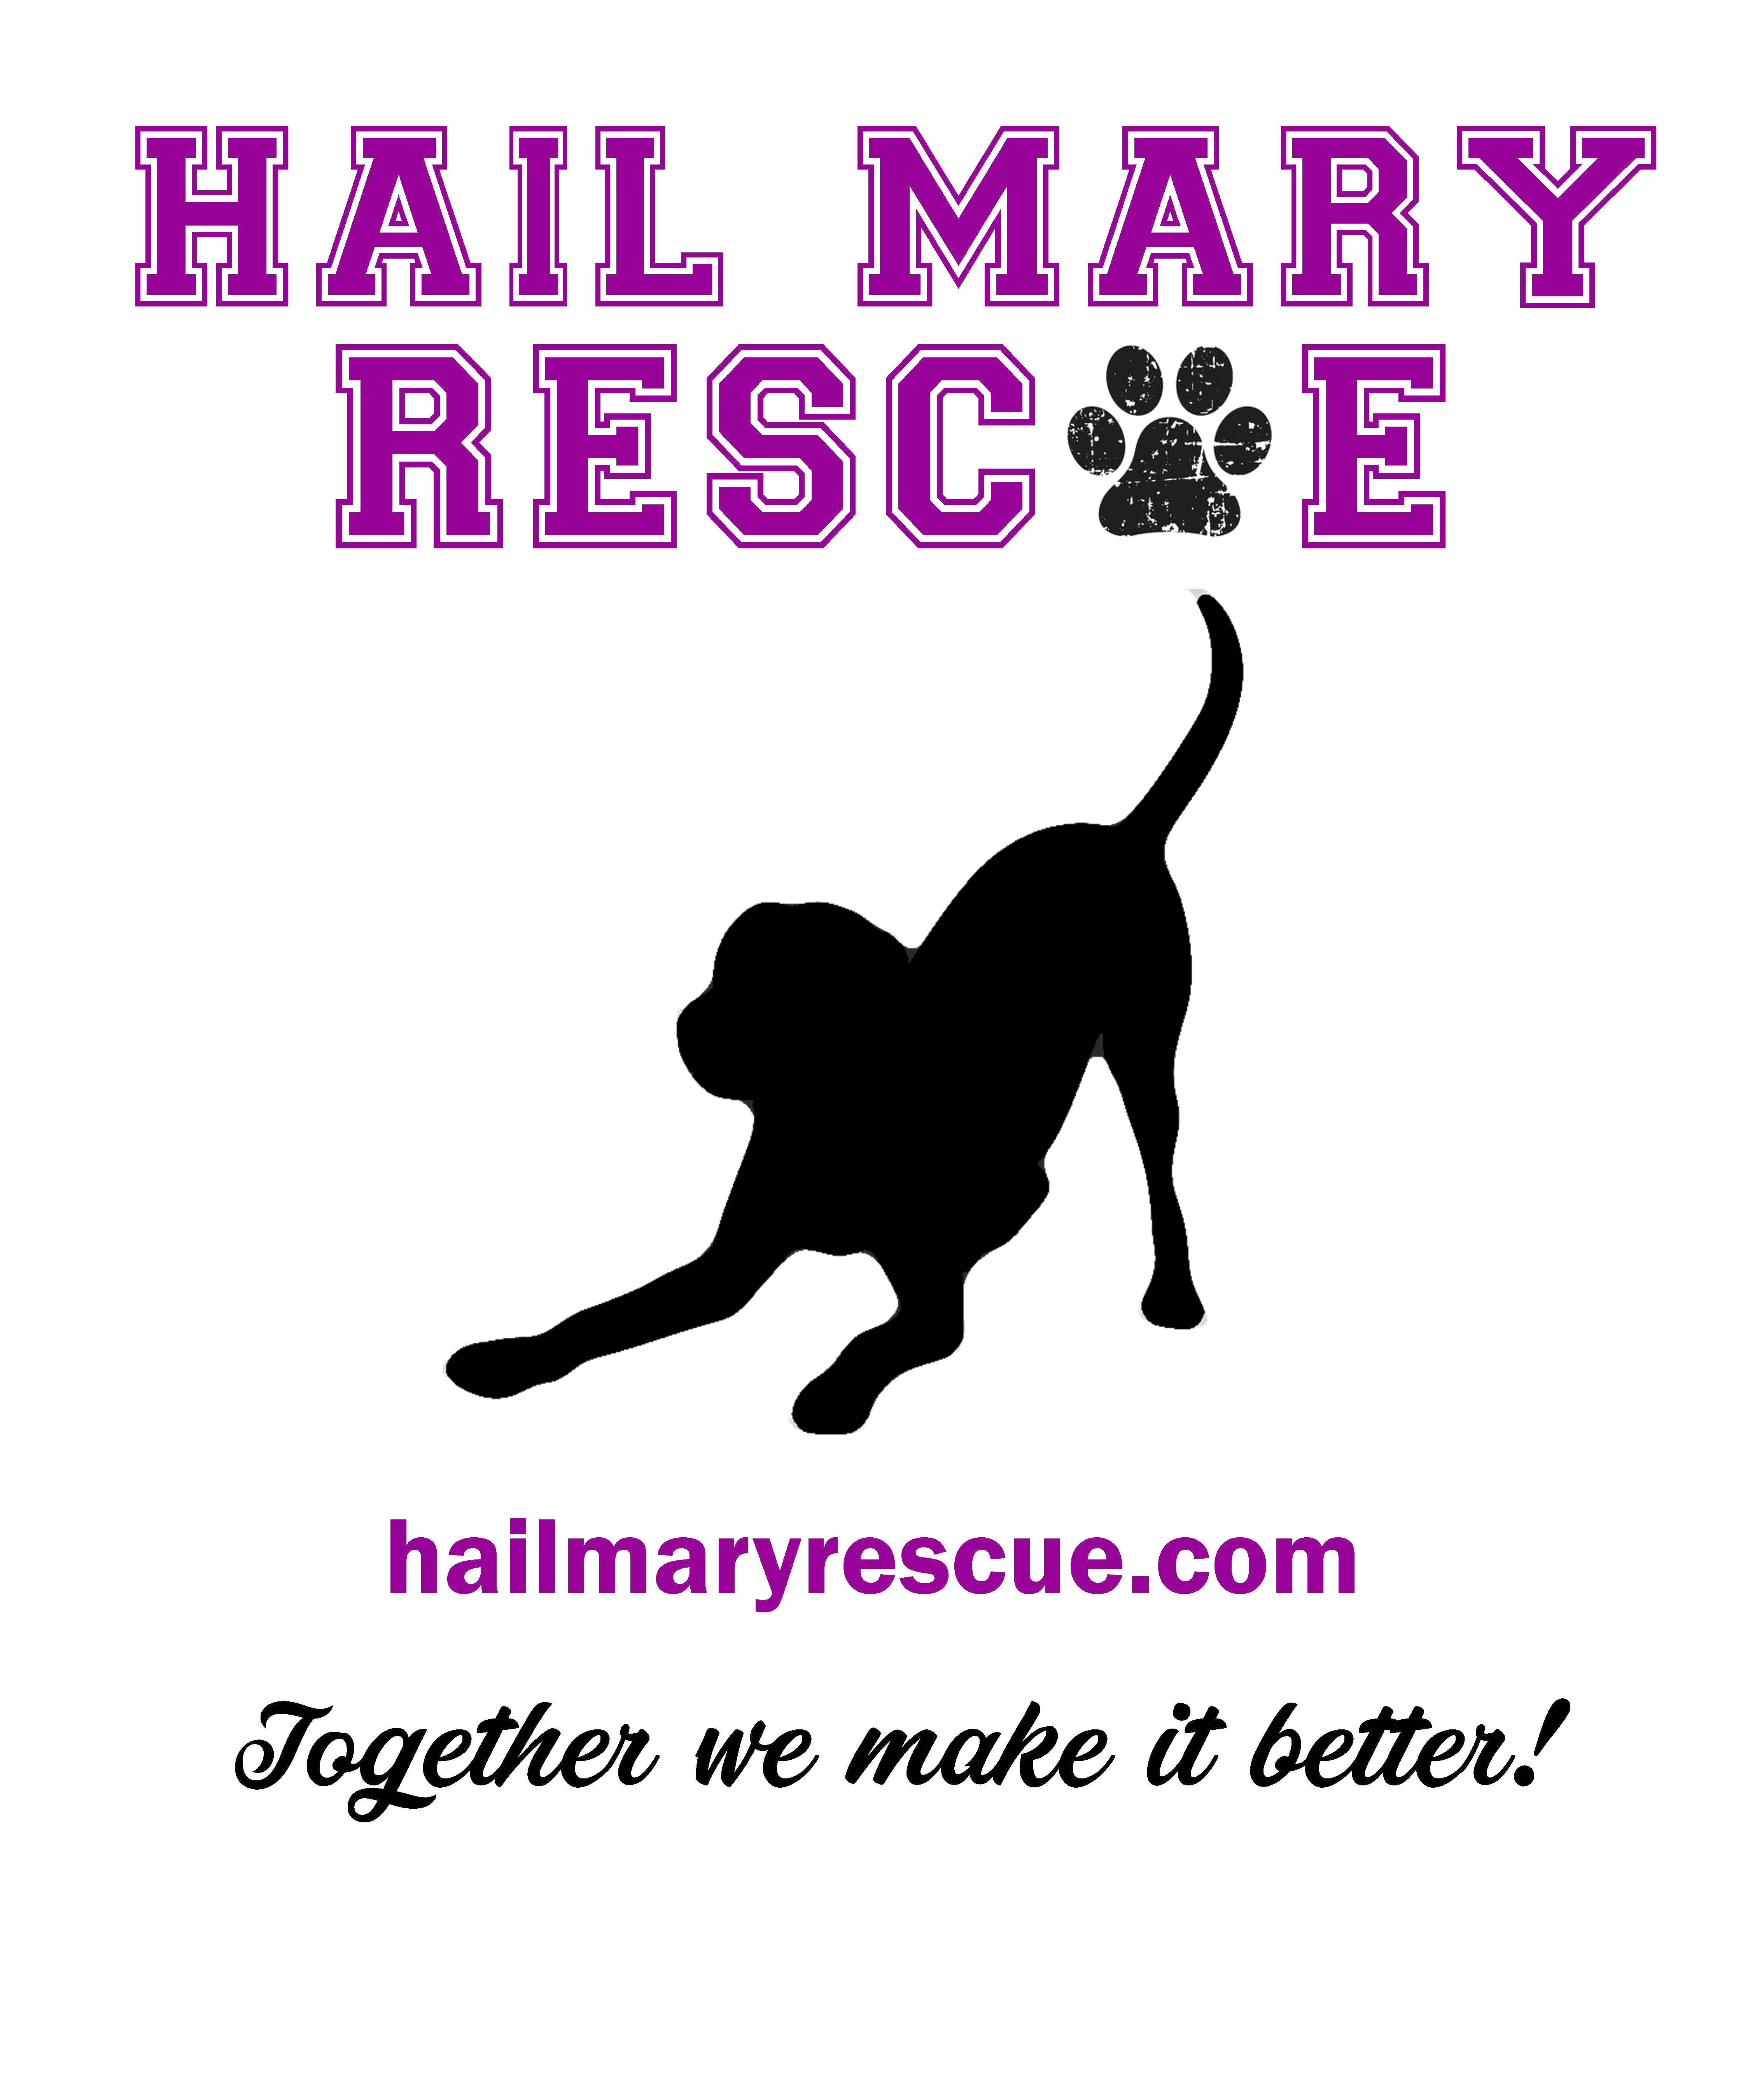

FOSTER CONTRACT

In order to become a foster parent, you will need to meet the requirements of the following:

- Complete a foster parent contract and have a subsequent home visit.
- Your own personal animals MUST be spay/neutered prior to fostering or foster same sex pets.
- Understand that this is a commitment to Hail Mary Rescue and your foster.
- Provide food and a safe, loving home for your foster where they can learn social behaviors they desperately need.
- Hail Mary Rescue provides food and vetting.
- Temporary foster or foster to adopt, MUST bring animal to scheduled appointments or call Mary Morvant immediately!
- No Liability. You agree to hold Hail Mary Rescue harmless from and against any and all claims.
- No ownership. You acknowledge that no rights of ownership of the Foster Dog. HMR maintains absolute ownership of the Foster Dog.
- No compensation. You acknowledge that we are not obligated to pay You any compensation for taking care of the Foster Dog.
- I agree and understand that Hail Mary Rescue officers may also remove a foster pet from a foster home for any reason at any time they deem necessary.

- Hail Mary Rescue is a 501(c)(3) non-profit organization. The mission of HMR is to move heaven and earth to save animals from the shelters in our surrounding areas.

- IMPORTANT RULES AND REMINDERS
REGARDING YOUR ONGOING FOSTER

        - Foster parents MUST abide by the following rules:

        - Foster’s Duty to Promote:
- Agree to promote your foster by submitting sending bio and pics of foster to Hail Mary Rescue representative. She will create a flyer to be posted on the website.
- Refer anyone interested to www.hailmaryrescue.com to fill out an application.
- Introduce your foster to all other animals within the potential adopter’s home to make sure it will work.
- If you do not feel comfortable telling someone NO about adopting your foster, please let a HMR officer handle it.

- At Home Policies:

- NO off-leash park visits.
- Any fecal matter will be picked up and the area in which it sat either bleached or properly disinfected after each bowel movement. No exceptions. (HMR is not responsible for your personal animals getting sick)
- Foster dogs must be on leash at all times when outdoors unless in your own secured fenced yard.
- Much energy, love, time and vet care is devoted to our foster pets, and we are committed to finding homes for ALL the adoptable pets in our care. Some pets are in foster care because they're seriously ill or injured. Fortunately, most pets in foster care heal beautifully. On rare occasions, a pet in foster care may start to exhibit potentially dangerous behavior that was unknown or suppressed prior to rescue. Your safety is our #1 priority. You must always inform Mary Morvant if your foster animal exhibits any aggressive or negative behavior.
- Any aggressive behavior (to either humans or other pets) must be immediately communicated to Mary Morvant first. If unable to contact, use contact list of contact numbers below. Go down in order. (Training classes can be provided to fosters in need)
- All vet visits must be pre-approved by calling one of the HMR officers. Vet visits will not be reimbursed without pre-approval from a HMR officer unless an emergency arises. Go down contact list.
- If foster becomes sick or is injured? CALL Hail Mary Rescue First!!!! Use contact list

HMR Representative Contact Numbers:
1-Mary Morvant 985-414-5146 3-Ginger Laiche 985-688-8522
2-Faye Adams 985-438-0667 4-John Vest 985-688-9922

1. How long are pets in foster homes? It completely depends on the pet and the situation. The average stay in a foster home is about 2 months, but it can be as little as 2 weeks. Obviously, others, recovering from an injury/HW+, certain breeds and senior dogs, may stay much longer.
2. Can I or a member of my family or friends adopt my foster dog? YES! As long as they meet ALL requirements necessary for adoption.
3. How are foster pets promoted? Photos of our adoptable pets in foster homes are posted on the Hail Mary Rescue website and Facebook page where the public can view them. Foster pets are also promoted at special events. Foster parents can also help promote their foster pet to their family, friends, colleagues and the general public through a variety of means including emails and even just by socializing your foster dog “walking” in local pet stores with an “Adopt Me” bandana around their neck.
4. What is the process for adopting a foster? Potential adopters are required to submit an adoption application for review. Applications can be found on the website. Once approved by HMR officer, meet and greets with the foster pets can be scheduled with qualified applicants.

Questions to ask: 1) How is temperament of dog & kids/energy level, 2) How much exposure have your dogs/kids had with dogs & how did they react? 3) Is your current dog house trained? 4) Do you leave dog toys around the house? 5) Is your dog allowed on furniture/bed?

Final approval of all adoptions is at the discretion of the foster. Once approved, the adopter pays adoption fees of $125 to HMR and the foster pet then goes to its new forever home. The packet of all hard copies of vet records are then given to the adopter. If contract and fee is sent to a HMR officer, contract can be emailed to adopter.

5. I live in an apartment, can I foster? Yes, you can still foster living in an apartment. Many of our pets need one- on-one socialization, so a small space can be beneficial. However, it’s important that you select an appropriate pet for your lifestyle and are willing to commit to providing your foster with the needed physical and mental stimulation. And of course, you need landlord approval. HMR is not responsible for pet deposits or damages caused while in your care.
6. What if I have children? Fostering is a wonderful family experience. It’s important to select a pet that is “age” appropriate with your children, and as a general rule, children under 13 years old should NOT be left alone and unsupervised with any foster pet. You must also be diligent about providing guidance, instructions and rules to your children about caring for fostered animals.
7. I don’t have a yard, or it’s not fenced, can I foster dogs? Yes! A yard is nice to have for those early morning, or late night potty breaks and for a game of ball, but is not a requirement for all fosters. However, the foster dogs must be on a leash at ALL times when outside and never allowed to be left unattended in a yard.
8. If I have my own animals, can I still foster? Yes, your own animals must be spay/neutered and keep in mind that it’s always a health risk to expose your animal to other animals whether it’s walking at parks, vet waiting rooms or other common animal areas. The health risk is minimal if your animals are current on their vaccinations, maintains a healthy diet and lifestyle, are not elderly or very young, therefore it is recommended that you not socialize with your personal animals for 7 days. If you or someone in your household is immune compromised, consult your doctor before fostering since working or living with animals exposes humans to a group of diseases called zoonotic. A zoonotic disease (there are about 200) is defined as a disease transmitted from animals to humans and also from humans to animals. To find out more about zoonotic, talk to your doctor and/or veterinarian. Proper hygiene, preventative measures and an understanding of these illnesses can reduce the risk of disease.
9. What supplies are needed to foster? Foster parents provides a loving environment and basic training for the pet. HMR provides you with all the other supplies and equipment needed throughout your foster experience (as requested).

10. Do I have to crate-train my foster pet? Yes, because it is one of the most efficient and effective ways to house train a puppy or re-train an adult dog. Some dogs do not like crates, and most dogs need to be transitioned or “trained” to use a crate. Putting the dog in a crate while you are gone will give you peace of mind knowing that they are in a safe place, away from harm, and not doing any damage to your belongings or themselves. For many dogs, a crate can also represent a safe and comfortable place to call their own and provides them with a sense of security. Dogs actually like having a “den to cuddle up in. (Crating should never be used as punishment)
11. Do I need to have prior medical knowledge or expertise? No, but you may be asked to dispense medicine to your foster pet so you will have to be comfortable following veterinarian’s instructions if fostering a sick or injured pet. If you need assistance a HMR representative can always instruct.
12. Can I return my foster if I am unable to foster any longer? We prefer that foster parents continue to foster until we find a permanent home for their foster pet, however, we understand that situations change and it may become necessary to discontinue fostering. We request that a foster parent provide as much notice as possible (72 hours) so that we can find an alternative foster home.

FOSTER CONTRACT
Hail Mary Rescue is a 501(c)(3) non-profit organization. The mission of Hail Mary is to aid local animal shelters by rescuing, networking, transporting, spay/neutering, etc. as many shelter dogs as possible before being euthanized. Hail Mary Rescue also promotes the spaying and neutering of pets in order to decrease the number of unwanted pets.
- I Have read and agree to the terms of the Foster contract. I agree to the guidelines/rules set forth by HMR and understand and fully acknowledge that my foster privileges can be revoked at any time by a HMR officer

              - (Print) Name of Foster (Print) Name of Hail Mary Rescue Representative

- Signature of Foster Signature of Hail Mary Rescue Representative

- Date Date

- (Print) Address Contact Numbers

City, State, Zip Contact Numbers

- Email Address

