Mount Pearl Marlins Swim Club
126 Smallwood Drive
Mount Pearl, A1N 1G4
709-690-3236

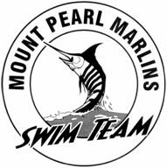

www.mountpearlmarlins.ca

https://www.facebook.com/swimmingNL?ref=hl#!/pages/Mount-Pearl-Marlins/203049029756914

PRESIDENT Kim Sullivan kimsullivan@nf.sympatico.ca
VICE_PRESIDENT Kim Walsh kwalsh@stewartmckelvey.com
TREASURER Maria Bouzane marlinstreasurer2016@gmail.com
SECRETARY Laura Holden lholden2@hotmail.com
REGISTRAR Joanne Brace joannecarlabrace@gmail.com
FUNDRAISING Carla Row carlamaryrow@hotmail.com
MEET MANAGER
OFFICIALS ADMIN
DIR. AT LARGE Lisa Sheppard lisasheppard@hellokitty.com
DIR AT LARGE Calla Butler calla@warp.nfld.net
DIR AT LARGE Anica Stowe anicajean@hotmail.com
HEAD COACH Duffy Earle duffy.earle@gmail.com

