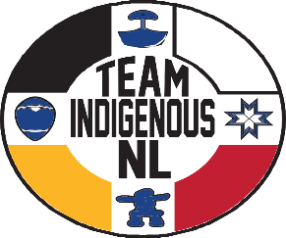
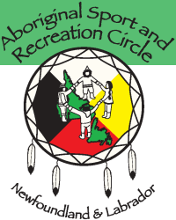
2023 North American Indigenous Games
Team Indigenous NL

Athlete Expression of Interest

The Aboriginal Sport and Recreation Circle NL (ASRCNL) is seeking Expressions of Interest from Indigenous youth of Newfoundland Labrador, interested in competing for Team Indigenous NL (TINL) at the 2023 North American Indigenous Games (NAIG) in Halifax, Nova Scotia from July 15-23, 2023. Team Indigenous NL will be looking for participants (male and female) to try out for numerous sports including:

- Athletics U14, U16, U19 Born 2009 or later; 2007 or later; 2004 or later
- Badminton U16, U19 Born 2007 or later; 2004 or later
- Basketball U19 Born 2004 or later
- Swimming U14, U16, U19 Born 2009 or later; 2007 or later; 2004 or later
- Volleyball U19 Born 2004 or later
- Beach Volleyball U16, U19 Born 2007 or later; 2004 or later
- Golf U16, U19 Born 2007 or later; 2004 or later
- Wrestling U16, U19 Born 2007 or later; 2004 or later

This form is used to gather information to help determine interest level and where ID Camps will be held. Athletes can only participate in one sport at the NAIG but can try out for more than one sport.

Athletes could be responsible for up to $1,700 or as low as $0 to participate at the 2023 NAIG for Team Indigenous NL dependant on financial support received from sources such as Aboriginal Governments, First Nation Councils and/or corporate sponsorship etc. If self identified indigenous athletes are not a recognized member of any of the Indigenous Nations/Governments, an approved Declaration of Indigenous Ancestry is required, however they would be ineligible for funding support from Aboriginal Governments/First Nation Councils.

2023 North American Indigenous Games
Team Indigenous NL

Athlete Expression of Interest

Team Indigenous NL will be looking for participants (male and female) to try out for numerous sports including:

- Athletics U14, U16, U19 Born 2009 or later; 2007 or later; 2004 or later
- Badminton U16, U19 Born 2007 or later; 2004 or later
- Basketball U19 Born 2004 or later
- Swimming U14, U16, U19 Born 2009 or later; 2007 or later; 2004 or later
- Male Volleyball U19 Born 2004 or later
- Volleyball U19 Born 2004 or later
- Beach Volleyball U16, U19 Born 2007 or later; 2004 or later
- Golf U16, U19 Born 2007 or later; 2004 or later
- Wrestling U16, U19 Born 2007 or later; 2004 or later

Name | Contact # | Date of Birth | Sport | M/F | Home Community

Band Number (if applicable):______________________________________________________

Medical Concerns: Please attach a separate letter outlining any medical concerns or issues.

Signature (Parent Signature required if Athlete is younger than 18) _____________________________________

Email________________________________________________________________________

If you have any questions you may contact:
Mike Alexander, Team Indigenous NL Coordinator (ASRCNL)
Ph: (709) 643-3130 Fax: 709-643-3150
E-mail: bsgasrc@nf.aibn.com

