MESSAGE OF JESUS CHRIST TO LORENA
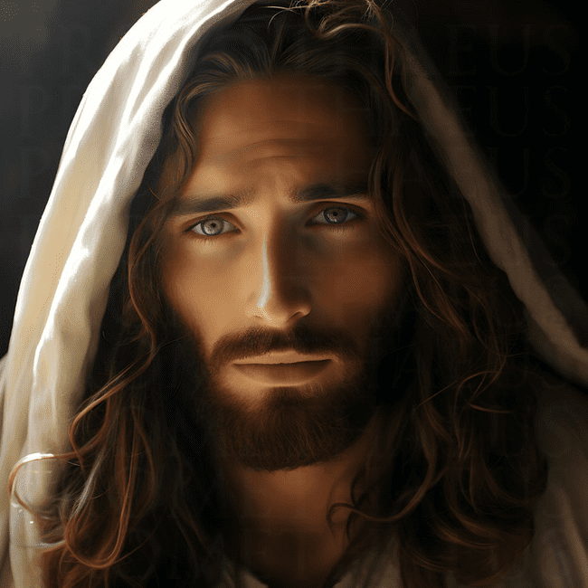
December 1, 2024
THE FIVE STARS, FIVE GUIDELINES AND FIVE DIAMONDS
My Dear Beloved, I Want to Give You Today 5 Stars of My Divinity so that You May Know the Seas of My Mercy and My Love for All Humanity, These 5 Stars Will Illuminate Your Night and Will Be Lights in the Storm.

They are 5 Stars, which will give Light in your Life from today onwards and which will lead you into My Divine Will and will teach you to listen to My Voice and follow My Way even in the darkness and storm, they, like the Star of Bethlehem, will Guide you to Me.

And I, as sweet Love Crucified for you and for all Humanity, will be waiting for you, at the foot of My Cross of Calvary, will make before Me a Covenant of Love and there by My side you will be Crucified and together with Me in the Sepulcher you will be Resurrected to Eternal Life.

But to Reach Calvary, You Must Follow the Stars That I Will Give You and Crucified Next to Me You Will Follow the 5 Guidelines to Die With the Beloved, After Being Crucified Next to Me I Will Give You the 5 Diamonds of Reward, After Resurrecting and Transforming Your Humanity by Being Given Birth by the Virgin Mary of Guadalupe as a New Humanity and Live in New Heavens and New Earth.

The First Star and the Most Important of All is to Know My Mother as Your Mother, just as I gave her to you at the Foot of the Cross, that beautiful Star, the most Relucid of all the stars in the firmament, will lead you to know Me by means of a dialogue between My Mother and you, which will instruct you in the journey to Calvary by means of Premises that will make you grow in Holiness and Spirituality.

The Second Star is Prayer, without it you will not be able to have a dialogue with My Beloved Mother that I have given you today, you must learn to Know Her and Love Her With All Your Heart, a disciple of Mine who Loves My Mother and has already fulfilled the necessary Premises to come to ME, therefore Pray With My Mother the Most Powerful Weapon That is the Rosary Every Day, this will restore you and help you to be stronger spiritually in the face of the Battles.

The Third Star is Important is to Let the Holy Spirit Flow in You and give you the necessary tools to make the wisest and correct decisions in your walk towards Me, if you follow His inspirations and anoint yourself with His Power by invoking Him through Prayer and Praise you will be filled with Him and you will always take the right path and make the right decisions.

The Fourth Star Will Illuminate You in the Darkness and Obscurity of the World because as a Lighthouse in the dense Sea it will guide you to a safe harbor and this Star is My Heart, which was pierced by a lance for the Love of you and from that lance in My Side My Beloved Church was born, you were born and by taking refuge in My Heart you will have the necessary Light to know what to do and how to Guide your steps and those of your other brothers and sisters, Take refuge in My Heart Pierced of Love for you and feel and live My Love for you and remember that you were born when Water and Blood flowed from My Side as My Church, My Church conformed by ALL MY DISCIPLES who have decided to follow Me being the Light of the Nations, through My Heart that will unite forever with His Bride the Church, so that in one Heart, the Body and the Head will give life to the New Humanity.

Now Do You Understand How Important It is to Be Guided by These Stars That That I Gave You Today?

The Fifth Star is the Consumation of the Other 4, It is a Perfect Transformation at the Light of the Holy Spirit, through My Holy Spirit in My Heart you will learn to know and practice the Divine Will in every instant of your life, this Divine Will will lead you to be Crucified together with Me so that through it, you will die to yourself and be Crucified together with Me to Resurrect to a new life converted into a LIVING TABERNACLE. *Therefore, first of all and to take your first steps, you will come to My Mother, She will guide you, you will pray asking for the Anointing of the Holy Spirit, taking refuge in My Heart, KNOWING IT AND LIVING IN THE DIVINE WILL, already on the Cross with your hands and feet pierced by the nails, you will learn to follow My Divine Will.

*I Will Give You 5 Guidelines so that You May Learn to Be Crucified for Love of Me, Just as I Was Crucified for Love of You.

The First Guideline Will Be to Forget Yourself so that you no longer exist, but I in you and your thoughts and actions will be Mine, not yours, and so we arrive at .....

The Second Guideline Where You Will Learn to Live the Vicissitudes of Life for Love of Me With Resignation and Trust you will surrender everything to me and I will live it for you, therefore it will become sweet nourishment for the Soul, so that thus lived in My Will and Love will be Sweet Balsam that will make you grow in Love and perception of pain as a Cross that will lead you to Me in order to be transformed and this Second Guideline will lead you to …

The Third Guideline which is to learn to live in My Love which is to love for My Love to yourself, to Me and to your neighbor and this is achieved by a life of surrender and love in every good or bad event in your life accepting My Will as a Balsam of Love that will lead you to the Eternal Homeland.

The Fourth Guideline is to Grow in Holiness by Feeling the Rigor of Your Feet and Hands Crossed, the Thorns in Your Head and the Threats in Your Body, you will learn through pain to become dead to your disordered desires and passions, dying to the flesh to the world and to sin, living only in you My Graces and My Virtues.

The Fifth Guideline Will Take You to Expiring in My Love, Giving Your Life to My Beloved Father, expiring your last breath united to My Heart and this moment in which you expire, your heart and Mine will be united in a single heart, which will beat in unison with the whole heart of Creation and all the hearts of the children given to Light as New Humanity will give way to an Era of Love in the Heavens and New Earth.

*In the Heavens and New Earth, I Will Give You the 5 Diamonds of Peace and Love During the Thousand Years of Peace.

The First Diamond is the Transcendence to Life Without Dying Because You Will Be Transformed and Will Not Pass Through Physical Death, but you will die to the flesh to give way to the new woman, through this Diamond the Second Death will have no effect on you because you will pass to Eternal Life, because the Second Death will have no power over you, this Diamond the Transcendence in your life and not going through the Second Death is the Key to the other diamonds.

The Second Diamond is the Dignity of how My Beloved Church That Was Born From My Side When I Was Crucified, will Lead the New Creation Together With the Children of Light, who are also born as the Church of My Pierced Heart and the small and humble New Church will rise from the ashes, to be the Seed of New Christians.

The Third Diamond is Life in the Heavens and New Earth as a New Daughter of My Beloved Mother Born by Her, obtaining with this the Gifts Lost in the fall of Adam and Eve, which will make you understand the act of living totally in every instant of your life in the Divine Will of My Beloved Father.

The Fourth Diamond is the Sun of My Divine Love Which Lights Up the New Creation Without the Need for Sun and Moon, because My Glory will radiate the necessary Light of My Heart together with that of all creatures which will illuminate the whole New Jerusalem so that there will always be Light and not darkness, Night Will No Longer Exist, Only the Day Will Be Illuminated With the Light of My Divine Will of My Love, Having Only Fullness.

The Fifth Diamond is the Consummation of the World Created by My Father God, to Give Way to the End of This One, so that the Living Come to Enjoy the Eternal Glory in the Paradise of My Love,which is the Garden of My Eternal Love where all united in one heart WE WILL DWELL IN THE ETERNAL DWELLING OF MY FATHER FOR ALL ETERNITY, blessed is the one who receives this beautiful Diamond will live Eternal Happiness forever, and I will give to each and every one a Crown of Glory as a sign of the royalty to which they are entitled, by carrying the Flower of My Divine Will in their hearts, to give way to the Love of the United and Pierced Hearts and to the Most Holy Trinity for being the Light of Heaven for those who Love My Precepts and Love with all their heart, dying to themselves to be able to Live Eternally in the Heavenly Abode of My Beloved Father God.

Follow These 5 Stars, 5 Guidelines and 5 Diamonds That Will Make You Live in My Will and Be Given Birth as a New Humanity, So Today I Ask You to Follow My Instructions, so that, as a Daughter of My Divine Will, You Will Have the Necessary Tools to Achieve It.

I, Your Beloved Jesus Christ, Will Guide You and Give You Everything You Need to Achieve It, I Am Waiting for You and All Your Brothers and Sisters in My Wedding.

MARANATHA!!

